Ways to help with Writing
Encourage your child to:
- Use lower case (small letters) and not capital letters in their words. The children can use capital letters for names and the start of a sentence.
- Make up their own sentences. They should be short sentences around 5 or 6 words long at the most. You can help them split a long sentence into 2 short sentences
- Say their sentence several times before they write it. This will help them remember it. Then to count how many words they need to write. Then to write one word at a time, leaving a finger space between words. When they have finished writing they should count the words and read the sentence out. SAY IT, COUNT IT, WRITE IT, CHECK IT. We call this “holding a sentence”.
- Spell all tricky words correctly – see the list below.
- Use the phonic sounds they know to spell the other words in their sentence. They can use the sound mats sent home to see the letters they should use.
- Hear the first sound, middle/next sound, last sound in the word e.g. ‘chop’ 1st sound ‘ch’, 2nd/middle sound ‘o’ and last sound ‘p’
- Put a full stop (a small dot, not a big dot!) at the end of the sentence to should they have finished.
- Write at least 1 sentence every day.
- Hold their pencil correctly.
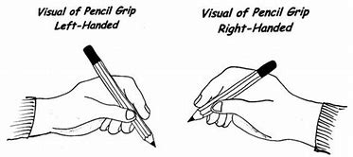
- Form the letter correctly, starting in the correct place and going in the correct direction

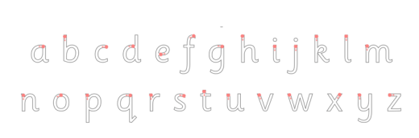

Please do NOT do the following:
- Make the sentence up for your child to write. Only help them if their sentence is very long by splitting it into 2 short sentences.
- Write the sentence for your child to copy.
- Spell out words for you child. It is ok for them to be spelt using the sounds the children have learned e.g you child will spell the word ‘beach’ like this ‘beech’ as they have not learned the ‘ea’ sound yet. This is fine at the moment. It is more important that your child feels confident at having a go, rather than worrying that every bit is correct. As time goes on we will expect children to use the correct spelling as they get more confident in writing and make progress with their phonics.
- Ask you child to write more than 3 sentences at a time or for longer than 15 minutes in one go.
- Ask you child to write the same word/sentence until it is correct.
Do NOT worry if:
- Your child confuses d and b. It is very common at this stage/age and your child will get it right eventually
- Your child forgets finger spaces – they are concentrating on getting the words in their head down on the paper. Just remind them as they write.
- Your child doesn’t know what a capital letter for the start of a sentence looks like. We have only been learning the correct formation of lower case (small letters) at the this time.

