Share the picnic food between the teddy bears. You can use practical equipment to help you.
How many cakes will each bear get?
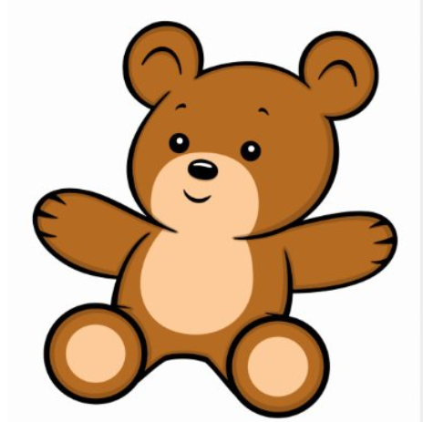

How many sandwiches will each bear get?
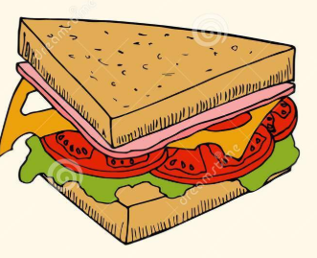

How many drinks will each bear get?
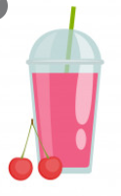
How many biscuits will each bear get?
How many slices of pizza would each bear get?
How many strawberries would each bear get?
Is this fair? Why/why not?
