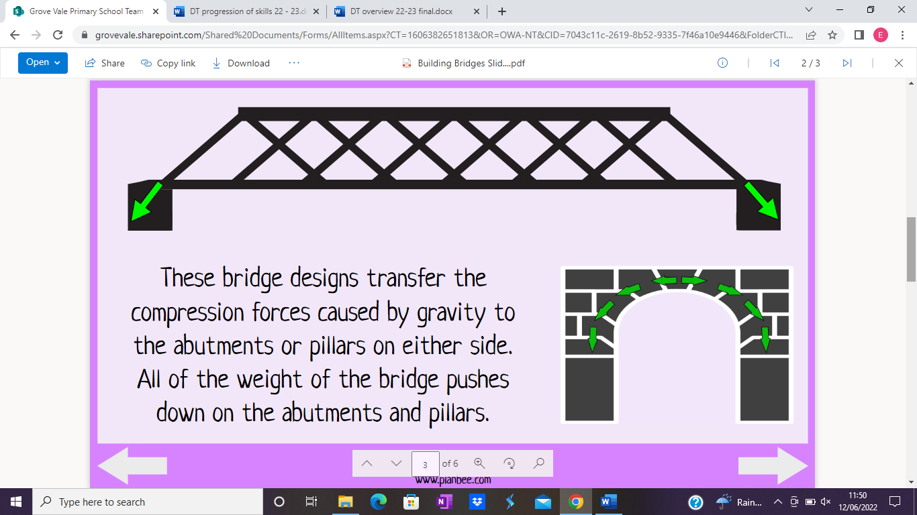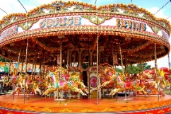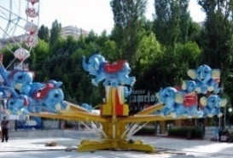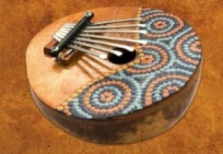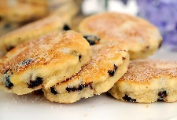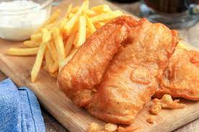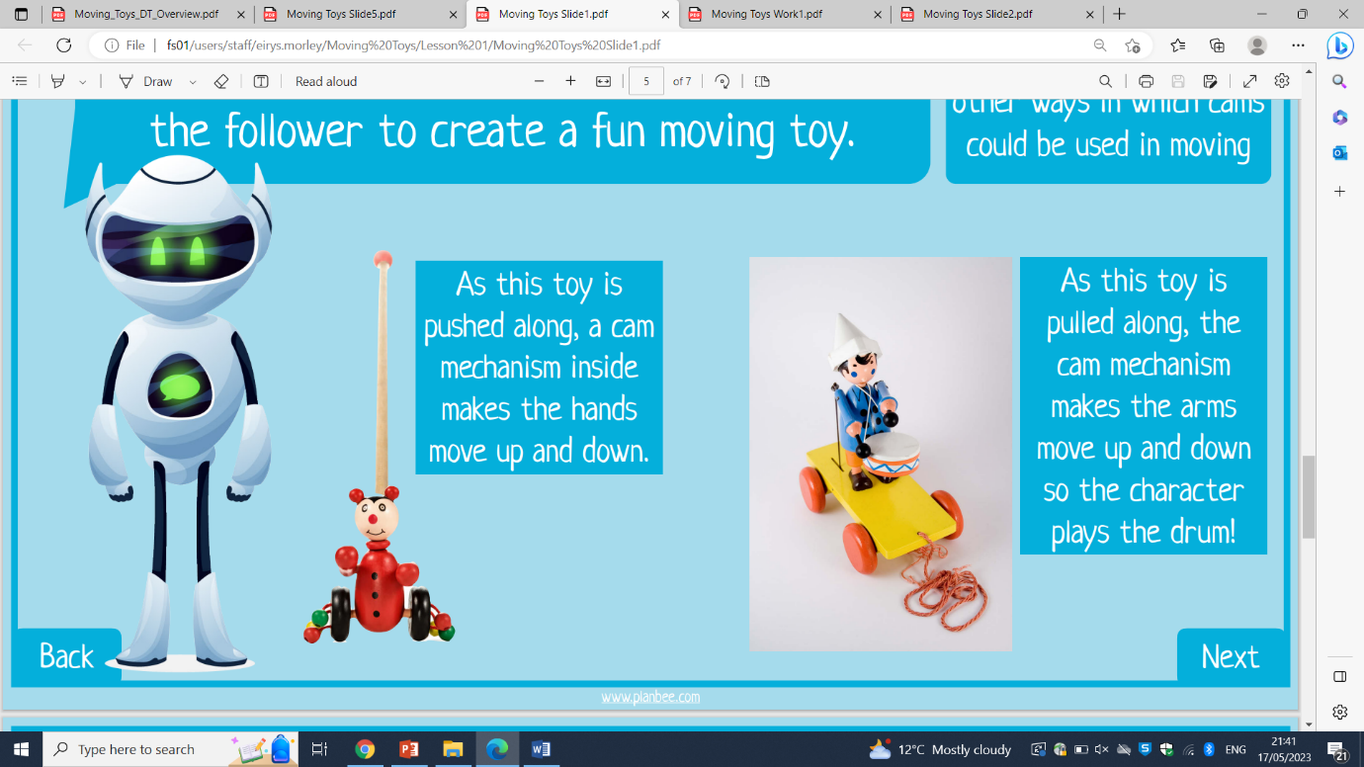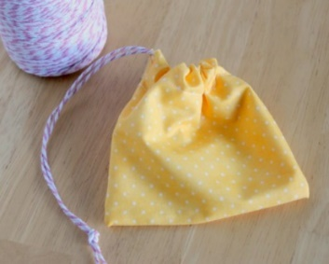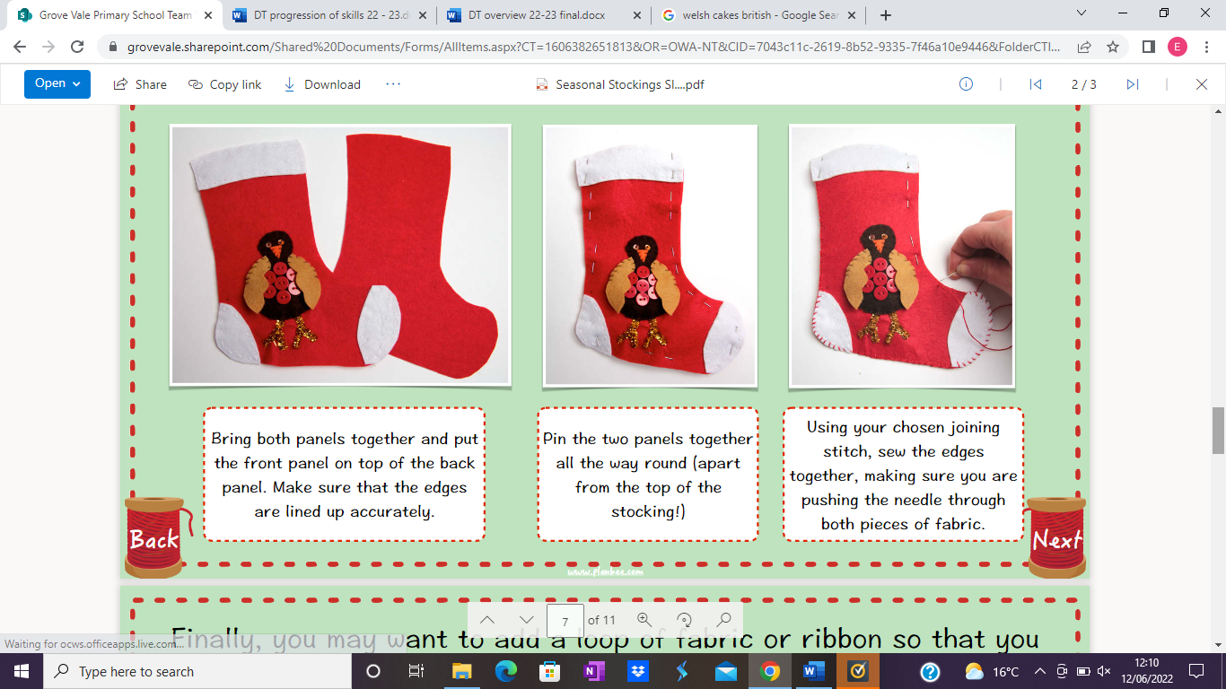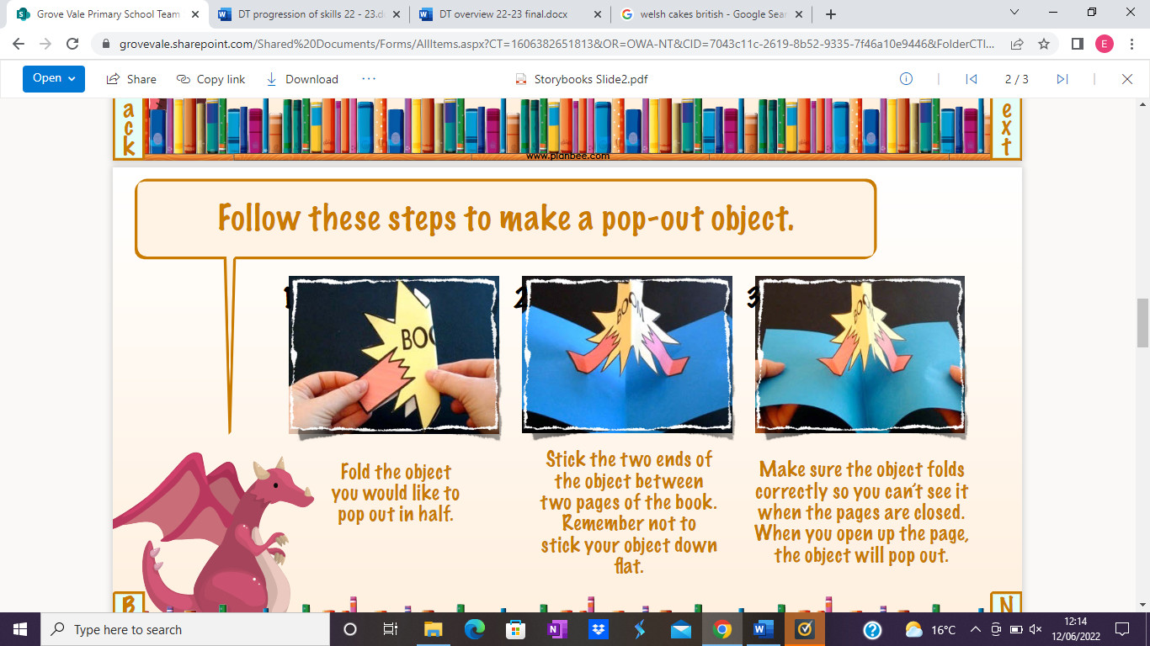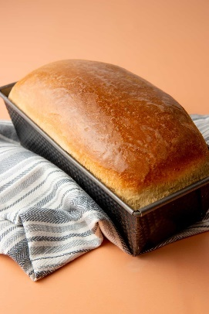

**Summer – Fairgrounds**

Design and use an appropriate circuit for a fairground ride to include a rotating part.

Create and use simple gears, pulleys, cams or linkages linked with an electrical circuit to create a product.

**Spring – African instruments**

Select the most appropriate materials to create a 3D structure, ensuring it is strengthened and reinforced with the ability to make a sound.

Test a range of materials to ensure the strength and pitch of the instrument makes the product functional.

**Autumn – Great British dishes**

Identify which foods grow at different times of year and in different climates. Discuss and evaluate whether a meal is balanced or not. Combine food ingredients appropriately (kneading, stirring, whisking etc). Plan how to have a healthy/affordable meal. Combine ingredients accurately using a range of cooking techniques, measure and weigh the appropriate ingredients following a given recipe.

**We are resilient.**

**We are ambitious.**

**We are curious.**

**We are creative.**

**Autumn – Fashion and textiles**

Create a 3D decorative product with purpose using a range of stitching techniques (running, cross, back).

Combine materials for more useful purposes, identifying and fixing snags and glitches.

**Spring – Moving Toys**

Describe and design a product using a cam mechanism to create movement.

Select, create and use the most appropriate mechanism and materials for the specific purpose.

**Summer – Building bridges**

Use a range of materials to test bridge construction considering beams, arches, pillars or piers.

Select the most appropriate materials to create a 3D structure, ensuring it is strengthened and reinforced as a suspension bridge.

**Rewind to year 4**

**Autumn – Seasonal Stockings**

Develop and improve accuracy in joining materials together using a range of strategies including stitching.

Use a simple running stitch to join materials together in an accurate way.

Create a 3D product with purpose using a range of stitching techniques (running, cross, back).

**Spring – Story books**

Create and use a product with a simple moving mechanism

Select, create and use the most appropriate mechanism for a specific purpose.

**Summer – Seasonal food**

Identify which food is native to the UK, where other foods originate and how seasonality and current events can affect the production of foods.

Make healthy choices and explain why.

Measure and weigh the appropriate ingredients following a given recipe for bread.

**Year 5 - DT**

**Fast-forward to year 6**