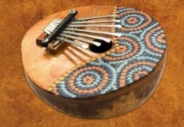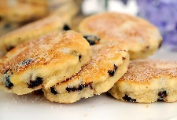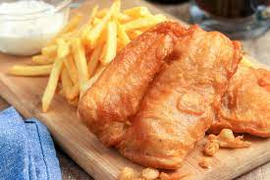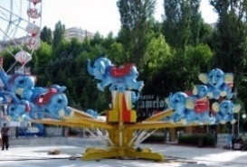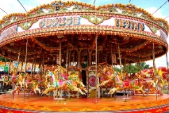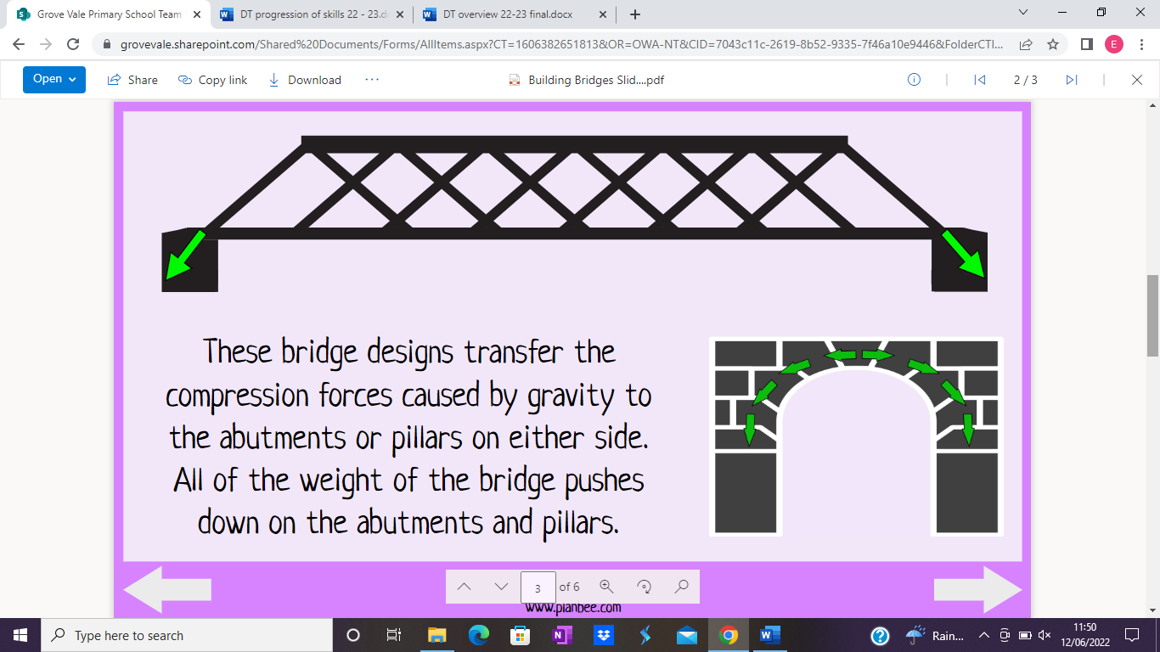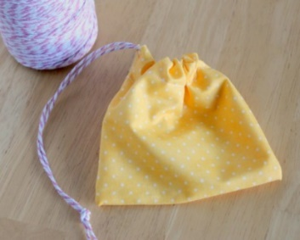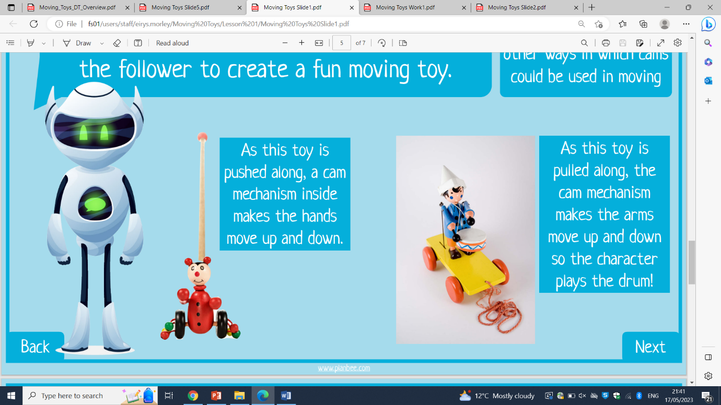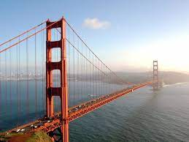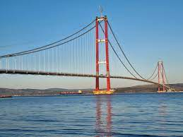

**Autumn – Fashion and textiles**

Create a 3D decorative product with purpose using a range of stitching techniques (running, cross, back).

Combine materials for more useful purposes, identifying and fixing snags and glitches.

**We are resilient.**

**We are ambitious.**

**We are curious.**

**We are creative.**

* Develop the creative, technical and practical expertise needed to perform everyday tasks confidently and to participate successfully in an increasingly technological world.
* Build and apply a repertoire of knowledge, understanding and skills in order to design and make high-quality prototypes and products for a wide range of users.
* Critique, evaluate and test their ideas and products and the work of others.
* Understand and apply the principles of nutrition and learn how to cook.

**Summer – Fairgrounds**

Design and use an appropriate circuit for a fairground ride to include a rotating part.

Create and use simple gears, pulleys, cams or linkages linked with an electrical circuit to create a product.

**Spring – African instruments**

Select the most appropriate materials to create a 3D structure, ensuring it is strengthened and reinforced with the ability to make a sound.

Test a range of materials to ensure the strength and pitch of the instrument makes the product functional.

**Autumn – Great British dishes**

Identify which foods grow at different times of year and in different climates. Discuss and evaluate whether a meal is balanced or not. Combine food ingredients appropriately (kneading, stirring, whisking etc). Plan how to have a healthy/affordable meal. Combine ingredients accurately using a range of cooking techniques, measure and weigh the appropriate ingredients following a given recipe.

**Spring – Moving Toys**

Describe and design a product using a cam mechanism to create movement.

Select, create and use the most appropriate mechanism and materials for the specific purpose.

**Summer – Building bridges**

Use a range of materials to test bridge construction considering beams, arches, pillars or piers.

Select the most appropriate materials to create a 3D structure, ensuring it is strengthened and reinforced as a suspension bridge.

**Rewind to year 5**

**Year 6 - DT**

**Fast-forward to year 7**