Knowing how to learn is one of the most important ingredients to becoming knowledgeable in all aspects of life. The skills you learn will help determine the path you choose in life.

Having these opportunities at school is wonderful part of this process. However, education does not just happen at school, learning is happening all the time.

Education is not just about learning facts, it’s about how you think and apply, it has real purpose in everything you do.

Becoming educated is a lifelong process.  It can be hard and frustrating at times, even boring. But it can also be incredibly exciting and enriching.

So, use your subject friends to help you through your learning journey.

Understanding the skills to be good at …….

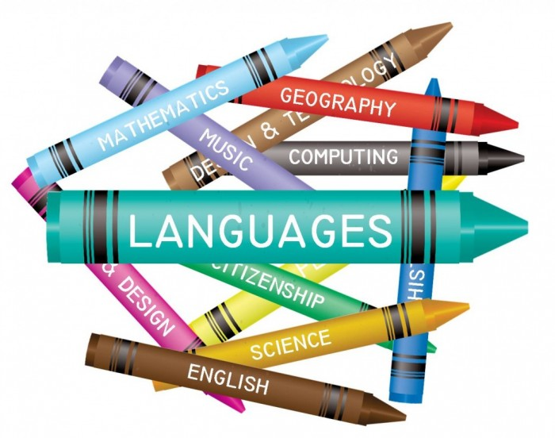

7

The best primary practice includes a blend of rigorous, discrete subject teaching and equally effective cross-curricular links – both approaches are needed for effective learning.

### Making connections

It’s helpful to think about cross-curricular links in two ways. First, there are the links where children use and apply aspects of learning from one subject in another – e.g. the application of science understanding in D&T. Learning in both subjects can benefit. Not only will children have the opportunity to deepen their understanding of key science concepts, they’ll also be better equipped to make informed design decisions in D&T. For instance, children designing and making bags can use their science understanding of the properties of materials when selecting from a range of fabrics, thinking about who the bags are for and how they’ll be used. Of course, there are also opportunities with this project for children to make use of learning from a number of other subjects: Maths, art and design and ICT to name but three.

And secondly, for children to understand the skills needed in the complete learning package to be effective with this approach.

**The Launch**

Early this year, the School Council did a Catwalk of subject characters to introduce the skill sets needed to the whole school, which was received with some excitement.

Teachers are now embedding this skill techniques during their lessons, reminding the children to be successful this understanding is needed.

*So, lets meet the characters....*

**Maddy the Mathematician**

* Has a passion for maths.
* She has a wide range of mathematical vocabulary.
* Able to recall number facts and learn from her mistakes.
* She has a broad range of skills in using and applying mathematics.
* She is able to solve maths problems in a wide range of contexts, including the new or unusual.
* Can think independently and persevere when faced with challenges, showing a confidence of success

6

1

**Rosie the Writer**

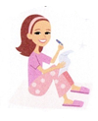

* Has a love for writing.
* Is able to make her writing come to life.
* Can write about lots of different things, fiction and non-fiction.
* Is able to use interesting, exciting words in her writing.
* Makes sure her writing has all the right features.
* Checks her writing is in the right order and makes sense.
* Uses the correct punctuation and spells her words correctly.
* Makes sure her writing is lovely and neat and her handwriting is perfect.

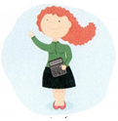

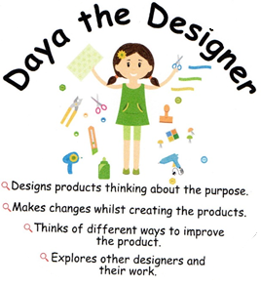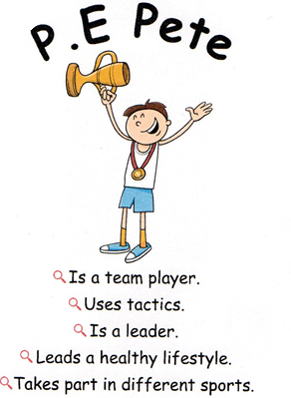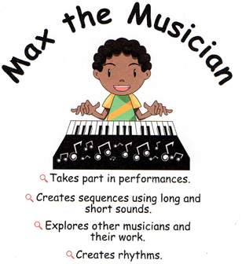

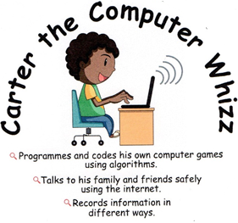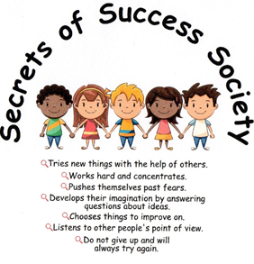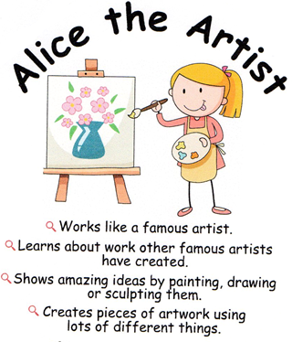

**See if you can find all your subject friends around the school.**

4

3

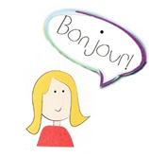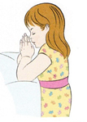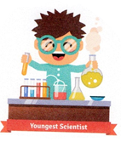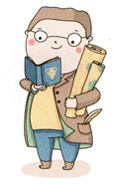

2

5

**Lisa Linguist**

* Reads out loud everyday words and phrases.
* Reads and understands short written phrases.
* Uses books or glossaries to find out the meanings of new words.
* Write some sentences in French.
* Can name different places where French is spoken.

**Ruby RE**

* Describes the teachings of different religion.
* Able to name some religious festivals or celebrations.
* Can name and describe places of worship.
* Understands different religious lifestyles.
* Can name and explain religious symbols.
* Reflects on her own life and asks questions that puzzle her.
* Explains her choices in life and how her actions affect others.

**Simran the Scientist**

* Asks questions to find out how things work.
* Investigates to see how things work and how things change.
* Finds out how things work.
* Predicts what might happen.
* Records what he has have found out.
* Evaluates what he has found out to tell others.

**Genna the Geographer**

**Harry the Historian**

* Ask and answer geographical questions.
* To know some places in the world.
* Describes human and physical features.
* Uses maps to find different places in the world.
* Looks for clues.
* Asks and answers questions.
* Thinks about what happened in the past.
* Describes events from the past using a timeline.
* Has a passion for reading.
* She can sound out all of her words.
* Able to read lots of different texts.
* Understands the meaning of lots of interesting words.
* Can understand what she is reading and answer questions about it.
* Knows lots about the world through all the different things she reads.

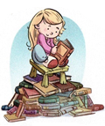

**Ria the Reader**