Grove Vale Primary School
SEND Information Report

Written: September 2020
Next Update: September 2021

SENCO: Mrs. Sarah Pickett
Contact: sarah.pickett@grovevale.sandwell.sch.uk
SEND governor: Mrs Louise Maccarthy
Local Offer: https://www.sandwell.gov.uk/send

Contents
- Whole School Approach
- A Graduated approach to teaching
- Reviewing progress
- Different SEN Needs
- Provision and intervention for SEND pupils at Grove Vale
- Staff training
- Evaluating the effectiveness of SEN provision
- Outside support agencies
- SENDIASS
- Transition
- Complaints
- Admission arrangements for SEND pupils

Whole School Approach:
When is a pupil moved onto the school SEND database?

If a pupil is having provision that is additional and different from other pupils of the same age then they are said to have special educational needs.

Under the Children and Families Act 2014 a child of compulsory school age or a young person has a learning difficulty or a disability if he or she:
• has significantly greater difficulty in learning than the majority of others of the same age; or
• has a disability which prevents or hinders him or her from making use of facilities of the kind generally provided for others of the same age in mainstream schools or post 16 institutions; and,
• needs special educational provision to be made for him/her.
For example, children could have difficulty with:
• keeping up with children in all of their subjects
• some of the work in schools such as reading, writing, number work or understanding information
• expressing themselves or understanding what others are saying
• making friends or relating to adults
• behaving appropriately in school
• organising themselves
• their sensory or physical needs which may affect them in school.
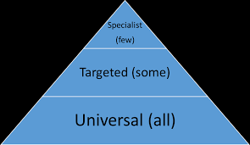
A Graduated approach to teaching
Stage 1 – high quality universal teaching
Teachers to consider:
- environment, thinking about: display/lighting/seating/distraction
- language (appropriate, modelled and explained) and questions used
- types of resources used (accessible and supportive)
- differentiation
- grouping/pairing/adult support
- alternative methods

Stage 2 – targeted support + high quality teaching
- teachers will jointly plan, targeted intervention, with the SENCO and teaching assistants.
- intervention will be little and often, helping close the gap with booster sessions.
- Using published interventions
- this is evaluated and reviewed and changed if no progress is seen
Stage 3 – specialist support + high quality teaching
If after targeted support limited progress is seen, school may refer the pupil to outside support agencies for more specialist recommendations and support. Parental consent is needed.

Reviewing Progress
At Grove Vale we encourage the ‘Assess-Plan-Do-Review’ process. Pupils specific areas of need are supported through intervention. Targets are set prior and progress and achievement is monitored throughout.
Assess
Involves taking into consideration all the information about the pupil.
Class teacher, alongside SENCO carries out an analysis of child’s needs.
Gain advice from external agencies
Review  Measuring the impact of the support provided and consider whether changes to that support need to be made.  Parents, pupils, teacher, SENCO and outside agencies contribute to this review. | 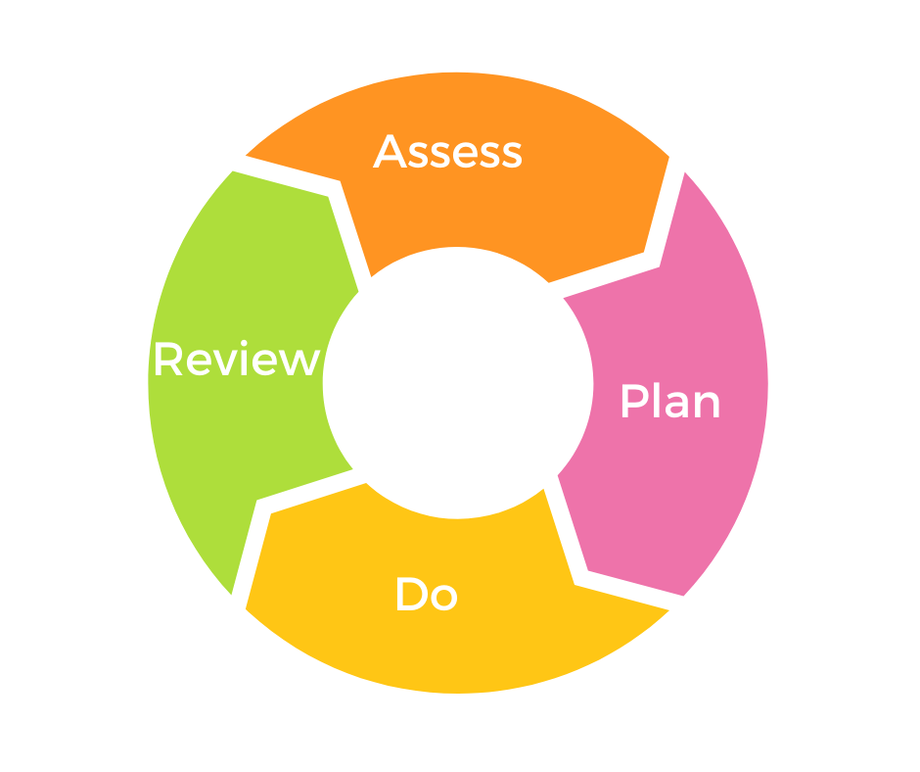 | Plan  This stage identifies the barriers for learning, intended outcomes and details what additional support with be provided to help overcome the barriers. Parents will be formally informed that the pupil is now on the school SEN database.
Do
Providing the support.
Class teacher working with pupil on a daily basis.
Class teacher works closely with support staff to assess progress from interventions and link to class teaching.
SENCO to support class teacher.

Different SEN Needs
At Grove Vale we have SEND children with a range of needs.
• Communication and Interaction
Children with speech, language and communication needs (SLCN) have difficulty in communicating with others. This may be because they have difficulty saying what they want to, understanding what is being said to them or they do not understand or use social rules of communication. The profile for every child with SLCN is different and their needs may change over time. They may have difficulty with one, some or all of the different aspects of speech, language or social communication at different times of their lives.
Children and young people with ASD, including Asperger’s Syndrome and Autism, are likely to have particular difficulties with social interaction. They may also experience difficulties with language, communication and imagination, which can impact on how they relate to others.
• Cognition and Learning
Support for learning difficulties may be required when children learn at a slower pace than their peers, even with appropriate differentiation. Learning difficulties cover a wide range of needs, including moderate learning difficulties (MLD), severe learning difficulties (SLD), where children are likely to need support in all areas of the curriculum and associated difficulties with mobility and communication, through to profound and multiple learning difficulties (PMLD), where children are likely to have severe and complex learning difficulties as well as a physical disability or sensory impairment.
Specific learning difficulties (SpLD), affect one or more specific aspects of learning. This encompasses a range of conditions such as dyslexia, dyscalculia and dyspraxia
• Social, Emotional and Mental Health
Children may experience a wide range of social and emotional difficulties which manifest themselves in many ways. These may include becoming withdrawn or isolated, as well as displaying challenging, disruptive or disturbing behaviour. These behaviours may reflect underlying mental health difficulties. Other children may have disorders such as attention deficit disorder, attention deficit hyperactive disorder or attachment disorder.
• Sensory and Physical
This includes children with vision impairment (VI), hearing impairment (HI) or a multi-sensory impairment (MSI). Children with an MSI have a combination of vision and hearing difficulties.

 | TOTAL SEND | EHCP | Communication and Interaction | Cognition and Learning | Social, Emotional and Mental Health | Sensory and Physical
Reception | 7 | 2 | 5 | 0 | 0 | 2
Year 1 | 3 | 0 | 3 | 0 | 0 | 0
Year 2 | 4 | 0 | 4 | 0 | 0 | 0
Year 3 | 5 | 3 | 3 | 0 | 1 | 1
Year 4 | 7 | 0 | 2 | 3 | 2 | 0
Year 5 | 5 | 0 | 2 | 2 | 1 | 0
Year 6 | 8 | 1 | 2 | 3 | 1 | 2
TOTALS | 40 | 6 | 21 | 8 | 5 | 5

Provision and intervention for SEND pupils
Listed below are many of the interventions which are used at Grove Vale to support these areas:
Communication and interaction
Specific intervention | What they support | Desired outcome | How measured
Speech and Language Therapy | Pupils with specific speech problems | Pupils can speak | Reviewed annually by NHS therapist
Wellcomm | Pupils who find it hard to communicate and understand other | Pupils understand, vocabulary and grammar will improve when communicating. | Use of wellcomm screening
SULP (social use of language programme) | Pupils who find it hard to socialise and interact with others | Pupils able to play with other children, share and take turns | observations
MAKATON | Giving Non-verbal children a way to communicate. | Pupils able to communicate their wants and needs | Reviewed annually by NHS therapist
Intense interaction | Pupils who play solitary, encourage them to take turns and play with familiar adult | Pupil can share, take turns, interact with others | Observation,
Picture, exchange communication system  (PECs) | Giving Non-verbal children a way to communicate. | Pupils able to communicate their wants and needs | Reviewed annually by NHS therapist
Lego therapy | Children who find it hard to communicate and interact with others. | Able to ask questions, communicate what they want and problem solve.  Able to take turns and share. | observations
Cognition and learning
Specific intervention | What they support | Desired outcome | How measured
Spelling boosters | Pupils with barriers to learning spelling | Number of words they can spell will increase | Spelling test
Reading support | Pupils whose reading age is lower than expected. | Reading age will increase | Salford reading test
Toe by Toe | Pupils with barriers to learning spelling | Number of words they can read and spell increase | Word reading/spelling test
SOS grids | Pupils with barriers to learning spelling | Number of words they can spell will increase | Spelling test
Multi-sensory approached to spelling | Pupils with barriers to learning spelling | Number of words they can spell will increase | Spelling test
Phonics boosters | Children with gaps in their phonological awareness | Number of graphemes known increased | Phonic assessment/check
Social, emotional, mental health
Specific intervention | What they support | Desired outcome | How measured
Nurture groups | Pupils with social and emotional difficulties due to:  Trauma  family breakdown  being in care  anxieties  behaviour issues  anger issues | Improvements in pupils mental health and well being | Data from Boxall profile  Feedback from pupils
Play therapy |  | Improvements in pupils mental health and well being | Data from Boxall profile  Feedback from pupils
Emotion coaching |  | Improvements in pupils mental health and well being | Data from Boxall profile  Feedback from pupils
Counselling sessions |  | Improvements in pupils mental health and well being | Data from Boxall profile  Feedback from pupils

Sensory and/or physical needs
Specific intervention | What they support | Desired outcome | How measured
Care room | Personal care tasks are carried out, changing children. | Pupils are clean and happy | observations
Enlarged texts, access to magnifier, raised platforms | Children with visual impairments so they can access their work | Pupils can read/see work | Observations, progress
Ramps and hand rails | Pupils with limited mobility to access and navigate the school | Pupils can enter school and use resources in EYFS classrooms. | Observations, progress

Specialist equipment and facilities to support SEND children.
Sensory room  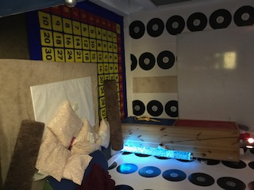 | Specialist changing bed  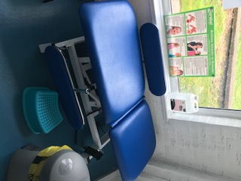 |  | Nest  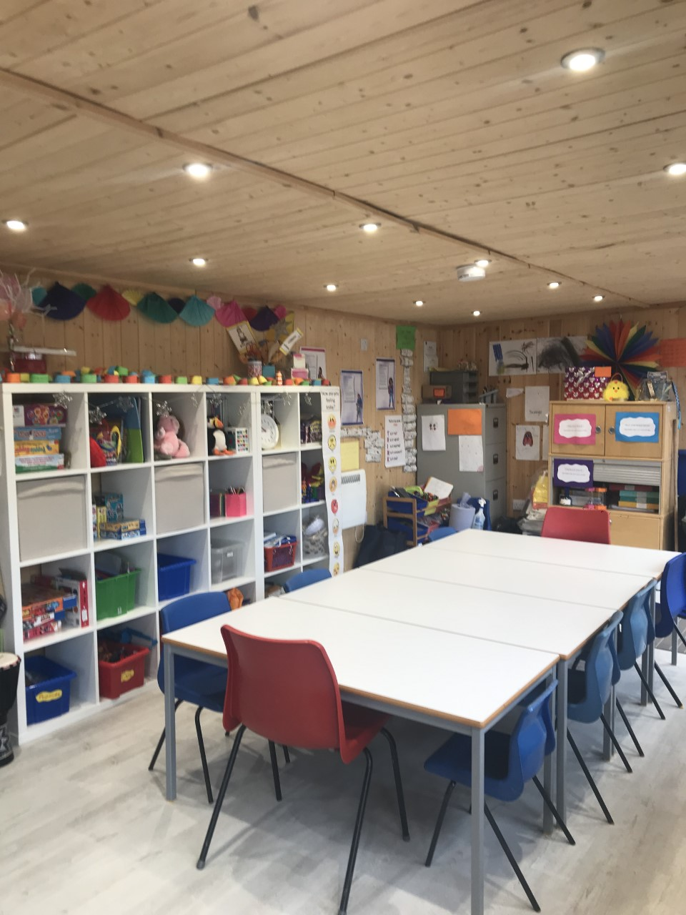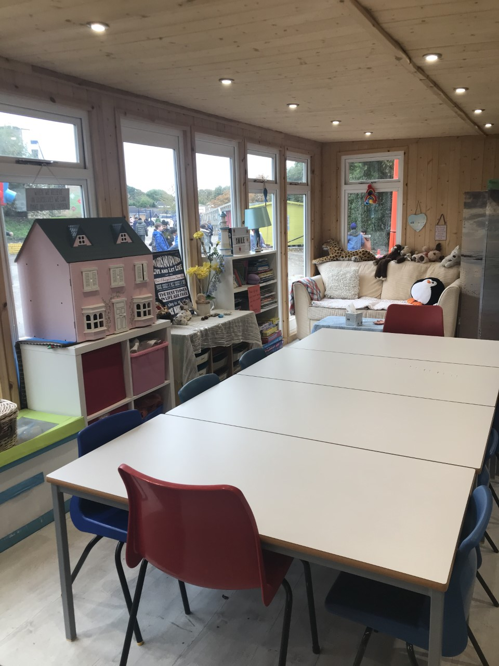
Learning hub 1  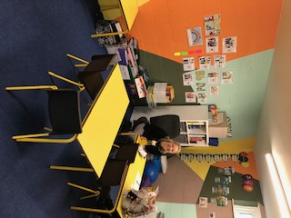 |  | Learning hub 2  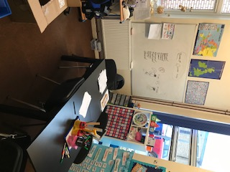

Staff training
Staff | Training | Outcome
LSA x 3 | Makaton | Able to communicate with pupils SLCN needs
LSP | Intense interaction | Strategies gained regarding how to engage autistic pupil
All staff | Speech, Language and Communication Needs | Strategies gained regarding making classrooms communication friendly and about the types of SLCN difficulties.
SENCO and nurture lead | Mental first aider | Information gained regarding types of mental health issues and approach schools can take.
Whole school + dinner staff | 1st aid – inhalers and epipens | Staff aware of pupils with care plans and how to support and administer inhalers and epipens.
Support staff and EYFS staff | Paediatric first aid | Staff able to administer basic first aid to children.

Evaluating the effectiveness of SEN provision
We evaluate the effectiveness of provision for pupils with SEN by:
• Teachers plan to enable SENd pupils to achieve their individual targets on their all about me. Reviews are completed every term and shared with parents. When a pupil has achieved the target, new targets are set.
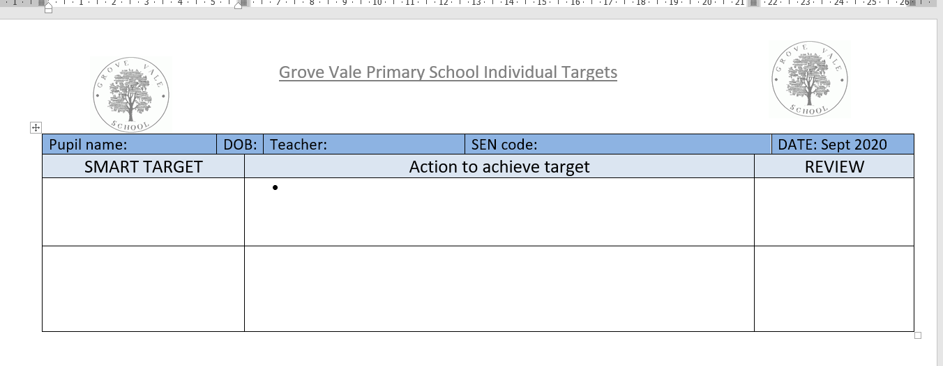
• The SENCO will also monitor the quality of any interventions
• The SENCO will hold annual reviews for pupils with Education, Health Care plans

Outside support agencies
Local authority provision
Inclusion support:
- specialist teachers for learning
- specialist teacher for social, emotional and mental health
- educational psychologist
- Early years inclusion support
- CCAT (complex communication and autism team)
- Specialist teachers for the visually and hearing impaired
This service can be contacted by phone on 0121 569 2777, by email at inclusion_support@sandwell.gov.uk or at Connor Education Centre, Connor Road, West Bromwich, B71 3DJ
Health provision
- NHS speech therapist
- CAMHS
- NHS physio
- NHS occupational therapist
- NHS school nurse

Support for parents - SENDIASS 
SENDIASS are the Special Educational Needs and Disability Information Advice and Support Service (SENDIASS) for Sandwell families. Our aim is to enable parents/carers, children and young people to make informed decisions about education, by ensuring they have the advice, information and support to make those decisions. They are a free, impartial and confidential service.

What they can do to help you
- Provide clear, accurate and impartial advice about special educational needs and disability
- Enable you to use your rights to ensure the educational needs of your child are met
- Listen to your questions and concerns
- Offer support and guidance with SEN procedures
- Explain the process of accessing SEN School Support
- Provide support in preparing for meetings (sometimes we can attend these with you, depending on our availability)
- Support you through the statutory assessment process for an Education Health and Care Plan (EHCP)
- Answer questions around your child’s EHCP
- Offer support to help you through the EHC Assessment and application for EHCP
- Signpost you to other national and local services where necessary, including support groups and activities
- Help you to resolve disagreements (including referring you for independent SEN mediation, where appropriate)
- Provide training for parents/carers and professionals on different aspects of SEND.
Contact:
https://www.actionforchildren.org.uk/in-your-area/services/disability/sandwell-iass/
0121 500 4010 SENDIASSEnquiries@actionforchildren.org.uk

Transition
Introduction to reception - All pupils starting reception with receive a home visit or phone call with our EYFS staff. This is to gather information from parents regarding their child’s needs and education. Concerns about particular needs will be brought to the attention of the SENCO who will arrange a further meeting with parents and gather further information from previous settings and health visitor etc.
Year 6 to secondary: Pupils with Educational health care plans will discuss their options for secondary school at their annual review which is held during the summer term of year 5. Visits to new schools are arranged in liaison with the senior schools. A plan of transitional activities will be put into place, this might involve children visiting their school, making transition book, making connection with key members of staff at new school.
The SENCO will also have conversations with SENCOs from senior school regarding other pupils with SEND needs. Discussions over their needs and current intervention takes place, extra transition maybe available for these pupils if needed.
Raising concerns and complaints
Parents and carers meetings are held every term. Class teachers and the SENCO can be contacted by using the contact form on our website. A member of staff will then be in touch by phone to discuss any query. If a face-to-face meeting is needed an appointment will be made.
Parents who wish to complain are strongly encouraged to initially speak to the class teacher or SENCO regarding their complaint. If the issue cannot be resolved at this level or the complaint is regarding the SENCO the parent will be directed to the school’s complaints procedure, which is available on our school website.
Please also see our Compliments and Complaints Policy on the school website.
Admissions arrangements for pupils with SEND
Please refer to the school Admissions policy, this is a Sandwell LEA policy.
Accessibility arrangements for SEND pupils
Please refer to the school’s Accessibility Plan, which can be found on the school website.

