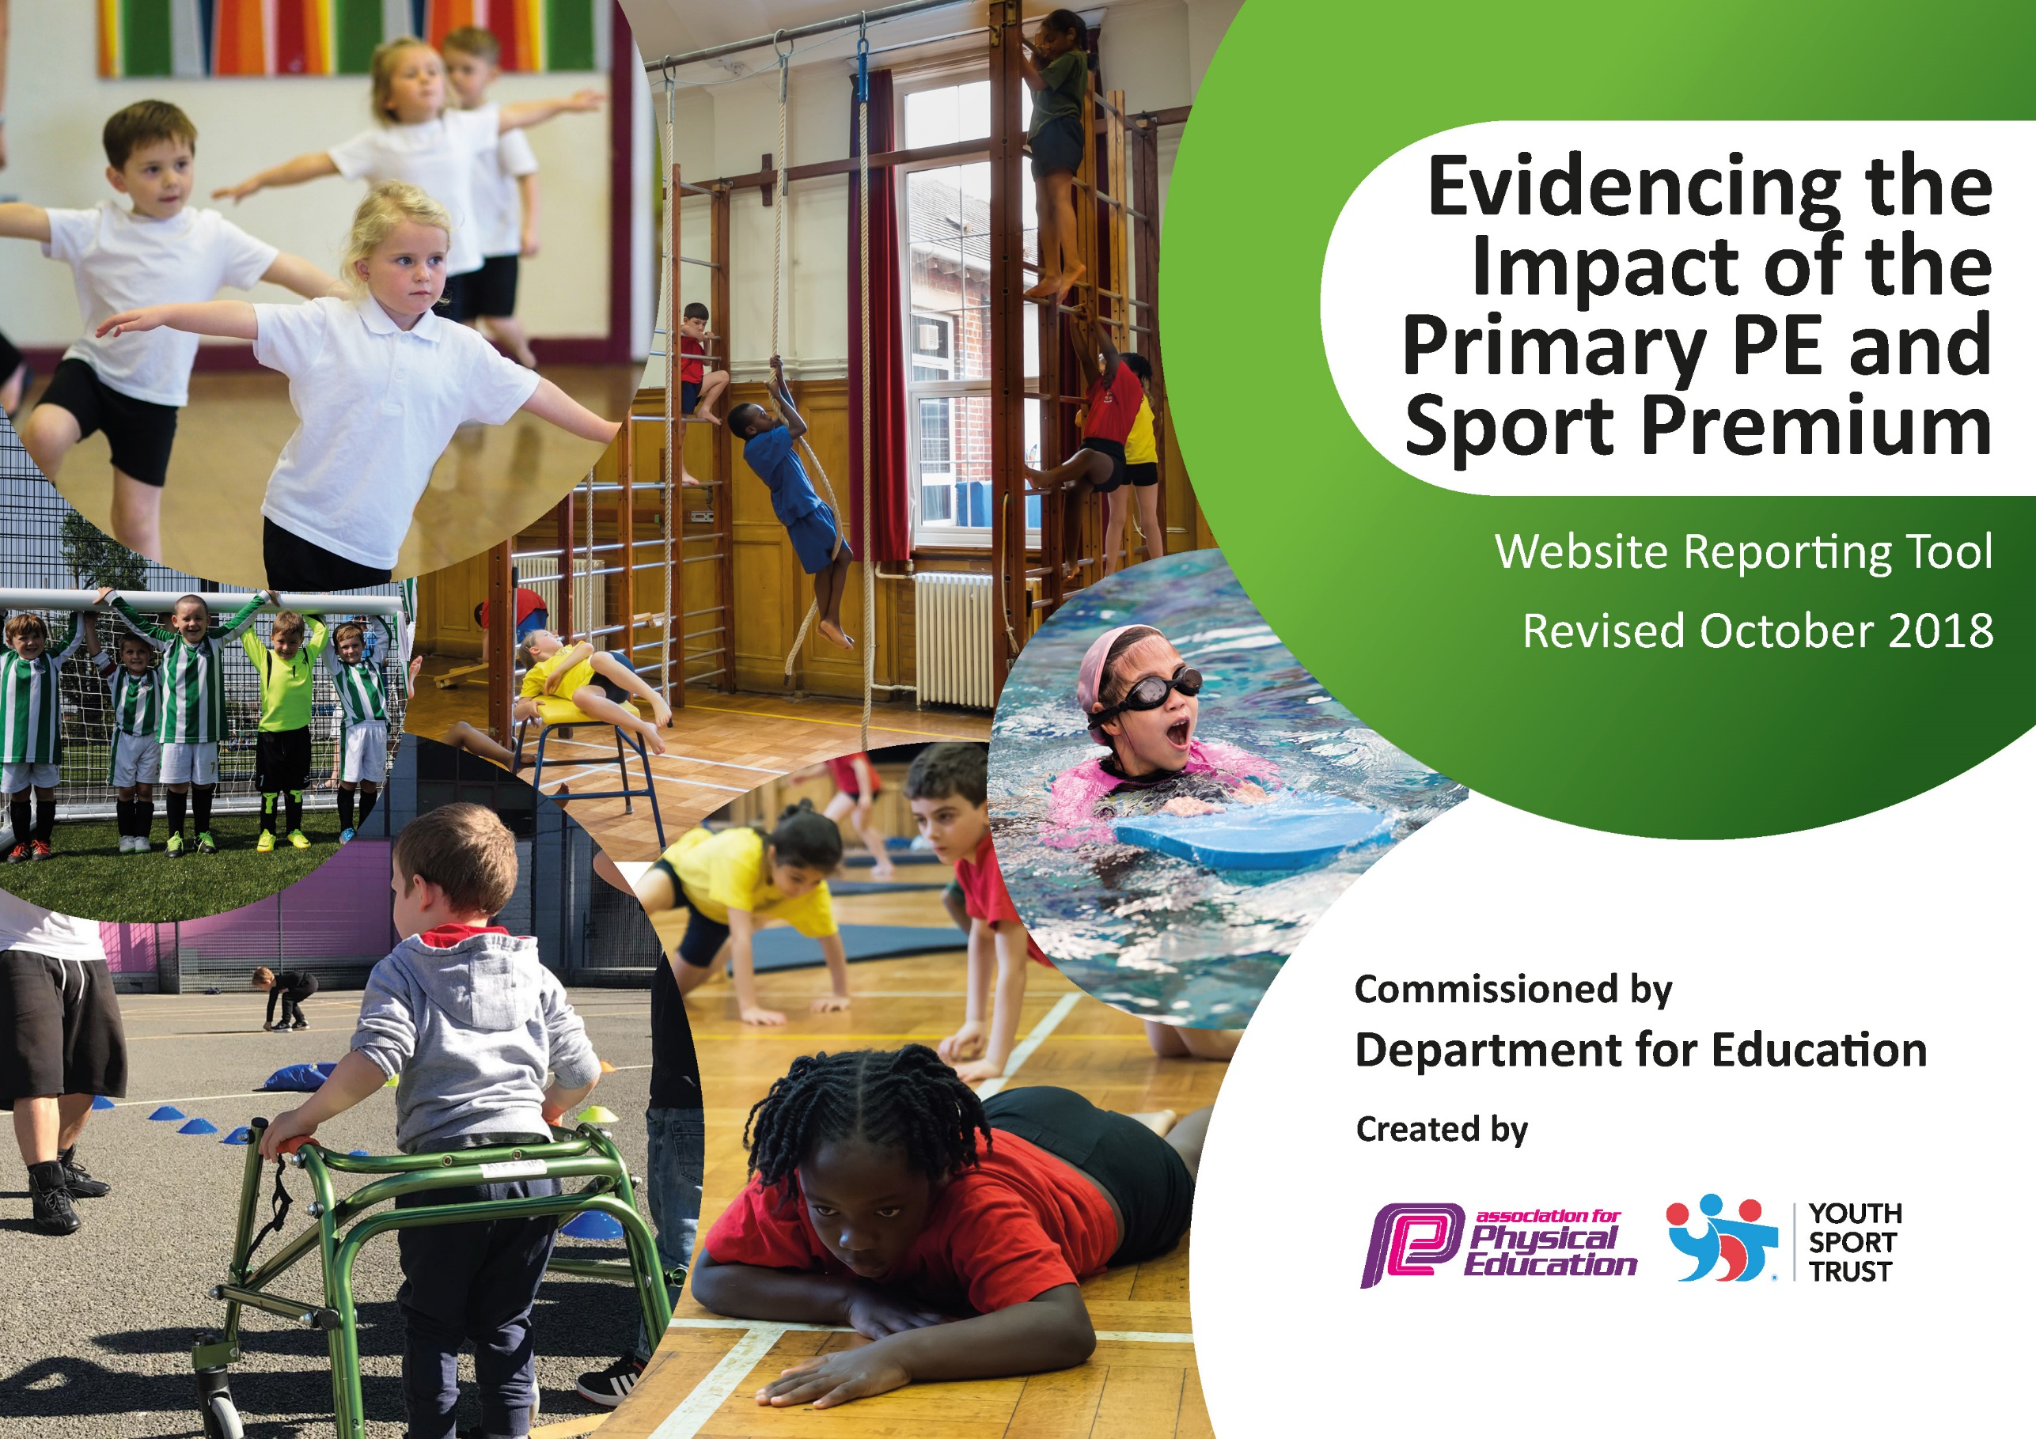
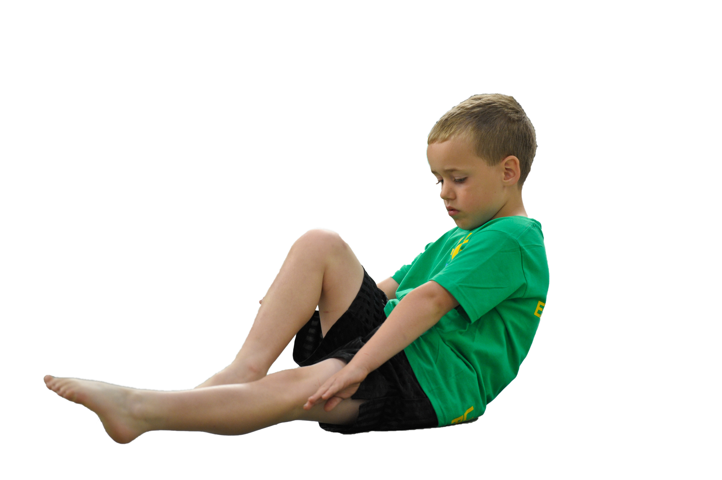
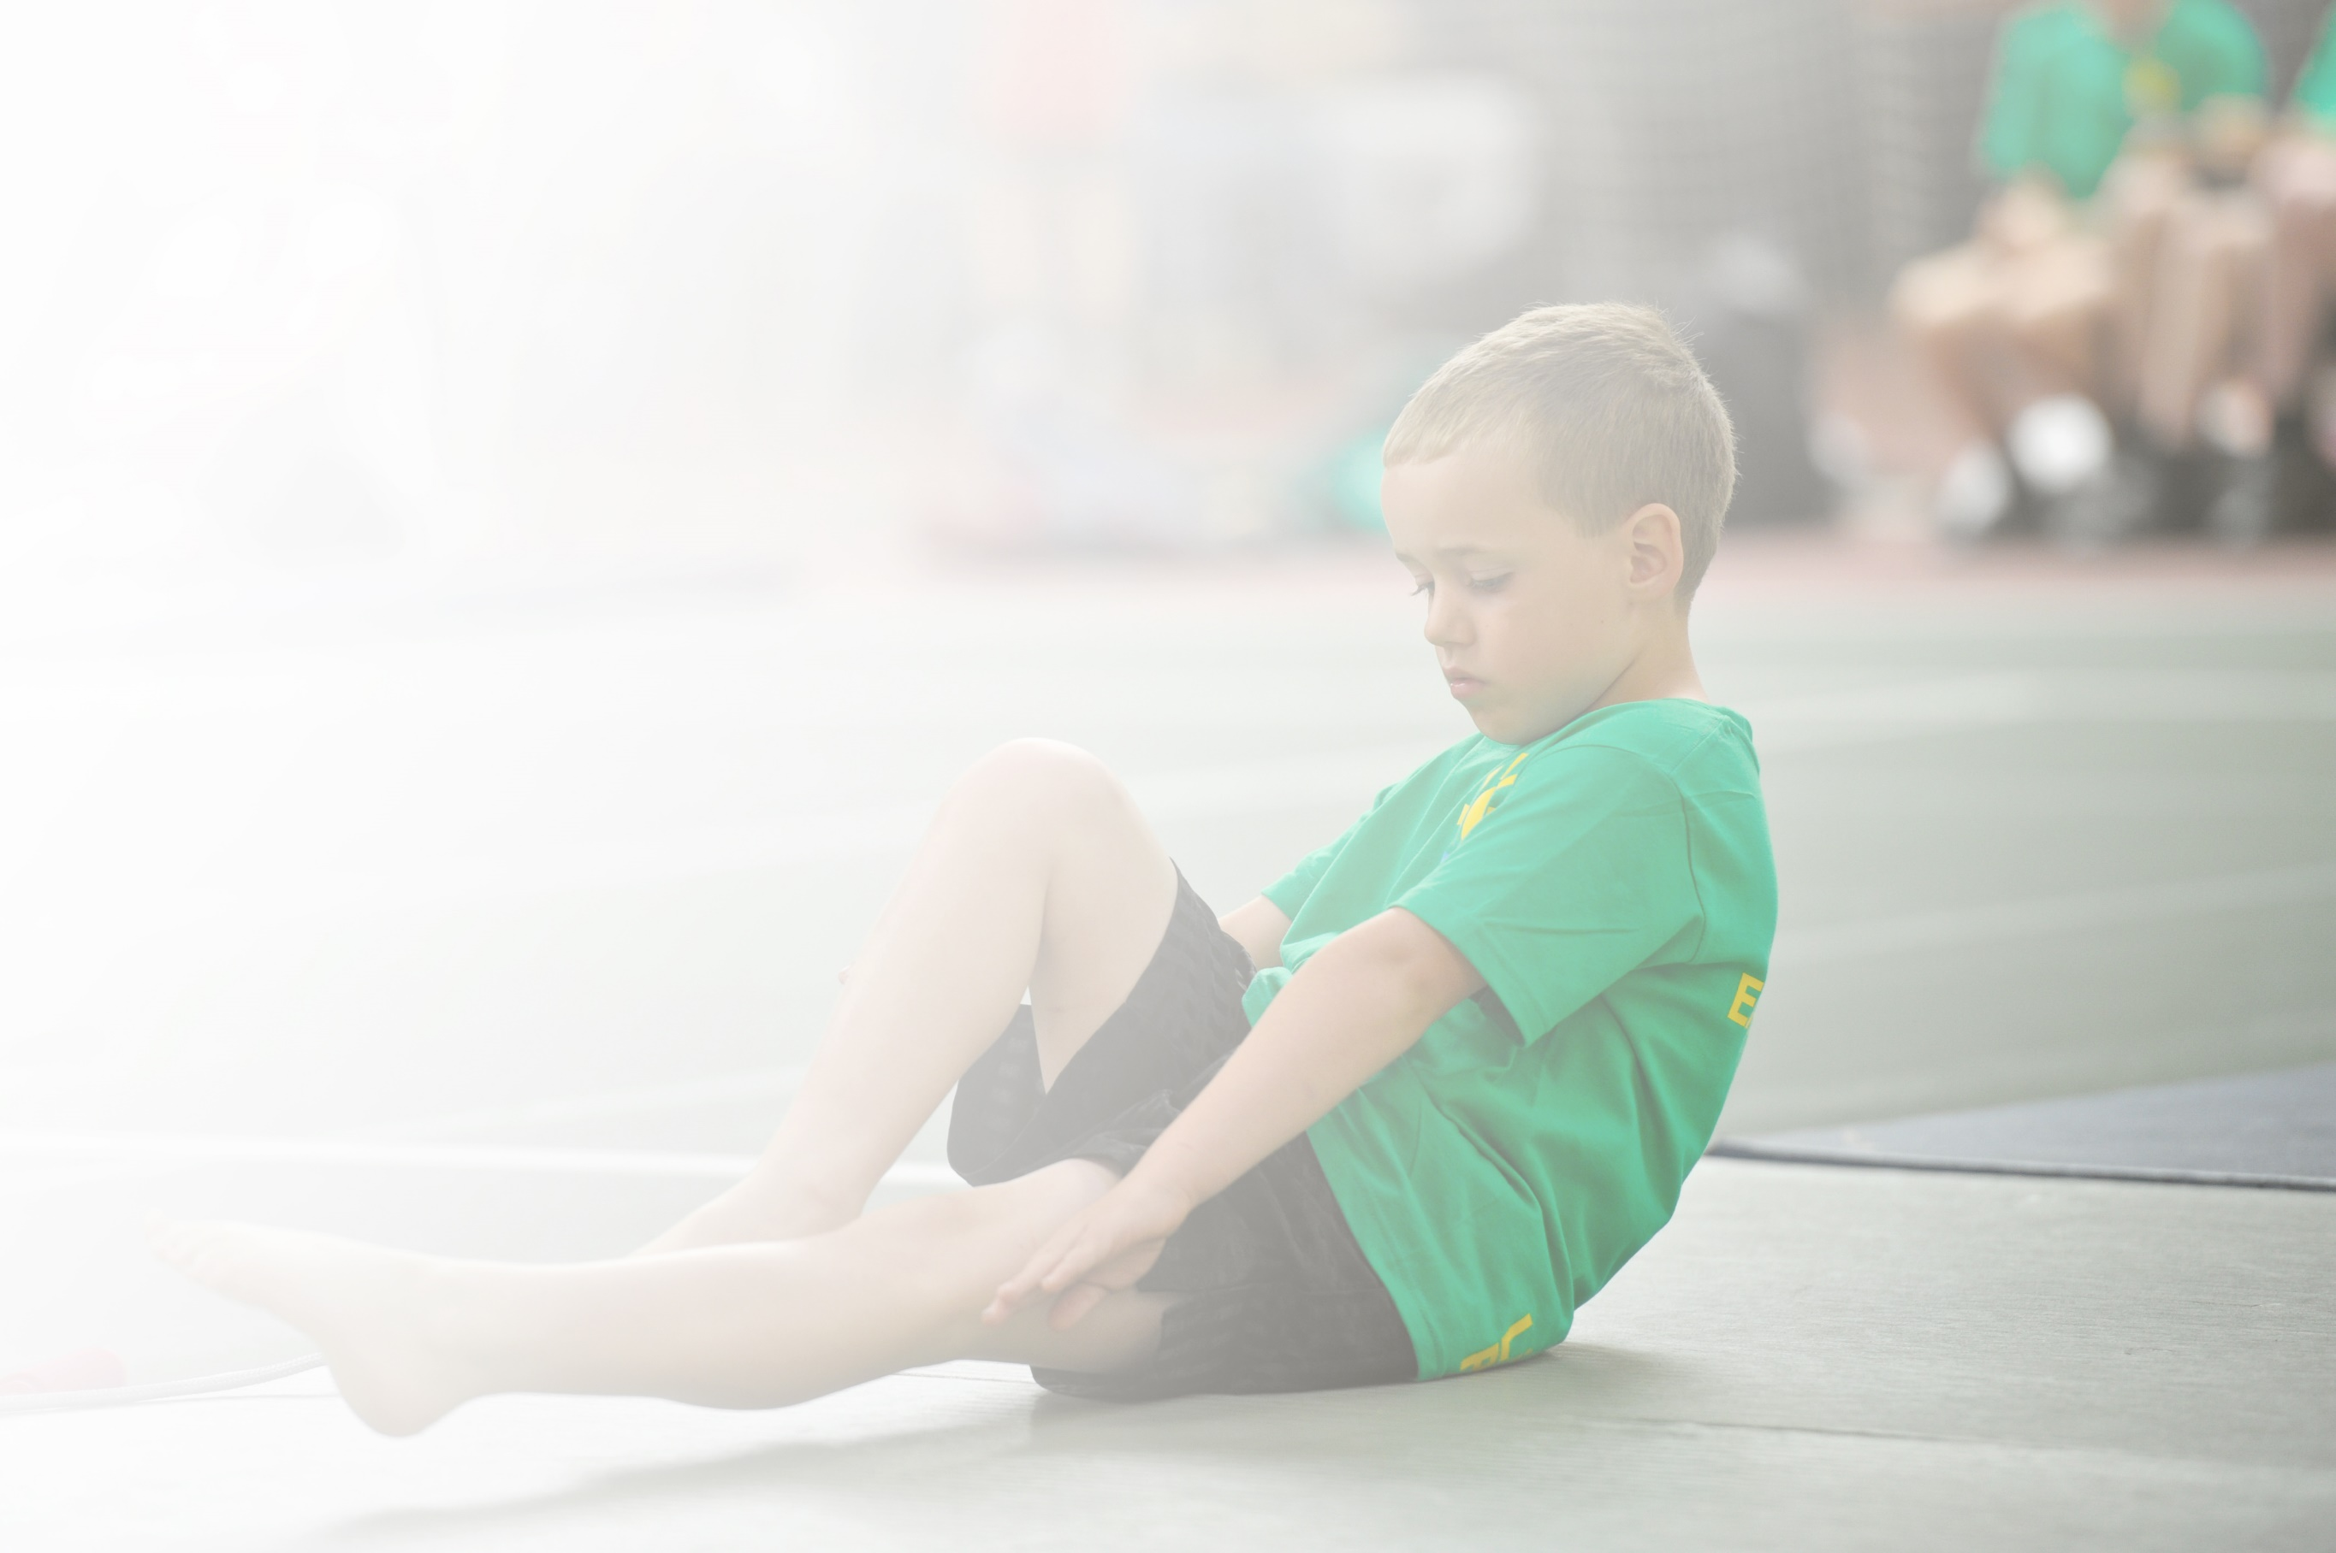
Schools must use the funding to make additional and sustainable improvements to the quality of Physical Education, Sport and Physical Activity (PESPA) they offer. This means that you should use the Primary PE and Sport Premium to:

- Develop or add to the PESPA activities that your school already offer
- Build capacity and capability within the school to ensure that improvements made now will benefit pupils joining the school in future years

Please visit gov.uk for the revised DfE guidance including the 5 key indicators across which schools should demonstrate an improvement. This document will help you to review your provision and to report
your spend. DfE encourages schools to use this template as an effective way of meeting the reporting requirements of the Primary PE and Sport Premium.

We recommend you start by reflecting on the impact of current provision and reviewing the previous
spend. Under the Ofsted Schools Inspection Framework, inspectors will assess how effectively leaders use the Primary PE and Sport Premium and measure its impact on outcomes for pupils, and how effectively governors hold them to account for this.

Schools are required to publish details of how they spend this funding as well as on the impact it has on pupils’ PE and sport participation and attainment by the end of the summer term or by 31 July 2019 at the
latest.
We recommend regularly updating the table and publishing it
on your website throughout the year, as evidence of your
ongoing review into how you are using the money to
secure maximum, sustainable impact. To see an
example of how to complete the table please
click HERE.

Support for review and reflection - considering the 5 key indicators from DfE, what development needs are a priority for your setting and your students now and why? Use the space below to reflect on previous spend, identify current need and priorities for the future.

Key achievements to date: | Areas for further improvement and baseline evidence of need:
- The engagement and participation of all pupils in regular physical activity promoting healthy active lifestyles. 98% regular participation in lessons, this was 97% last year  - Working alongside the Albion Foundation to team teach a range of year groups and a wide range of sports. All the children in 7 year groups have accessed the WBA/school coaching. 7 teachers including 1 newly qualified or teachers in their 2/3rd year of teaching received training.  - Broader experience of a range of sports and activities offered to ALL pupils including athletics, basketball and quick cricket.  - Launch of a sports council alongside the Albion ambassadors programme to encourage children as leaders to support sports and physical activity  - Increased participation in competitions especially in football, netball and cricket  - Couch to 5k with the children as an after school club  - Higher % of children swim competently, confidently and proficiently over a distance of at least 25 metres than the national average | - Key indicator 1: The engagement of all pupils in regular physical activity – Chief Medical Officer guidelines recommend that primary school children undertake at least 30 minutes of physical activity a day in school. Continue to have high expectations and focus on the daily mile and supermovers to get all pupils undertaking at least 15 minutes of additional activity per day.  - Key indicator 2: The profile of PESSPA being raised across the school as a tool for whole school improvement  - Key indicator 3: Increased confidence, knowledge and skills of all staff in teaching PE and sport  - Key indicator 4: Broader experience of a range of sports and activities offered to all pupils  - Key indicator 5: Increased participation in competitive sport

Meeting national curriculum requirements for swimming and water safety | Please complete all of the below:
What percentage of your current Year 6 cohort swim competently, confidently and proficiently over a distance of at least 25 metres?  N.B. Even though your children may swim in another year please report on their attainment on leaving  primary school. | 80%
What percentage of your current Year 6 cohort use a range of strokes effectively [for example, front crawl, backstroke and breaststroke]? | 75%
What percentage of your current Year 6 cohort perform safe self-rescue in different water-based situations? | 70%
Schools can choose to use the Primary PE and Sport Premium to provide additional provision for swimming but this must be for activity over and above the national curriculum requirements. Have you used it in this way? | Yes/No
Additional activity
To ensure all existing swimmers increase their attainment by 10m thus increasing their confidence in the water
85% of children to meet national requirements in Year 6.
To ensure that all pupils can perform self- rescue over a varied distance so they are confident and safe in the water

Action Plan and Budget Tracking
Capture your intended annual spend against the 5 key indicators. Clarify the success criteria and evidence of impact that you intend to measure to evaluate for students today and for the future.

Academic Year: 2019/20 | Total fund allocated: £19,641 | Date Updated: July 19
Key indicator 1: The engagement of all pupils in regular physical activity – Chief Medical Officer guidelines recommend that primary school children undertake at least 30 minutes of physical activity a day in school |  |  |  | Percentage of total allocation:
 |  |  |  | £1539-8 %
School focus with clarity on intended impact on pupils: | Actions to achieve: | Funding allocated: | Evidence and impact: | Sustainability and suggested next steps:
Continue to have high expectations and focus on the daily mile and supermovers to get all pupils undertaking at least 15 minutes of additional activity per day.  Embedding physical activity into the school day through active travel to and from school, active playgrounds and active teaching | Monitor daily mile expectations to ensure the % of chn running increases.  Purchase equipment for KS2 to use in the playground. Create timetables for usage. Track how children travel to school. Autumn launch of WOW WALK TO SCHOOL for the whole school. Meet with Public Health officers re funding to encourage cycling to school.  • Register on line for Travel Tracker  • Conduct a simple baseline survey  • Deliver a launch assembly  • set up on travel tracker  • Children state earning badges  Fit for kids school  Programme invited into school. With an overarching aim to promote the engagement of all the children in the activities. | £890- daily mile markings  £649- fit for kids daily workshop for the whole school | ALL pupils involved in 15 minutes of additional activity every day.  • 100% pupils benefiting from early morning wake and shake bitesize classroom-based fitness drills.  • Popularity of programme has resulted in pupils also exercising during wet playtimes/lunchtimes and occasionally after lunch.  WIDER IMPACT AS A RESULT OF ABOVE  • Pupils are more active in P.E lessons - taking part without stopping to rest so much.  • Attitudes to learning are improved - better concentration in lessons  ALL pupils involved in 15 minutes of additional activity every day  Children will have regular access to equipment at lunch and break times and are able to play games using the playground markings to be active. Children will receive badges  WIDER IMPACT AS A RESULT OF ABOVE  -Pupils are more active in PE lessons and take part without stopping to rest  -Standards in PE are improving with 95% meeting end of KS attainment targets  -Attitudes to learning improved with better concentration in lessons  -More children walk to school  - Children bring healthier lunchboxes into school | Supermovers further embedded in school day. Daily mile firmly embedded in school day.  Programme will continue to prove beneficial to pupils for the following reasons:  - Calming influence upon pupils that prepares for subsequent class work by way of enhanced concentration and application  - Improved self-esteem  - Enhanced enjoyment of physical activity.  Children in both key stages will access to a wider range of equipment and use the playground marking effectively and independently to be active.  Building a greater understanding of the benefits of exercise and a healthy lifestyle with more children walking to school and eating healthier including school lunchboxes
Key indicator 2: The profile of PESSPA being raised across the school as a tool for whole school improvement |  |  |  | Percentage of total allocation:
 |  |  |  | £2100 -11%
School focus with clarity on intended impact on pupils: | Actions to achieve: | Funding allocated: | Evidence and impact: | Sustainability and suggested next steps:
Sports Assembly ran termly – profile of PE, School Sport & Physical Activity and children’s achievements are shared with all children/staff and parents are invited to join us to celebrate in school/outside of school achievements.  Develop capacity for Forest School provision to provide opportunities for healthy and active lifestyles as well as promoting importance of mental health and wellbeing. | Order certificates for assembly. Organise the timetable of sports assemblies to raise profile.  Teaching Assistants to assist and support in running of Forest school in order to build capacity for future | £100  £2000 | Photographs & Certificates. Using the core values of the school children are awarded trophies in each class.  See separate Forest School  impact report which takes in to  account parent and pupil voice. | Encourages and inspires children to be more active and to take part in events in and out of school.  More staff will be aware and be able to support the forest school provision so more children will be be able to access the programme each year. All children from Reception to Year 4 to have regular Forest School sessions.

Key indicator 3: Increased confidence, knowledge and skills of all staff in teaching PE and sport |  |  |  | Percentage of total allocation:
 |  |  |  | 36%
School focus with clarity on intended  impact on pupils: | Actions to achieve: | Funding  allocated: | Evidence and impact: | Sustainability and suggested  next steps:
In order to improve progress and achievement of all pupils the focus is on up-skilling the staff.  Build capacity or capability within school, to ensure improvements benefit pupils joining in future years  Providing staff with professional development, mentoring, training and resources to help them teach PE and sport more effectively and embed physical activity across school during lessons and breaktimes. | School to audit the experience of staff and timetable training sessions/team teaching with the designated PE lead (EW)  Internal specialist PE will support curriculum development in PE.  To support implementation of new scheme of work.  Team teaching is encouraged to enhance and develop the skills and knowledge of our teachers  Lunchtime supervisor training  (2hours) & follow up implementation  Sessions  EW to attend relevant training for her own CPD | £7080 | Understanding primary school physical education.  Principles of pedagogy in primary school physical education.  Planning for continuity and progression in primary school physical education.  Using assessment to impact on learning and progress in primary school physical education.  Good and outstanding features of teaching primary school education.  Increased staff confidence and ability to teach high quality P.E. lessons. Increased staff knowledge of leading lunchtime activities. | A sustainable legacy which will impact on children and young people.  Sustainable professional development.  Addresses high standards of teaching and learning, and will create additional positive impact upon our school development plan outcomes.  Increased staff confidence and ability to teach high quality P.E. lessons. Increased staff knowledge of leading lunchtime activities.
Key indicator 4: Broader experience of a range of sports and activities offered to all pupils |  |  |  | Percentage of total allocation:
 |  |  |  | £2230 -11%
School focus with clarity on intended  impact on pupils: | Actions to achieve: | Funding  allocated: | Evidence and impact: | Sustainability and suggested  next steps:
Supporting and involving the least active children by providing targeted activities, and running or extending school sports clubs and after school clubs. Ensure disadvantaged children have equality of opportunity.  To give children to opportunity to take part in orienteering projects in school to broaden their outdoor learning experiences. | Plan a timetable of activities, audit least active children and disadvantaged pupils. Work with families to encourage attendance at sports clubs.  Orienteering map of Grove Vale Primary School.  Presented with lesson plans, games & activities plus the software used to edit  control | £1780- orienteering programme  £450 staff training | A wider range of extra-curricular clubs on offer. E.g. Rugby, hockey, tennis, gymnastics, couch to 5Kand basketball, cricket lead by school staff. More staff involved and feel confident teaching a wider range of sports  PE lead to share expertise by running after school clubs  Increased % of children attending clubs and the creation of new clubs to give children wider opportunities.  Targeted pupils especially least active to attend extracurricular classes.  Pupils will experience new sports/outdoor experiences and improve self-esteem and confidence.  WIDER IMPACT AS A RESULT OF ABOVE  Behaviour has improved particularly at lunchtimes and this has led to improved learning in the afternoons  Very few instances of children forgetting kit to school and as a result progress and achievement in curriculum PE is good.  Pupils who were reluctant to attend clubs now attend.  Children will be engaged by the orienteering project and develop a love of outdoor learning. | Staff will work together and share practice which will lead to better confidence and more staff keen to get involved to ensure the extracurricular clubs will continue and thrive.  The orienteering map will be legacy in school and it will ensure improvements benefit pupils joining in future years
Key indicator 5: Increased participation in competitive sport |  |  |  | Percentage of total allocation:
 |  |  |  | 2%
School focus with clarity on intended  impact on pupils: | Actions to achieve: | Funding  allocated: | Evidence and impact: | Sustainability and suggested  next steps:
To continue to provide additional competitive sports identified by pupils survey in order to engage more pupils. | Staff member to lead practices after school  Arrange/take part in local competitions | £450 | Number of children participating in clubs increased especially targeted children.  WIDER IMPACT AS A RESULT OF ABOVE  Improved standards in invasion games in curriculum time  More girls are keen to take part in after school sports clubs.  Greater interest in a wider range of sports to engage pupils | Member of staff to take charge of the competition teams  Level 2 FA coaching course
Other indicator identified by the school- Additional swimming |  |  |  | Percentage of total allocation  £6242- 32%
To ensure all existing swimmers increase their attainment by 10m thus increasing their confidence in the water  85% of children to meet national requirements in Year 6.  To ensure that all pupils can perform self- rescue over a varied distance so they are confident and safe in the water | All children to have weekly swimming lessons from reception to Year 6  To utilise the coach based at the swimming pool to work alongside teachers  Train an additional swimming instructor so school are in a position to offer after school and holiday swimming clubs | £5492  £750 | 85% of pupils can swim 25 metres at Year 6  Evidence of pupils in lower year groups being able to swim 25 metres  75% of children able to swim over 50 metres  85% of pupils can perform safe rescue | Governors have agreed to ensure that they will ring fence funding to ensure the maximum amount of pupils leave the school being able to swim 25 metres.  The teachers will work together to ensure all staff involved are confident and secure in swimming expectations and practices.

