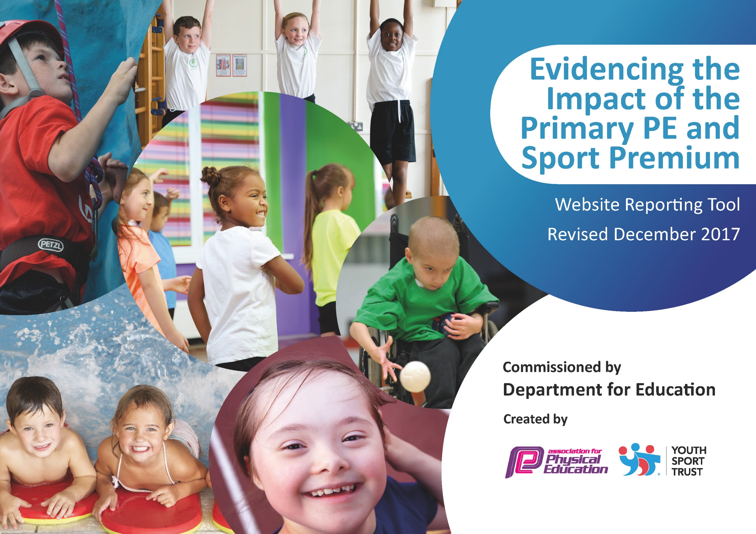

.

Support for review and reflection - considering the 5 key indicators from DfE, what development needs are a priority for your setting and your students now and why? Use the space below to reflect on previous spend, identify current need and priorities for the future.

Key achievements to date: | Areas for further improvement and baseline evidence of need:
- The engagement and participation of all pupils in regular physical activity promoting healthy active lifestyles. 97% regular participation in lessons  - Working alongside the Albion Foundation to team teach a range of year groups and a wide range of sports. All the children in 7 year groups have accessed the WBA/school coaching. 7 teachers including 3 newly qualified or teachers in their 2/3rd year of teaching received training.  - Broader experience of a range of sports and activities offered to ALL pupils including hockey, basketball and tag rugby.  - Launch of a sports council alongside the Albion ambassadors programme to encourage children as leaders to support sports and physical activity  - Increased participation in competitions especially in football  - Positive engagement with the reading stars project delivered by the Albion Foundation | - Provide more opportunities for a wider range of activities both within and outside the curriculum in order to get more children active e.g after school clubs. Audit of current provision and review of current opportunities. Key priority 4  - To create a more active playground to encourage children to be active in the playground. Review playground opportunities for children to be active, observe break/lunchtimes, survey the children. Key priority 1  - To have a secure knowledge of how children travel to school with a view to improving children’s travel to school rather than using a car. Audit how the children get to school. Key priority 1  - Introduce super movers and the daily mile to encourage an additional 30 mins activity per day. Key priority 1  - Continue to raise the profile of the Sports council to ensure that the profile of PE/sport is high. Key priority 2  - School to sign up to the School Swimming Champion Charter to promote and support the school’s commitment to provide additional provision for swimming over and above the national curriculum requirements. Key priority 3  - Continue to train and upskill staff with PE/Sports specific skills. Baseline staff confidence and experience teaching Sport. Key priority 3  - To offer a wider range of participation in competitive sports beyond football. Survey pupils. Key priority 5

Meeting national curriculum requirements for swimming and water safety | Please complete all of the below*:
What percentage of your current Year 6 cohort swim competently, confidently and proficiently over a distance of at least 25 metres? | 90%
What percentage of your current Year 6 cohort use a range of strokes effectively [for example, front crawl, backstroke and breaststroke]? | 83%
What percentage of your current Year 6 cohort perform safe self-rescue in different water-based situations? | 80%
Schools can choose to use the Primary PE and Sport Premium to provide additional provision for swimming but this must be for activity over and above the national curriculum requirements. Have you used it in this way? | Yes
*Schools may wish to provide this information in April, just before the publication deadline.

Action Plan and Budget Tracking
Capture your intended annual spend against the 5 key indicators. Clarify the success criteria and evidence of impact that you intend to measure to evaluate for students today and for the future.

Academic Year: 2017/18 | Total fund allocated: £19641 | Date Updated:
Key indicator 1: The engagement of all pupils in regular physical activity – Chief Medical Officer guidelines recommend that primary school children undertake at least 30 minutes of physical activity a day in school |  |  |  | Percentage of total allocation:
 |  |  |  | £6250 - 32 %
School focus with clarity on intended impact on pupils: | Actions to achieve: | Funding allocated: | Evidence and impact: | Sustainability and suggested next steps:
Launch supermovers to get all pupils undertaking at least 15 minutes of additional activity per day.  Introduce the daily mile to get all pupils undertaking at least 30 minutes of additional activity per day.  To create a more active playground to encourage children to be active in the playground.  Develop scoot to school in order to get more children travelling to school by scooter/bike rather than by car. | Introduce the staff to the BBC/Premier League initiative and share whole school expectations  Organise a course for the daily mile. Register the school on the dailymile.co.uk  Playground marking to incorporated into the playgrounds to encourage more team games and physical activity at break and lunchtimes.  Provide equipment at lunch and break times to encourage team games and activity  Invite Bedazzle in to talk to the children about physical activity, children to take part in workshops. Purchase 20 scooters to introduce scooters to school | £200 staff training  £200 staff training  Additional track required £2500  £2000  £150 – workshops with Bedazzle  20 x 30=  £1200 | ALL pupils involved in 15 minutes of additional activity every day.  • 100% pupils benefiting from early morning wake and shake bitesize classroom-based fitness drills.  • Popularity of programme has resulted in pupils also exercising during wet playtimes/lunchtimes and occasionally after lunch.  WIDER IMPACT AS A RESULT OF ABOVE  • Pupils are more active in P.E lessons - taking part without stopping to rest so much.  • Attitudes to learning are improved - better concentration in lessons  ALL pupils involved in 15 minutes of additional activity every day  Children will have regular access to equipment at lunch and break times and are able to play games using the playground markings to be active  WIDER IMPACT AS A RESULT OF ABOVE  -Pupils are more active in PE lessons and take part without stopping to rest  -Standards in PE are improving with 95% meeting end of KS attainment targets  -Attitudes to learning improved with better concentration in lessons  More children being involved in scooting to school | Supermovers embedded in school day.  Programme has proven to be beneficial to pupils for the following reasons:  - Calming influence upon pupils that prepares for subsequent class work by way of enhanced concentration and application  - Improved self-esteem  - Enhanced enjoyment of physical activity.  Daily mile firmly embedded in school day.  Children will access equipment and use the marking effectively and independently to be active.  Provide an area for children to leave their scooters/bikes in school.
Key indicator 2: The profile of PE and sport being raised across the school as a tool for whole school improvement |  |  |  | Percentage of total allocation:
 |  |  |  | £1210- 6%
School focus with clarity on intended impact on pupils: | Actions to achieve: | Funding allocated: | Evidence and impact: | Sustainability and suggested next steps:
Celebration assembly every week to ensure the whole school is aware of the importance of P.E. and Sport and to encourage all pupils to aspire to being involved in the assemblies.  P.E. noticeboard to raise the profile of P.E and Sport for all visitors and parents  Continue to focus on the Sports council and raise the profile of local sporting personalities to encourage pupils to aspire to be leaders in sport | Achievements celebrated in assembly. e.g. match results, tournaments, festivals, sporting events in the local community, unusual sporting achievements. Year groups to show cast their talents in sport. E.g dance, gymnastics, rugby  Buy and Display trophies.  Buy noticeboards and have them fixed. Give the sports council the responsibility to update the board.  Promote alongside the Albion Foundation the Sports Council and Albion ambassadors. Arrange meeting and assembly times.  Research local personalities and invite them into school  Sports council to work alongside the well- being champions to promote physical and mental well being | £250  £200  20x38=  £760 | All pupils have taken part in assembly throughout the year.  Parents and carers attend assemblies and awards evening.  The noticeboards are full of information about matches, clubs, tournaments and photos and pupils are keen to view the board  Local personalities to have visited school and taken part in an assembly  WIDER IMPACT AS A RESULT OF ABOVE  Pupils are very proud to be involved in assemblies/photos on notice boards etc is impacting on confidence and self esteem  Increased self esteem/confidence are having an impact on learning across the curriculum. | The SLT has seen the benefits of the raised profile in the school and is committed to funding these areas.  Pupils are thrilled and proud to be involved in assemblies and photos which has impacting on confidence and self-esteem. This has improved behaviour and learning across the curriculum.  Sports council to work pro-actively alongside the well- being champions.

Key indicator 3: Increased confidence, knowledge and skills of all staff in teaching PE and sport |  |  |  | Percentage of total allocation:
 |  |  |  | 15%
School focus with clarity on intended  impact on pupils: | Actions to achieve: | Funding  allocated: | Evidence and impact: | Sustainability and suggested  next steps:
In order to improve progress and achievement of all pupils the focus is on up-skilling the staff. | School to audit the experience of staff and timetable training sessions/team teaching with the coach from Albion Foundation | £3,040 | Understanding primary school physical education.  Principles of pedagogy in primary school physical education.  Planning for continuity and progression in primary school physical education.  Using assessment to impact on learning and progress in primary school physical education.  Good and outstanding features of teaching primary school education.  Increased staff confidence and ability to teach high quality P.E. lessons. | A sustainable legacy which will impact on children and young people.  Sustainable professional development.  Addresses high standards of teaching and learning, and will create additional positive impact upon our school development plan outcomes.  Increased staff confidence and ability to teach high quality P.E. lessons.
Key indicator 4: Broader experience of a range of sports and activities offered to all pupils |  |  |  | Percentage of total allocation:
 |  |  |  | £2142- 11%
School focus with clarity on intended  impact on pupils: | Actions to achieve: | Funding  allocated: | Evidence and impact: | Sustainability and suggested  next steps:
Continue to offer a wider range of activities both within and outside the curriculum in order to involve more pupils | Undertake all offers which are offered through Sports Partnerships, LA, National Associations, AFPE, Awarding Organisations with an aim to having more staff up-skilled and involved. Carry out a pupil survey to ascertain which sports pupils would like.  Involve external coaches in after school clubs | 40 x 40= £1520 for the Albion Foundation  £622 for staff overtime for clubs | A wider range of extra-curricular clubs on offer. E.g. Rugby, hockey, tennis, gymnastics, taekwondo and basketball, cheerleading lead by school staff. 3 more staff involved and feel confident teaching a wider range of sports  Albion Foundation to share expertise by running after school clubs  Increased % of children attending clubs and the creation of new clubs to give children wider opportunities.  Targeted pupils to attend extracurricular classes.  Pupils will experience a new sport and improve self-esteem and confidence.  WIDER IMPACT AS A RESULT OF ABOVE  Behaviour has improved particularly at lunchtimes and this has led to improved learning in the afternoons  Very few instances of children forgetting kit to school and as a result progress and achievement in curriculum PE is good.  Pupils who were reluctant to attend clubs now attend. | Staff will work together and share practice which will lead to better confidence and more staff keen to get involved to ensure the extracurricular clubs will continue and thrive.
Key indicator 5: Increased participation in competitive sport |  |  |  | Percentage of total allocation:
 |  |  |  | £1450- 7%
School focus with clarity on intended  impact on pupils: | Actions to achieve: | Funding  allocated: | Evidence and impact: | Sustainability and suggested  next steps:
To introduce additional competitive sports identified by pupils in recent survey in order to engage more pupils.  Engage more girls in inter/intra school teams | Identify a staff member to lead practices after school  Arrange/take part in local competitions  A member of staff to be trained to level 2/3 PESSPA qualification- arrange attendance at courses | £1000  £450 | Number of children participating in clubs increased  WIDER IMPACT AS A RESULT OF ABOVE  Improved standards in invasion games in curriculum time  More girls are keen to take part in after school sports clubs.  Greater interest in a wider range of sports to engage pupils | Member of staff to take charge of the competition teams  Level 2 FA coaching course
Other indicator identified by the school- Additional swimming |  |  |  | Percentage of total allocation  £5549- 28%
To ensure all existing swimmers increase their attainment by 10m thus increasing their confidence in the water  95% of children to meet national requirements in Year 6.  To ensure that all pupils can perform self- rescue over a varied distance so they are confident and safe in the water | All children to have weekly swimming lessons from reception to Year 6  To utilise the coach based at the swimming pool to work alongside teachers  School signs up for the School Swimming Champion Charter | £5492  £57 | 95% of pupils can swim 25 metres at Year 6  Evidence of pupils in lower year groups being able to swim 25 metres  75% of children able to swim over 50 metres  95% of pupils can peform safe rescue | Governors have agreed to ensure that they will ring fence funding to ensure the maximum amount of pupils leave the school being able to swim 25 metres.  The teachers will work together to ensure all staff involved are confident and secure in swimming expectations and practices.

