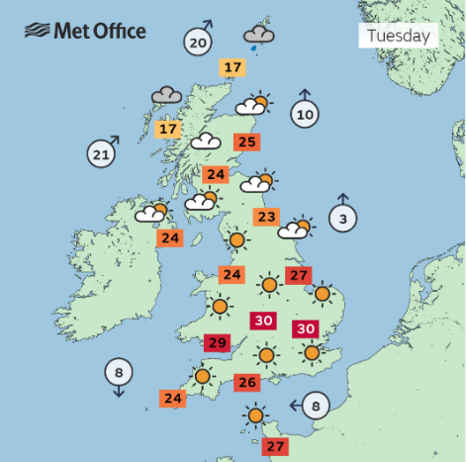
The UK – Year 1 – Spring 2

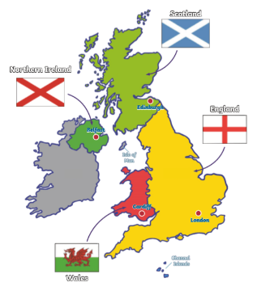
Key Facts
England is the largest country in the United Kingdom.
London is the capital city of England.
Cardiff is the capital city of Wales.
Belfast is the capital city of Northern Ireland.
Edinburgh is the capital city of Scotland.
Scotland has large mountains including Ben Nevis, which is the largest in the UK.
Wales has its own language (Welsh).
The seas that surround the UK are: North Sea, Irish Sea, English Channel and Celtic Sea.

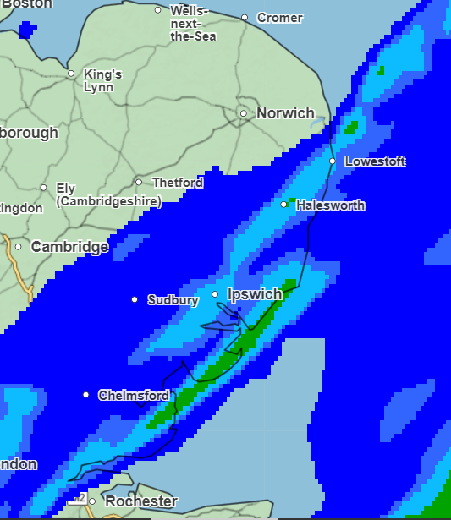

Key Vocabulary
United Kingdom | An island made up of England, Wales, Scotland and Northern Ireland. | Wales | A country within the United Kingdom.
Country | A nation with a government. | Capital city | A city or town where the government sits.
England | A country within the United Kingdom. | Weather | Rain, snow, sunny, cloudy, hail, windy.
Scotland | A country within the United Kingdom. | Island | A piece of land surrounded by water.
Northern Ireland | A country within the United Kingdom. | Government | The people who make the rules for a country.

