Key Facts
Your ears never stop hearing, even when you’re asleep.
Your ears don’t just help you to hear sounds. They also help you to keep your balance!
The average nose produces about a cupful of nasal mucus every day!
The ears and nose of humans continue to grow throughout the entire life.
A fully-grown human body has 206 bones. A new born baby has more than 300 bones.
Some parts of our bodies are more sensitive to touch than others. Your fingertips, lips and toes are the most sensitive to touch.
Everyone has a different number of taste buds. You can have between 2,000 and 10,000 taste buds.
We can remember smells for a very long time. A smell can remind us of a special place or person.
Human teeth are just as strong as shark teeth.
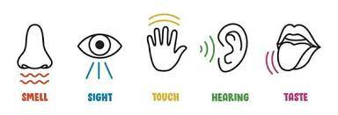
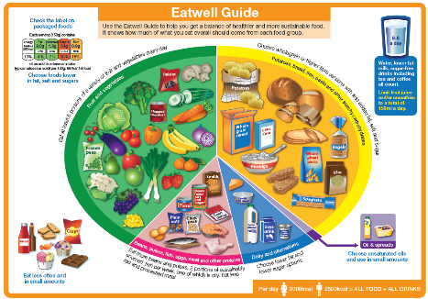
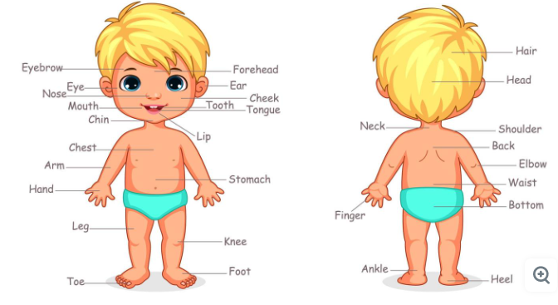
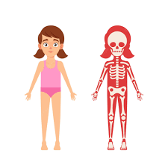
Humans – Year 1 – Summer 1

Key Vocabulary
Skeleton | The bones of the body that form a framework. | Touch | We mainly use our hands to touch and feel things. However, the skin all over your body can feel things too. We can tell if things are hot or cold, hard or soft, tickly or prickly and lots, lots more.
Human body | A combination of parts and systems that work together to perform the necessary functions of life. | Hearing | We use our ears to hear sounds. Some sounds are loud and some are quiet. Some people use hearing aids to help them hear more clearly.
Senses | Allow us to observe and understand the world around us. There are five main ways we can do this: | Taste | We use our mouths and tongues to taste food and drinks. We can tell if things taste bitter, salty, sweet or sour. Everyone has foods they like and foods they dislike!
Smell | We use our noses to smell things. Noses can detect things that smell nice, such as flowers, However, noses can also detect nasty smells, such as a rubbish bin or old socks! | Healthy | To be healthy means to not be sick. A person can maintain a healthy lifestyle by eating a healthy diet and exercising.
Sight | We use our eyes to see things. We can see things that are near to us and things that are far away. Some people wear glasses to help them see things more clearly. | Investigate | To observe or study by close examination and systematic inquiry.

