Key Facts
Ipswich is in the county of Suffolk.
Ipswich is Suffolk’s county town.
137,000 people live in Ipswich.
Brasília is the capital city of Brazil.
65 million people live in Rio De Janeiro.
In Brazil, people mainly speak Portuguese.
Brazil is surrounded by the Atlantic Ocean.
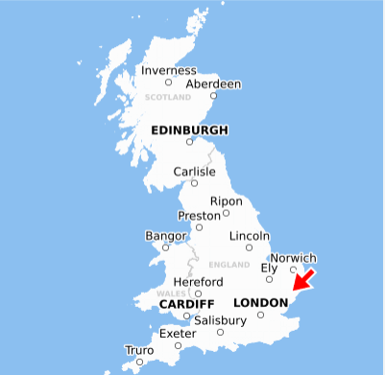
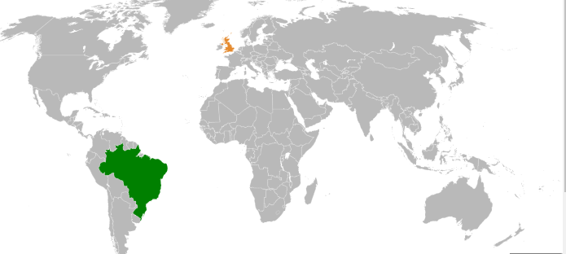
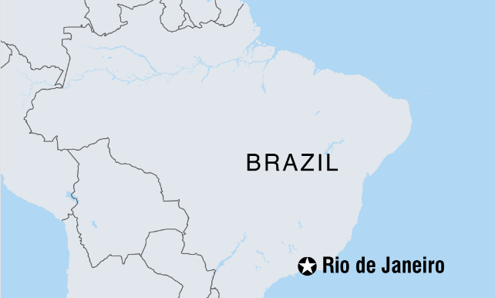
Year 2 – Spring 2 - Comparing Ipswich and Rio De Janeiro
Ipswich

Key Vocabulary
Compare | To say what is different or the same about something. | Mountain | A large hill rising from the Earth.
Equator | Imaginary line through the middle of the Earth that gets the most sun. | Forest | A large area covered with trees and plants.
Brazil | A country in South America. | Tourism | Visiting a place away from where you live.
Coast | Where the land meets the sea. | Temperature | How hot or cold a place is.
Location | A particular place. | Celsius | How to measure how hot or cold a place is.

