Key Facts
Within England, there are 48 counties
England's biggest city is the capital, London. It is the biggest city in Europe by population, with over 9 million people living there.
The population of England is, as of 2019, just over 55 million.
The longest river found entirely in England is the River Thames.
The highest mountain in England is Scafell Pike.
The largest lake in England is named Windermere.
Year 3 – Spring 2 - Our Wonderful Country
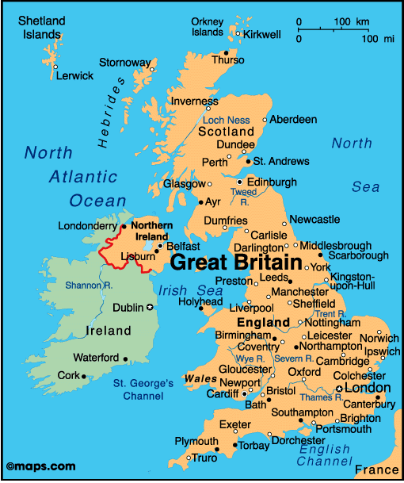
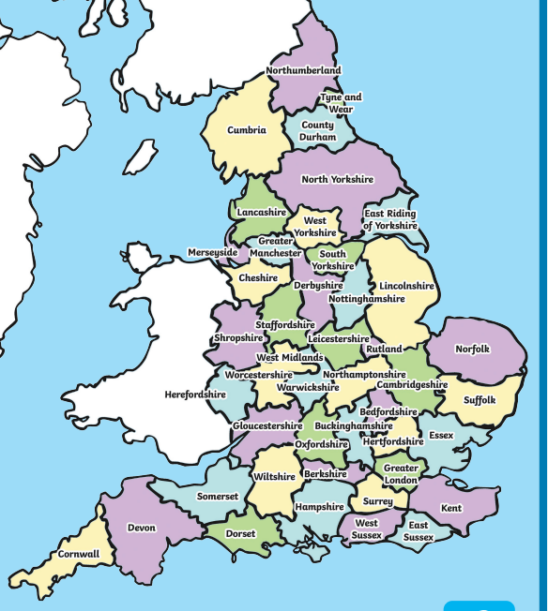

Key Vocabulary
Urban | Characteristics of a town or city. | County | A geographic region of a country.
Rural | Characteristics of the countryside. | Region | An area of a country having definable characteristics but not always a fixed boundary.
Local | Relating to your particular area | Variation | A change or slight difference in characteristics.
Human geography | How human activity is affected by or affects a place. | Population | People who live in a particular place.
Physical geography | Natural features of a place.

