Key Facts
The tectonic plates are constantly moving but sometimes they get stuck. When they get stuck, pressure builds up and the plates will suddenly move. This causes an earthquake.
After a big earthquake, aftershocks will often happen. An aftershock is one or more small earthquakes after the main one has occurred.
The country where most earthquakes happen is Japan.
The Earth is made up of four main layers: crust, mantle, outer core, and inner core.
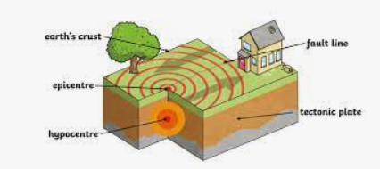
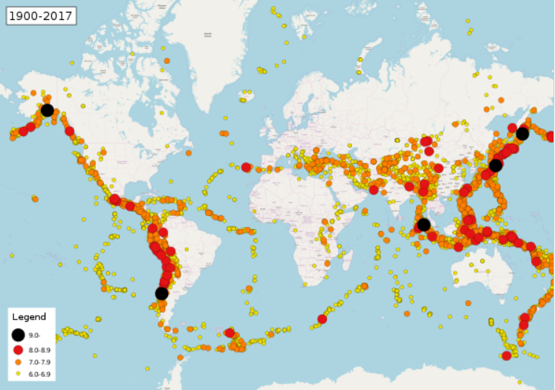
Year 4 – Spring 2 – Natural Disasters (earthquakes)
Regular earthquake sites
Tectonic Plates
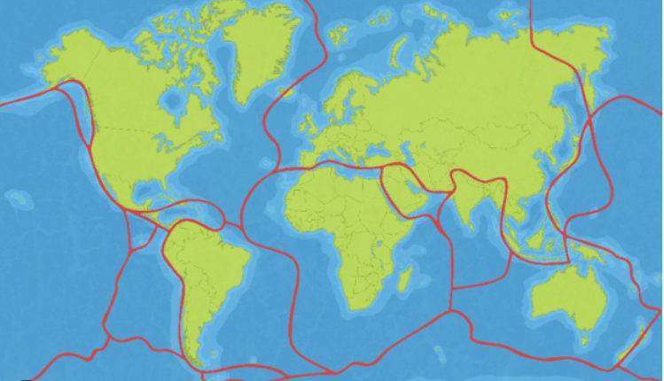

Key Vocabulary
Earthquake | The movements within the Earth's crust | Seismic wave | The vibration generated by an earthquake.
Tectonic | The Earth’s crust is made up of large areas called tectonic plates that join together. | Epicentre | The place on the Earth's surface directly above the point where an earthquake starts.
Magnitude | The size or extent of something | Cause and effect | The relationship between actions or events in which at least one action or event is a direct result of the others.
Impact | The effect or influence of something

