Key Facts
At least 80% of the developed world’s food originated in the tropical rainforest
The Amazon Rainforest produces more than 20% of the world’s oxygen
The Amazon Basin contains 20% of the world’s fresh water.
2.5 million insect species, 40 000+ plant species, 3 000 edible fruits and 2 000+ species of birds and mammals live in the Amazon Rainforest.
It has parts in Brazil, Peru, Colombia, Venezuela, Ecuador, Bolivia, Guyana, Suriname and French Guiana
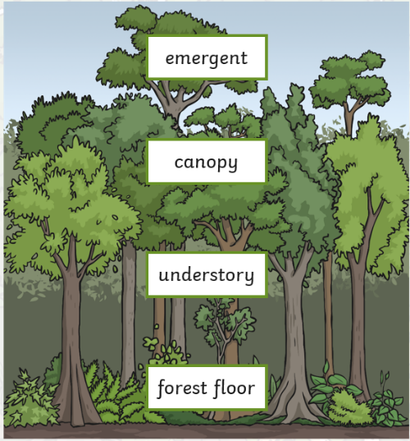
Year 5 – Spring 2 – Amazon Rainforest
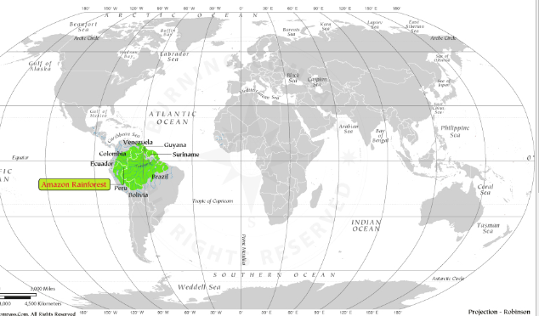
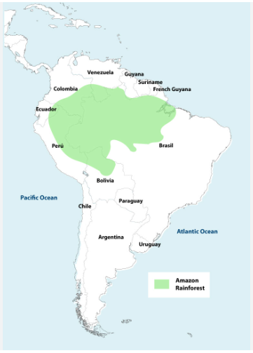

Key Vocabulary
Biomes | A large naturally occurring community of flora and fauna occupying a major habitat | Conservation | The prevention of wasteful use of a resource.
Adaptation | Becoming adjusted to new conditions | Vegetation belt | The plant life as a whole within a certain area.
Production | The action of making or manufacturing from components or raw materials | Economy | The country or region in terms of the production and consumption of goods and services and the supply of money.
Consumption | The action of using up a resource

