Key Facts
Mount Everest is the highest mountain in the world – 8848m
Contour lines on a map join land that is at the same height.
The temperature on mountains becomes colder the higher the altitude gets. Mountains tend to have much wetter climates than the surrounding flat land. Mountain weather conditions can change dramatically from one hour to the next

The tallest mountains in each country of the UK are: Snowdon, in Wales (1085m), Scafell Pike, in England (978m), Ben Nevis, in Scotland (1345m) and Slieve Donard (850m) in Northern Ireland.
Year 6 – Spring 2 – Mapping Mountains
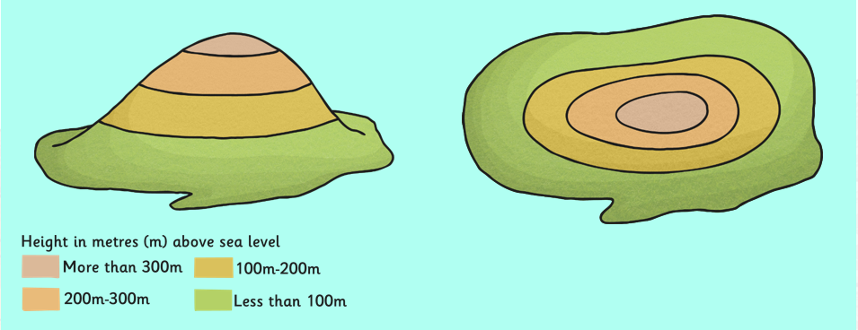
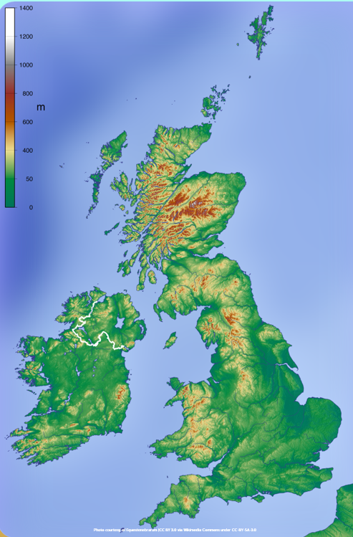
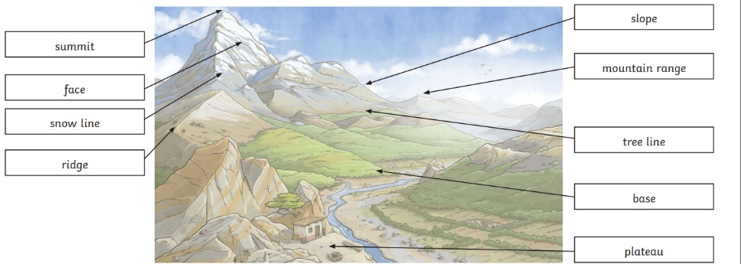

Key Vocabulary
Thematic maps | A type of map that portrays the geographic pattern of a particular subject matter. | Land-use patterns | The arrangement for the uses of land for different purposes.
Distinct | Recognisably different in nature from something else of a similar type. | Landform | - A natural feature of the Earth's surface.
Fold mountain | Tectonic plates collide and rock is pushed up. | Fault-block mountain | Cracks in the Earth’s surface open up, some chunks of rock are pushed up, some are pushed down.
Dome mountain | Formed when magma is forced upwards but doesn’t ever flow out of the crust. | Volcanic mountain | Formed around volcanoes and made of layers of ash and cooled lava.
Plateau mountain | Materials taken away through erosion leave deep valleys or gorges next to high cliffs. | Incline | A sloped surface.

