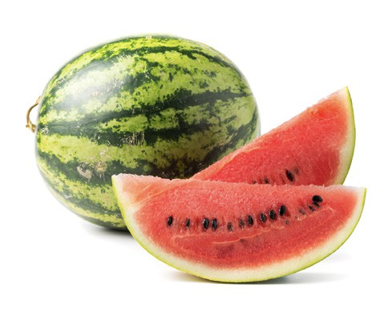
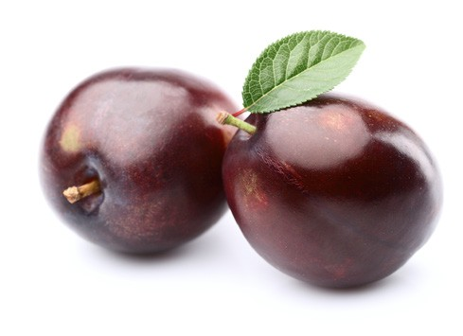
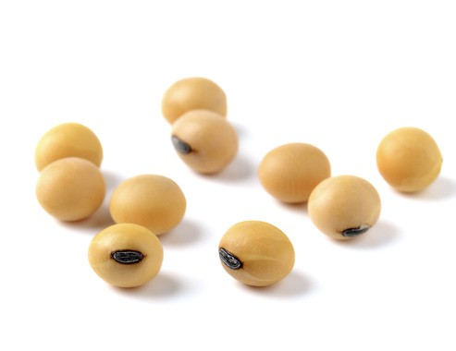
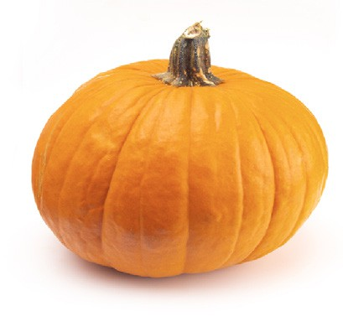
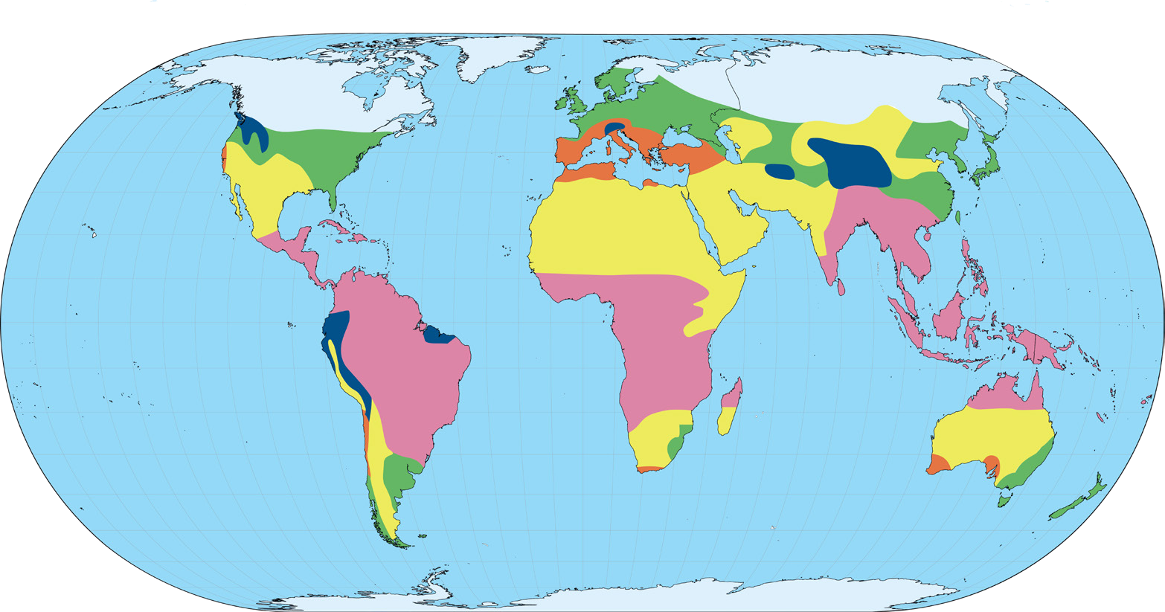
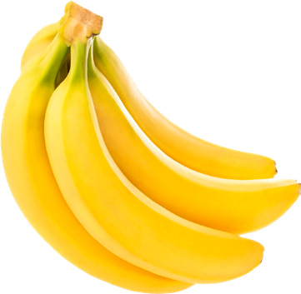
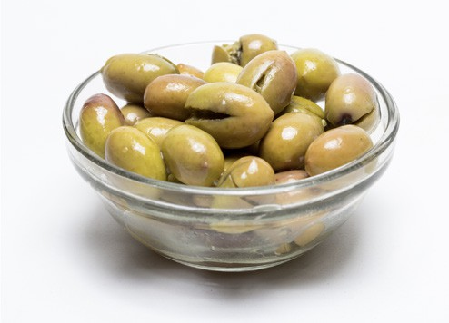
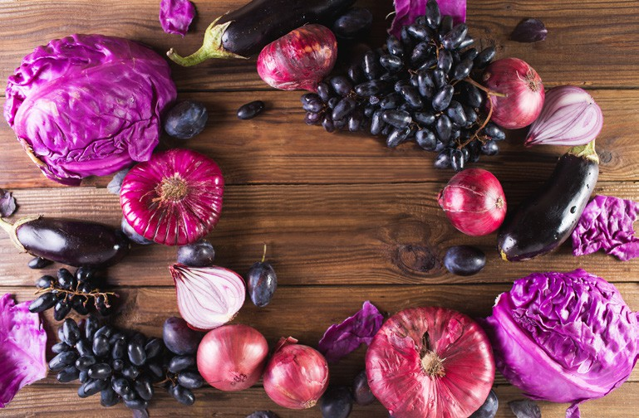
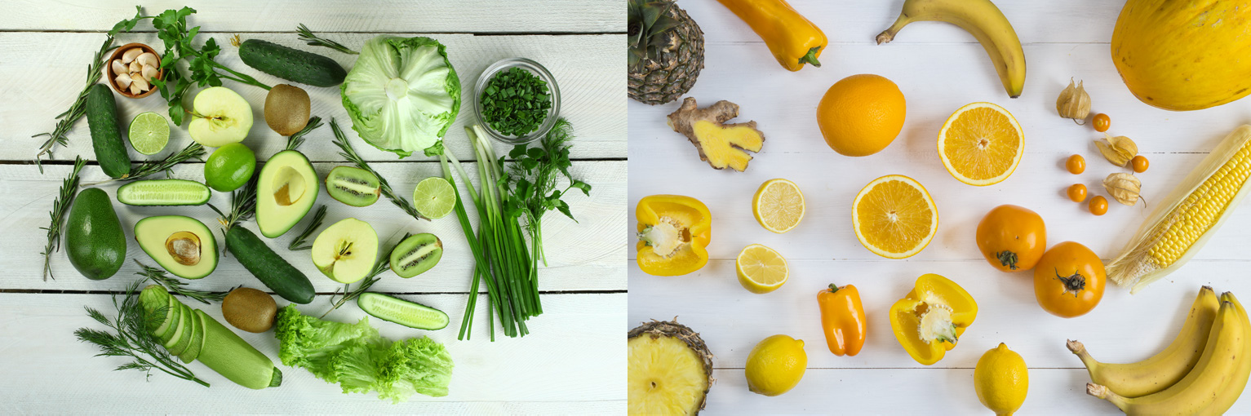
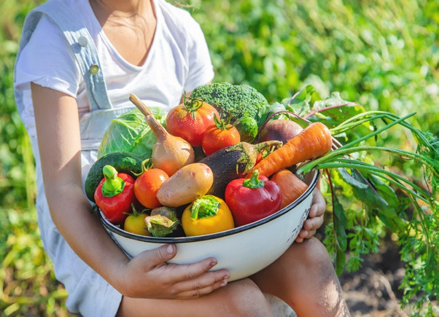
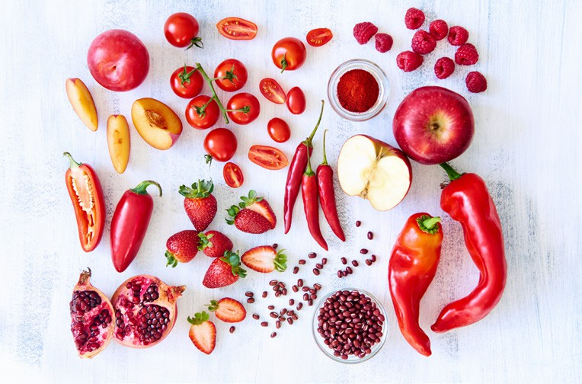

olives from Greece

plums from China

soya beans from Canada

pumpkins from Mexico

watermelons from South Africa

bananas from Brazil
Key facts

Fruits and vegetables are full of vitamins, minerals and fibre. The different colours give a clue to what they contain.
D&T - Eating seasonally

Blue and purple: vitamin C and fibre. | Red: vitamin A and vitamin C.
Green: vitamin E, iron, B vitamins and calcium. | Orange and yellow: vitamin A, vitamin C and fibre.

D&T - Eating seasonally

appearance The way something looks.
cutting
grating
spreading
taste testing
peeling

climate The weather conditions that an area usually has.

complementary Things that go together like colours or flavours.

design

evaluate
A plan for a recipe or dish.

To decide how good something is.

export Food sold to another country.

import ingredients
Food bought from another country. Foods that a recipe is made from.

peel seasonal temperate
To remove the skin of fruit or vegetables.

Food that grows at a certain time of the year. A climate with four seasons like the UK.

texture weather
The way food feels in your mouth. The temperature or conditions outside.

