Gusford Spring 2
Science Heroes
Year 1 – Robert Winston (1940)
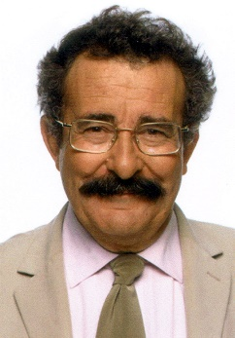
Robert Winston is a British professor, doctor and scientist. He is an expert on the human body and early childhood.

Year 2 – John McAdam (1756 – 1836)
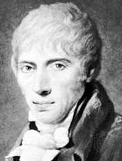
John McAdam was a Scottish civil engineer and road builder. He invented macadamisation, the process of paving roads with macadam.

Year 3 – Inge Lehman (1888 – 1993)
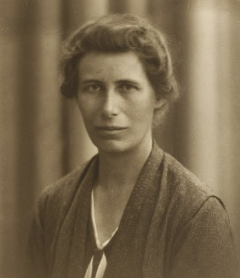
Inge Lehman was a Danish seismologist and geophysicist. She discovered the Earth’s inner core.

Year 4 – Thomas Edison (1847 – 1931)
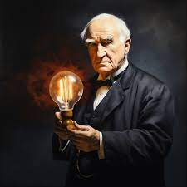
Thomas Edison was an American inventor and businessman. He invented the lightbulb, phonograph and motion picture camera.

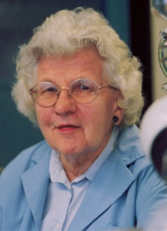
Year 5 – Ruth Benerito (1916 – 2013)
Ruth Benerito was an American chemist and inventor. She developed wrinkle-free cotton and has 55 patents to her name.

Year 6 – Rosalind Franklin (1920 – 1958)
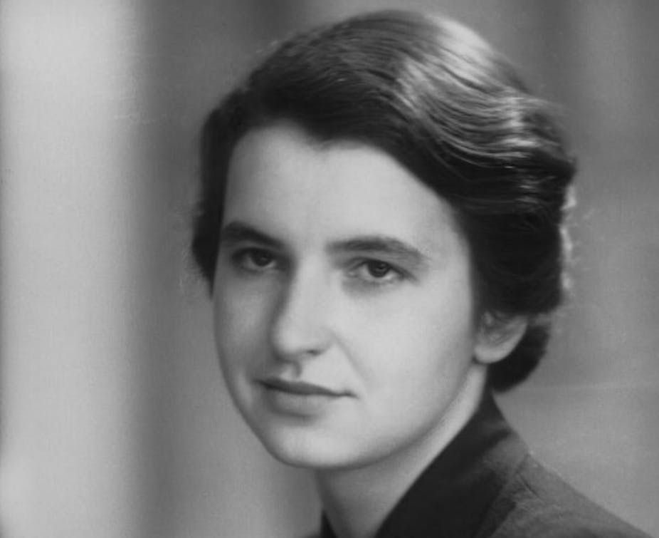
Rosalind Franklin was a British chemist and X-ray crystallographer. She discovered the double helix in DNA which explained how life is passed down from one generation to the next.

“Science and everyday life cannot and should not be separated. Science, for me, gives a partial explanation of life. In so far as it goes, it is based on fact, experience and experiment.” Rosalind Franklin

