Gusford Summer 1
Science Heroes
Year 1 – Beatrix Potter (1866 – 1943)
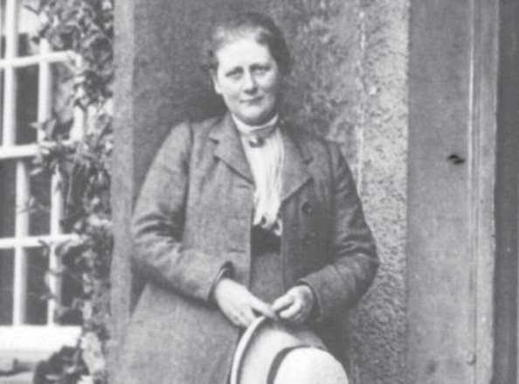
Beatrix Potter was an English writer, illustrator, natural scientist and conservationist. She is very well known for writing The Tale of Peter Rabbit but she was also interested in mycology, the study of fungi.

Year 2 – Agnes Arber (1879 - 1960)
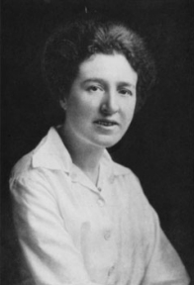
Agnes Arber was a British botanist and plant morphologist (somebody who studies the physical form of plants). She introduced the idea of the partial shoot theory in which each part of the plant is either a shoot or a partial shoot.

Year 3 – Joseph Banks (1743 – 1820)
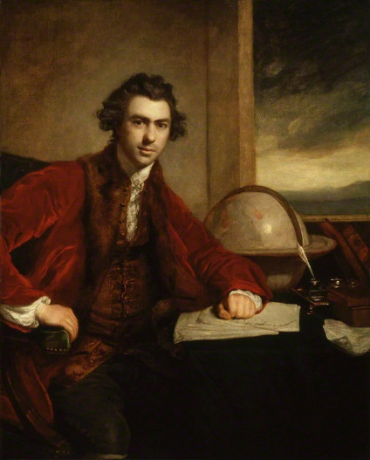
Joseph Banks was an English botanist who publicly supported scientific exploration and oversaw many voyages. He was the first person to introduce the Western world to acacia, mimosa and eucalyptus.

Year 4 – Ivan Pavlov (1849 – 1936)
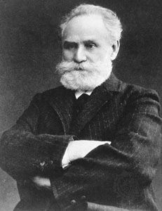
Ivan Pavlov was a Russian neurologist and physiologist. He discovered classical conditioning which is how we develop our emotional responses to people and events.

Year 5 – David Attenborough (1926)
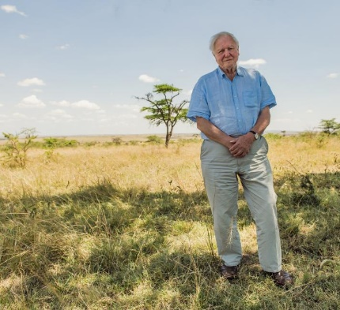
David Attenborough is a British biologist and natural historian. He is very famous for making documentaries about natural history and has many species named after him.

Year 6 – Leonardo Da Vinci (1452 – 1519)
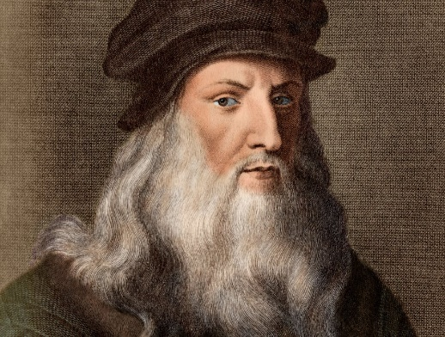
Leonardo Da Vinci was an Italian artist, engineer and scientist who made scientific investigations into anatomy, zoology and the science of flight. He created many inventions including a flying machine, a parachute and a revolving bridge.

Nature is the source of all true knowledge. She has her own logic, her own laws, she has no effect without cause nor invention without necessity. Leonardo Da Vinci

