Year 1 – Summer 2
How has Ipswich and its people changed over time?
Timeline of British History

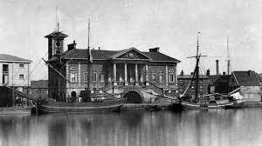
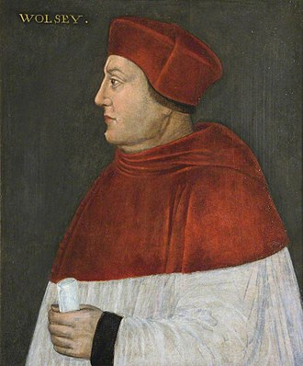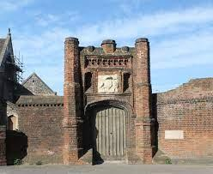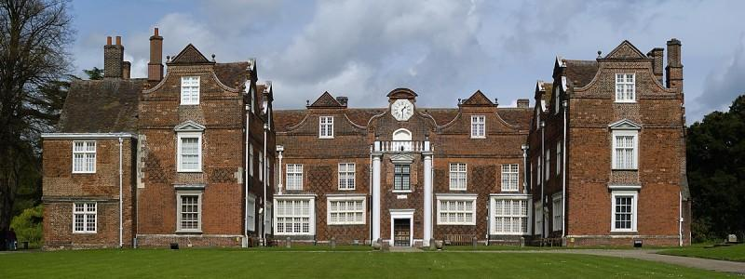
Ipswich docks
Cardinal Wolsey c.1525
Wolsey Gate
Christchurch Mansion
Key Vocabulary
Ipswich | The town we live in | timeline | Things that happen in order
dock | A place where boats can load and unload goods | trade | Buy and sell things
Anglo-Saxons | People who lived in Ipswich around 625AD | wool | Coat from a sheep
Vikings | People who came from Norway and Denmark | grain | Seeds we use to make bread
Huguenots | French Protestants who came to England to be safe | change | Things that are different

