What else does it look like?

What sound does it start with?

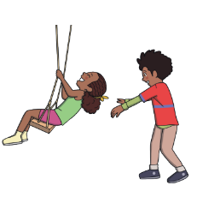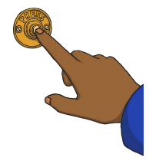

p

push

What does it look like?

How many syllables does it have?

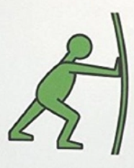

1

What else does it look like?

What sound does it start with?

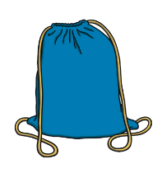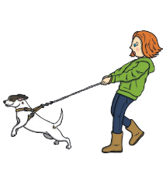

p

pull

What does it look like?

How many syllables does it have?

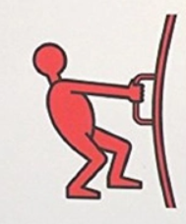

1

What else does it look like?

What sound does it start with?



f

float

What does it look like?

How many syllables does it have?

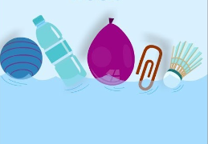

1

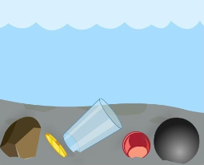

sink

What else does it look like?

What does it look like?

1

How many syllables does it have?

What sound does it start with?

s