What else does it look like?

What sound does it start with?

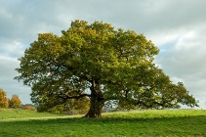

p

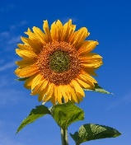

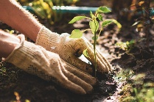

plant

What does it look like?

How many syllables does it have?

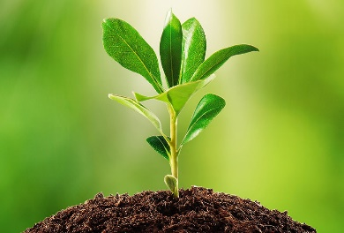

1

What else does it look like?

What sound does it start with?

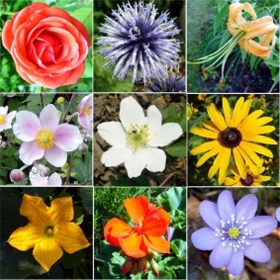

f

flower

What does it look like?

How many syllables does it have?

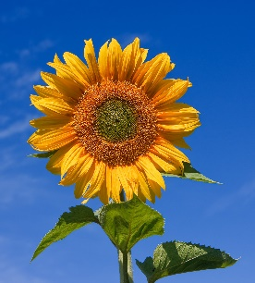

2

What else does it look like?

What sound does it start with?

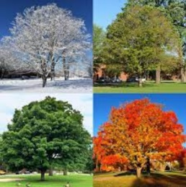

t

tree

What does it look like?

How many syllables does it have?

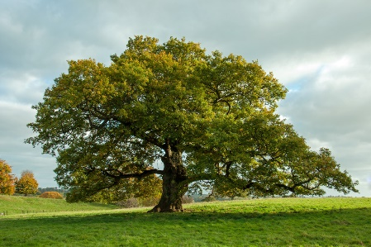

1

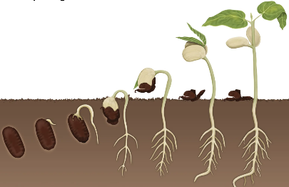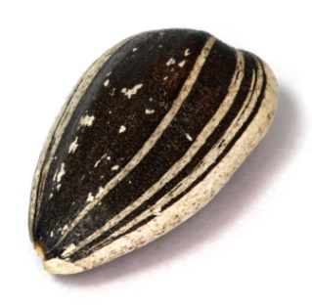

What does it do?

What does it look like?

1

How many syllables does it have?

What sound does it start with?

s

seed