What else does it look like?

What sound does it start with?

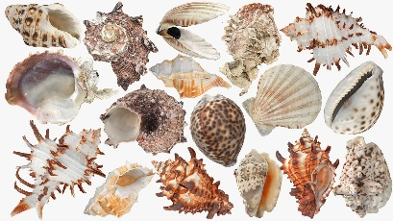

sh

shell

What does it look like?

How many syllables does it have?

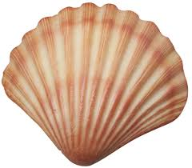

1

What else does it look like?

What sound does it start with?

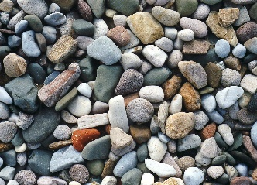

p

pebble

What does it look like?

How many syllables does it have?

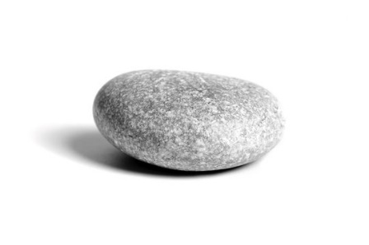

2

What else does it look like?

What sound does it start with?

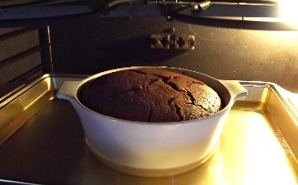

h

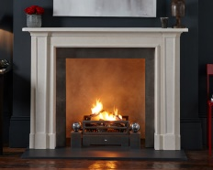

hot

What does it look like?

How many syllables does it have?



1

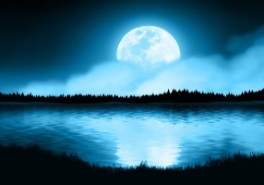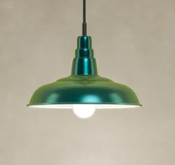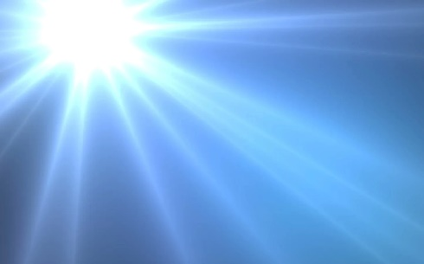

What else does it look like?

What does it look like?

1

How many syllables does it have?

What sound does it start with?

l

light