What else does it look like?

What sound does it start with?

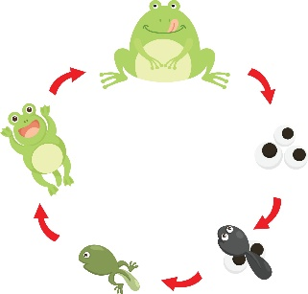

l and s

life cycle

What does it look like?

How many syllables does it have?

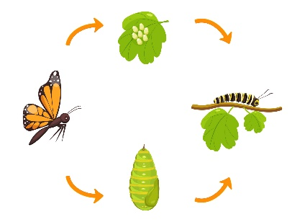

1 and 2

What else does it look like?

What sound does it start with?

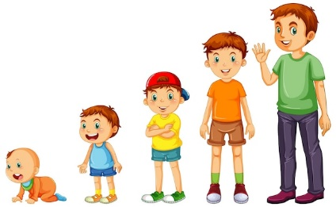

g

grow

What does it look like?

How many syllables does it have?

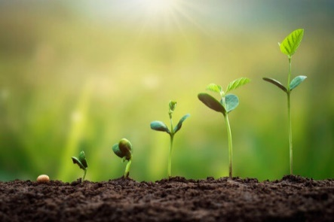

1

What else does it look like?

What sound does it start with?

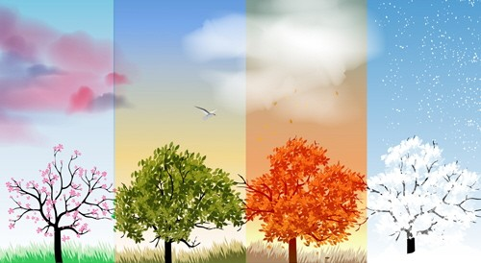

ch

change

What does it look like?

How many syllables does it have?

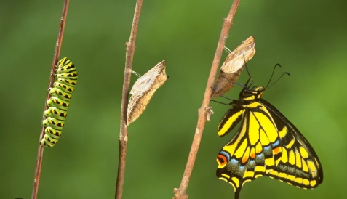

1

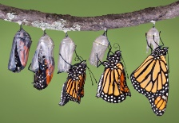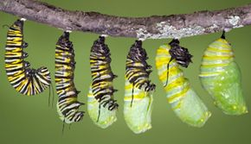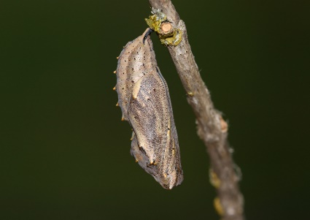

What does it do?

What does it look like?

3

How many syllables does it have?

What sound does it start with?

c

chrysalis