What would you find there?

What sound does it start with?

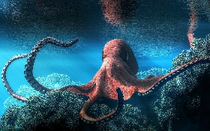

oa

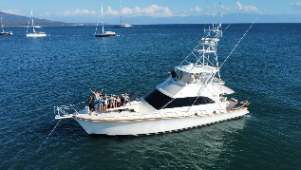

ocean

What does it look like?

How many syllables does it have?

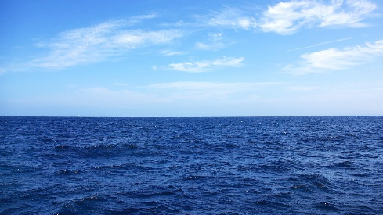

2

What would you find there?

What sound does it start with?

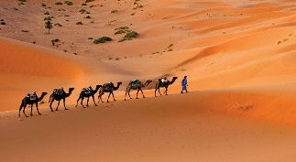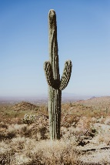

d

desert

What does it look like?

How many syllables does it have?

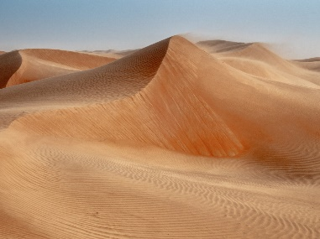

2

When does it happen?

What sound does it start with?

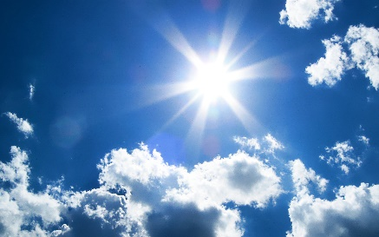

sh

shadow

What does it look like?

How many syllables does it have?

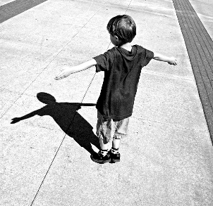

2

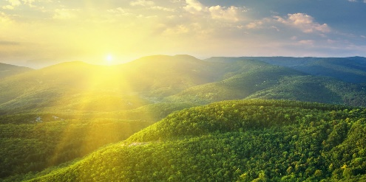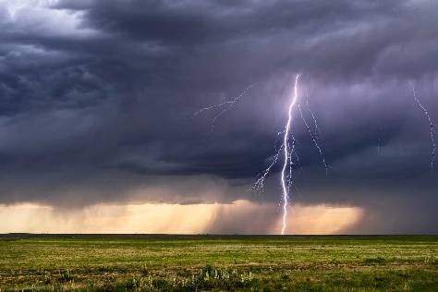

2 and 1

th and s

thunder storm

When does it happen?

What does it look like?

How many syllables does it have?

What sound does it start with?