What would you find there?

What sound does it start with?

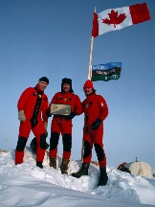

n

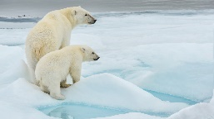

North Pole

What does it look like?

How many syllables does it have?

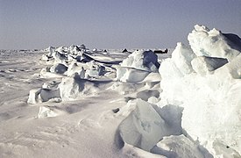

2

What would you find there?

What sound does it start with?

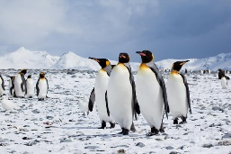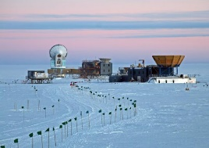

s

South Pole

What does it look like?

How many syllables does it have?

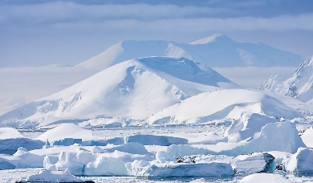

2

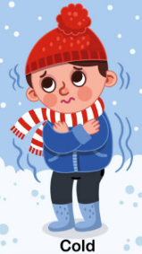

How does it happen?

What sound does it start with?

f

freeze

What does it look like?

How many syllables does it have?

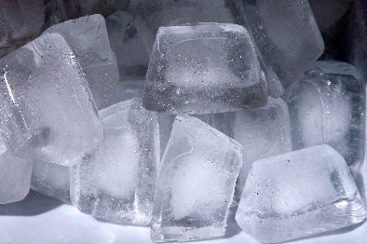

1

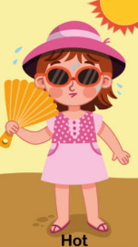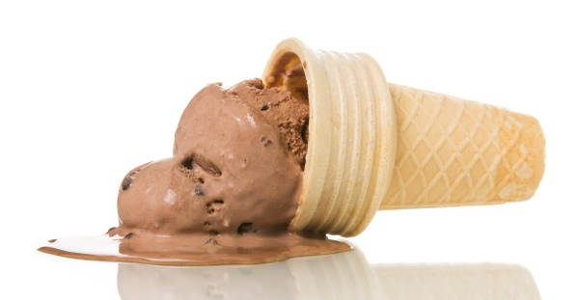

How does it happen?

What does it look like?

1

How many syllables does it have?

What sound does it start with?

m

melt