Key Facts
Humans are mammals and are part of the animal kingdom. .
Whales are mammals. They live in the water, but breathe air through lungs, have warm blood and give birth to live young.
Reptiles such as snakes, do have skeletons.
All animals begin life as either an egg or a baby that is born ready for life.
Herbivores are animals that eat only plants.
Carnivores are animals that only eat meat.
Omnivores are animals that eat both plants and meat.
Carnivores are at the top of the food chain.
The size of the animal does not decide what it eats.
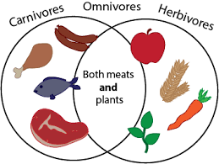
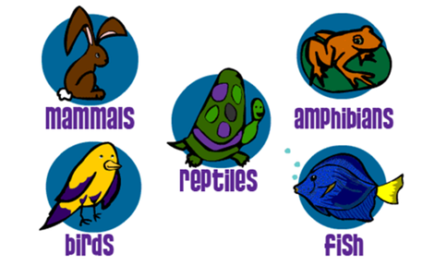
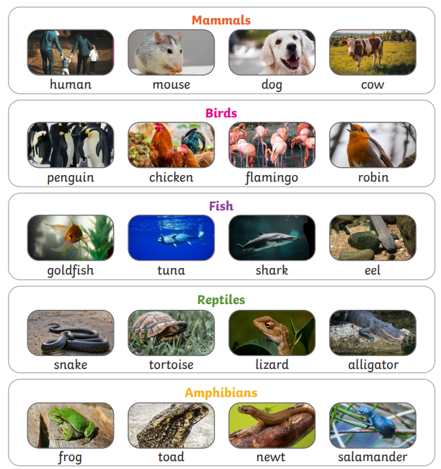
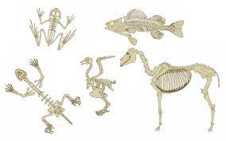
Year 1 – Spring 2 - Animals

Key Vocabulary
Amphibians | Are animals that live in the water as babies and on land as they grow older. They have smooth, slimy skin. | Herbivores | Are animals that eats mostly plants.
Birds | Are warm-blooded egg-laying animals, they have a beak, two legs, feathers and wings. | Carnivores | Are animals that eats mostly other animals.
Fish | Are animals that live and breathe under water. They have scaly skin, fins to help them swim and they breathe through gills. | Omnivores | An animal or person that eats a variety of food of both plant and animal origin.
Mammals | Are animals that breathe air, grow hair or fur and feed on their mother’s milk as a baby. | Skeleton | The bones of the body that form a framework.
Reptiles | Are animals that breathe air. They have scales on their skin. | Life cycle | A series of stages a living thing goes through during its life.

