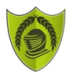
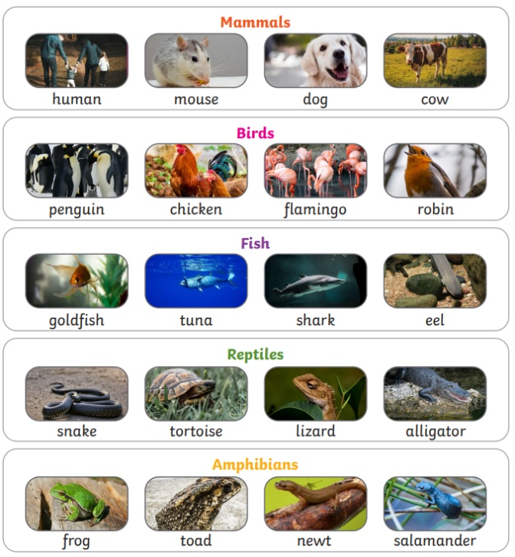
Year 1 – Summer 2 - Animals
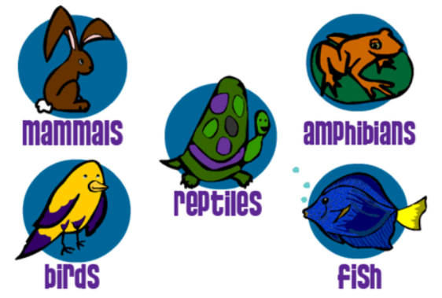
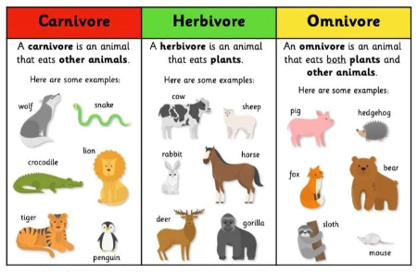

Key Vocabulary
Mammals | Animals that breathe air, grow hair or fur and feed on their mother’s milk as a baby. | Amphibians | Animals that live in the water as babies and on land as they grow older.
Birds | Animals that have a beak, two legs, feathers and wings. | Herbivores | Animals that eat plants.
Fish | Animals that only live in the water. | Carnivores | Animals that eat other animals.
Reptiles | Animals that have scales and lay eggs. | Omnivores | Animals that eat plants and other animals.

