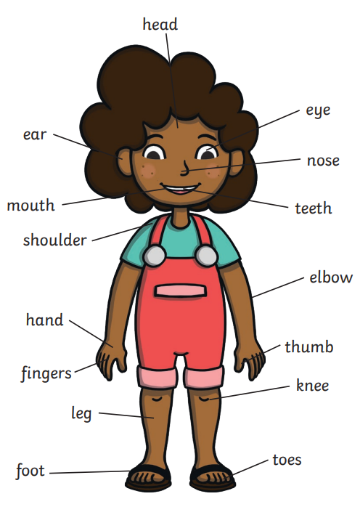
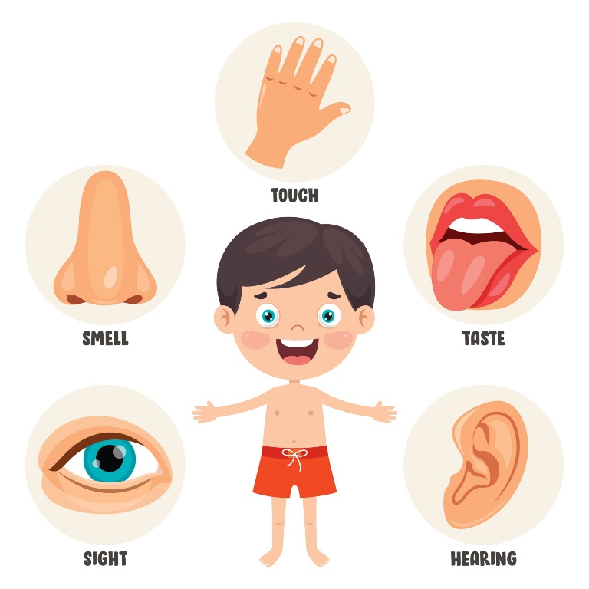
Year 1 – Summer 1 - Humans

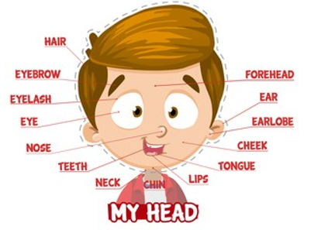

Key Vocabulary
Body | A group of parts that work together. | Hearing | What something sounds like. Our ears sense sound.
Movement | Changing place or position. | Smell | What something smells like e.g. flowers or baking. Our nose senses smell.
Senses | Things that receive information about what something is like. | Taste | What something tastes like e.g. salty, sweet or sour. Our mouth senses taste.
Sight | What something looks like. Our eyes sense sight. | Touch | What something feels like. Our skin senses touch.

