Year 1 – Autumn 1 + 2 – Materials
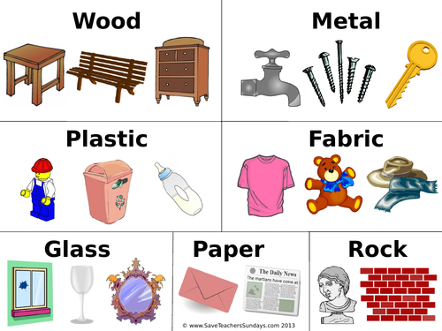
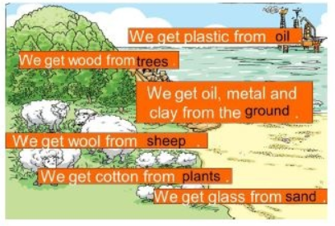

Key Vocabulary
Hard | Something that is not easily broken or bent. | Smooth | Something that feels and looks even and not bumpy.
Soft | Something that is easy to cut, fold or change the shape of. | Bendy | Something that can be made into a curved or bent shape.
Shiny | Something that reflects light easily. | Waterproof | Something that keeps water out.
Dull | Something that does not reflect light easily and does not look bright. | Absorbent | Something that soaks up water.
Rough | Something that feels and looks uneven and bumpy. | Opaque | Something that can’t be seen through.

