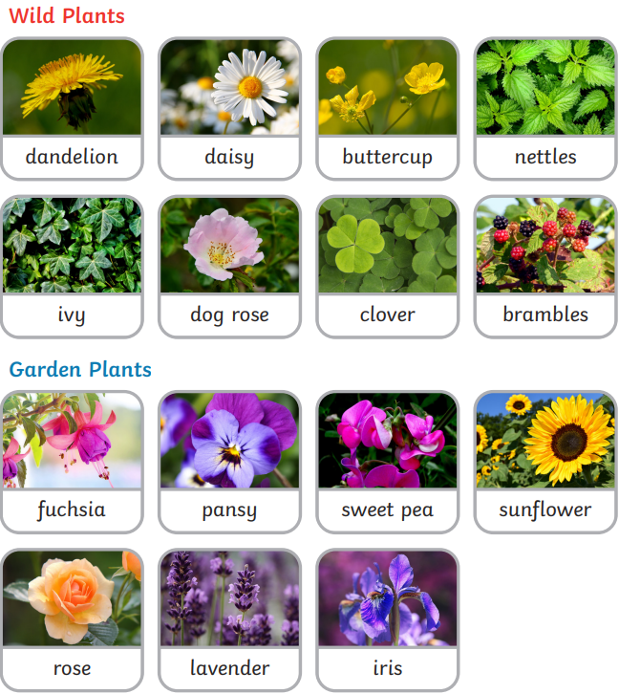
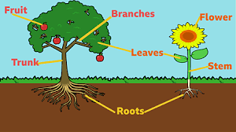
Year 1 – Summer 1 - Plants
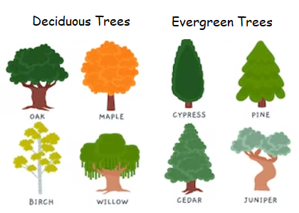

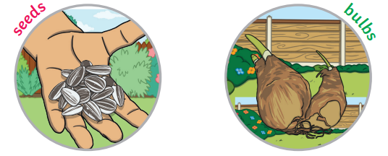

Key Vocabulary
Wild plant | A plant that grows where its seeds fall. | Deciduous | A tree or bush that loses its leaves.
Garden plant | A plant that people choose to grow in their gardens. | Evergreen | A tree or bush that has green leaves all year round.
Weed | A wild plant that is growing in a place that people don’t want it to. | Blossom | The flowers that appear on the tree before the fruit.
 |  | Petal | The small parts that make the outside of the flower.

