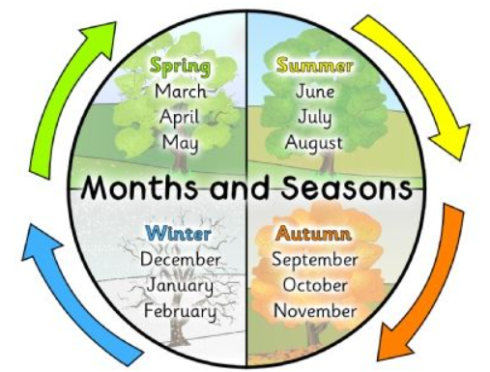
Year 1 – Spring 1 – Seasonal Change
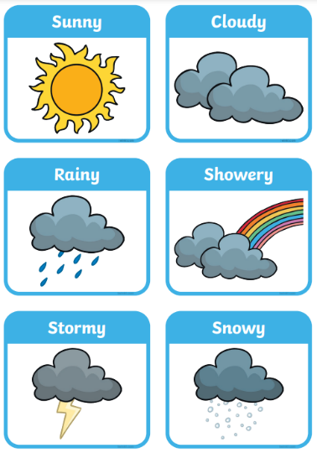
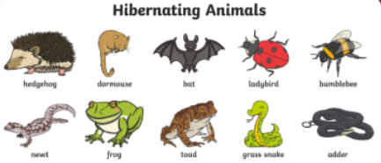

Key Vocabulary
Seasons | The four groups of weather changes. These are called autumn, winter, spring and summer. | Winter solstice | The shortest day of the year – 21st December.
Daylight | This is when it is light outside. The amount of daylight changes with each season. | Weather | What the sky and air are like outside e.g. windy, hot, raining.
Sunrise | The time in the morning when sun first appears. | Temperature | How hot or cold something is.
Sunset | The time in the night time when the sun disappears. | Hibernate | To spend the winter in a special kind of sleep.
Summer solstice | The longest day of the year – 21st June. | Migrate | To move away on a long journey from one place to another.

