Key Facts
Some animals give birth to live young. Some animals lay eggs which the young hatch from.
Humans need to eat a balance of different food groups, plus taking in water and air to survive.
Animals need air, water, food, shelter and space.
A life cycle is called a cycle as it goes around and around and repeats itself.
A human baby has more bones than an adult because some bones fuse together as they grow.
A female frog lays around 1000 eggs at a time. This is because so many eggs and tadpoles get eaten.
Year 2 – Autumn 2 – Animals including Humans
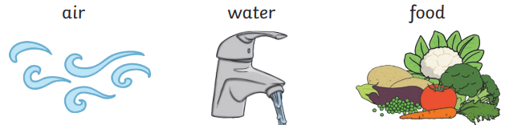

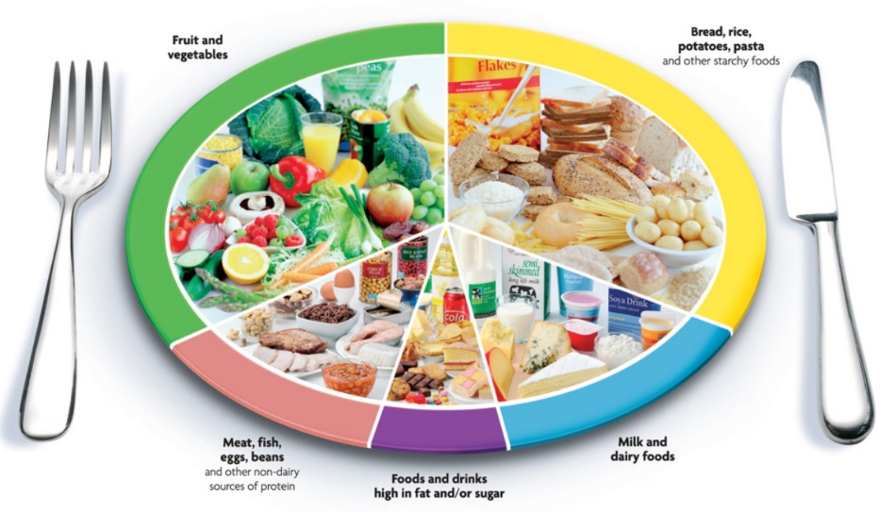

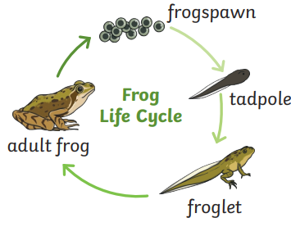
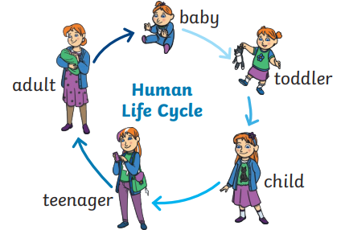

Key Vocabulary
Life cycle | The changes living things go through to become an adult. | Diet | The food and water that an animal needs.
Offspring | The child of an animal. | Food groups | The five main groups of food: fruit and vegetables, starchy food, dairy, proteins and fats.
Young | Offspring that has not reached adulthood. | Exercise | An activity to keep your body fit and strong.
Develop | To grow bigger and become stronger. | Germs | Tiny things that can cause illness.
Survival | To continue to exist. | Hygiene | How we stay clean and prevent illness.

