|  |
| --- |
| **Key Facts** |
| Ibn Battuta (1304 – 1377) – He was an explorer who travelled for nearly 30 years. He learnt about lots of different places (around 1325 – 1353). |
| Neil Armstrong (1930 – 2012) – He became the first person to walk on the moon. A team of people at NASA made this happen (1969). |
| Ride into History' with Amelia Earhart | News | ctnewsonline.com Amelia Earhart (1897–1937) - was an American pilot famous for becoming the first woman to fly solo across the Atlantic Ocean (1937). |
| Biografía de Francisco de Orellana | CurioSfera-Historia.com Francisco de Orellana (1490 – 1549) – **was a** Spanish soldier and first European explorer of the Amazon River 1541). |

**Year 2 – Autumn 1 – Great Explorers**

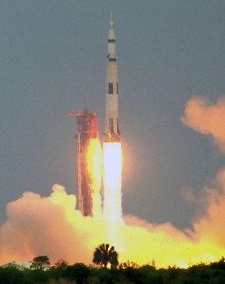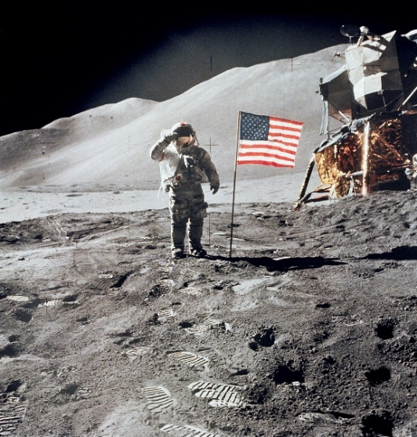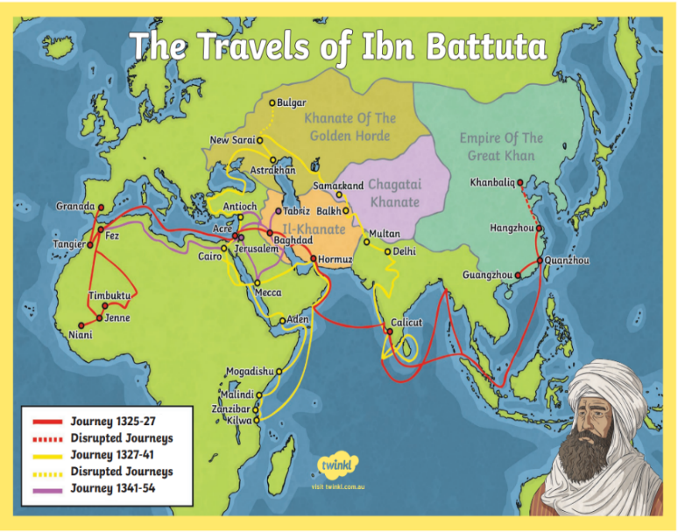

Neil Armstong having just landed on the moon off Apollo 11 (pictured below) with pilot Buzz Aldrin in 1969.

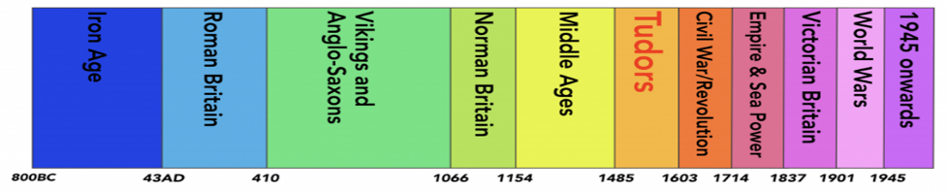

|  |  |  |  |
| --- | --- | --- | --- |
| **Key Vocabulary** | | | |
| Achievement | An **achievement** is something challenging that a person does well. | Exploration | A journey where explorers travel to somewhere unfamiliar. |
| Polar | Used when talking about something to do with the North or South Pole. | Explorer | Someone who goes on a journey to find something or somewhere new. |
| Equipment | Objects that are needed for an activity. | Astronaut | A person who is trained to travel space. |
| Expedition | A journey taken for a reason such as exploring. | Recent | In the past not long ago. |
| Historic | Famous or important in history. | Significant | Important and worth knowing about. |