Key Facts
Pushes and pulls make objects move.
A push or a pull can make an object start moving or stop an object from moving.
A push or a pull can make an object speed up or slow down.
A push or a pull can make an object change direction.
A squash is a push and a stretch is a pull. Twists and bends are a combination of pushes and pulls.
Year 2 – Summer 2 – Forces
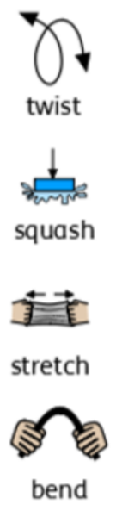
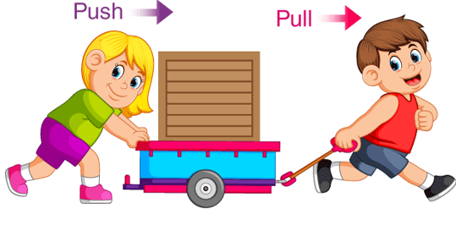

Pushes
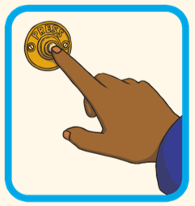 | 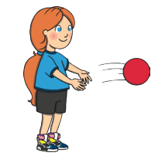 | 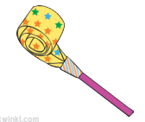
Pulls
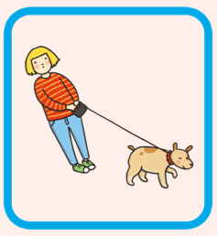 | 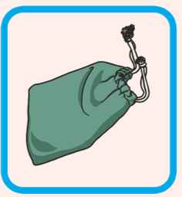 | 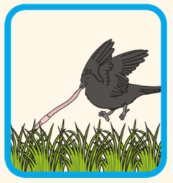
Pushes and Pulls
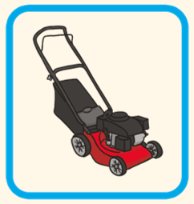 | 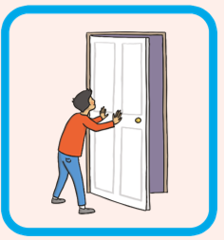 | 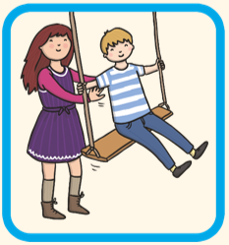

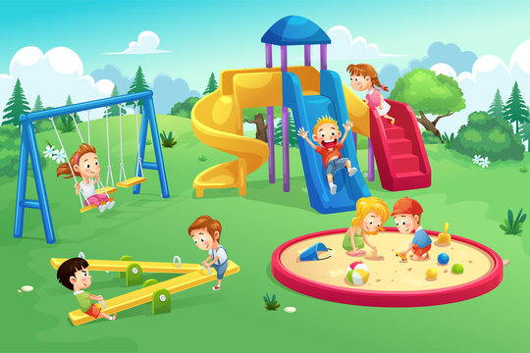

Key Vocabulary
Push | A way of moving something away from you. | Balanced | When the push and the pull are the same so there is no movement.
Pull | A way of moving something towards you. | Unbalanced | When the push and the pull are not the same so there is movement.

