Key Facts
There are 7 life processes and these are: movement, reproduction, sensitivity, nutrition, excretion, respiration and growth.
A habitat is a place where living things including plants can find all the things they need to survive. This includes food, water, space to move and grow and shelter.
A microhabitat is a small habitat such as under a rock or on a branch. Minibeasts live in a microhabitat.
A food chain is the order that living things depend on each other to survive. Nutrients are passed through the living things. Food chains begin with plant life and end with animal life.
Animals that eat other animals are called predators and animals that are eaten by other animals are called prey.
Year 2 – Autumn 1 – Living Things & Their Habitats
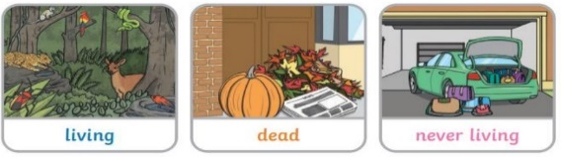
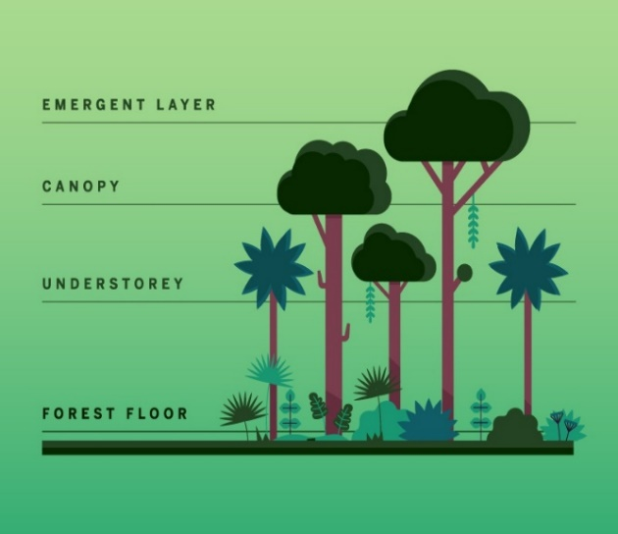
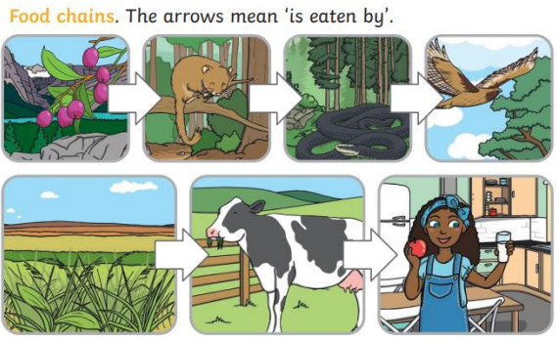

Key Vocabulary
Living | Things that have all the life processes. | Woodland | 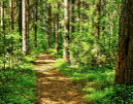  A land covered with trees.
Dead | Things that do not have life processes. Things that are dead were once living and did have life processes. | Ocean | 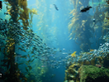  A huge body of salty water.
Never alive | Things that do not have all the life processes. They may move but they do not breath or reproduce. | Seashore | 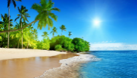  The edge of the sea which is often sandy and  stony. Seas are smaller than oceans and are  often next to land.
Shelter | A place giving protection from bad weather or danger. | Rainforest | 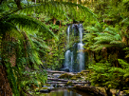  A tall forest that receives lots of rain every  year.
Condition | Something that an animal needs to survive e.g. food, water, space to move and grow and shelter. | Desert | 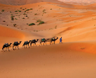  A place that has very little rainfall.

