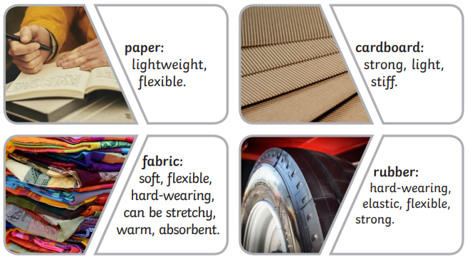
Year 2 – Spring 1 + 2 – Materials
Key Facts
John McAdam was a Scottish engineer who experimented with using new materials to build roads, inventing a new process called ‘macadamisation’.
John Dunlop was a Scottish inventor who invented the air-filled rubber tyre. It was originally invented in 1887 to use with bicycles, and then became very useful when automobiles were developed.
Charles Macintosh was an inventor and chemist who invented waterproof fabrics in 1818. The mackintosh raincoat was introduced in 1824.
Macadamisation was the name given to John McAdams construction process of building roads. The name tarmac means a road made like this using tar.

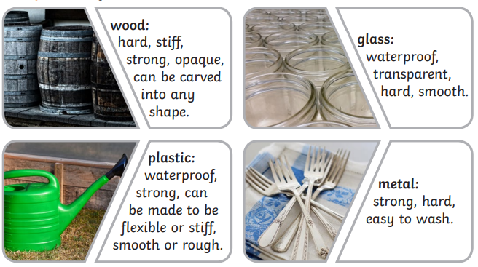

Material Purposes
Paper | Newspaper, wrapping paper and envelopes.
Cardboard | Cereal boxes, chipboard and paper towels.
Fabric | Clothes, hats and bandages.
Rubber | Tyres, belts and medical gloves.
Wood | Tables, doors and picture frames.
Glass | Windows, mirrors and glasses.
Plastic | Toys, bank cards and watering cans.
Metal | Cutlery, screws and jewellery.

Key Vocabulary
Materials | What things are made out of. | Squash | Push something so that it loses its shape.
Purpose | The job that something does. | Bend | Move both ends inwards.
Properties | What a material is like and how it behaves. | Twist | Turn something to make a spiral shape.
Suitability | How well something does something due to its properties. | Stretch | Move both ends outwards.

