Year 2 – Summer 1 – Plants
Plants that grow from seeds
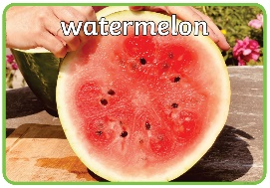 | 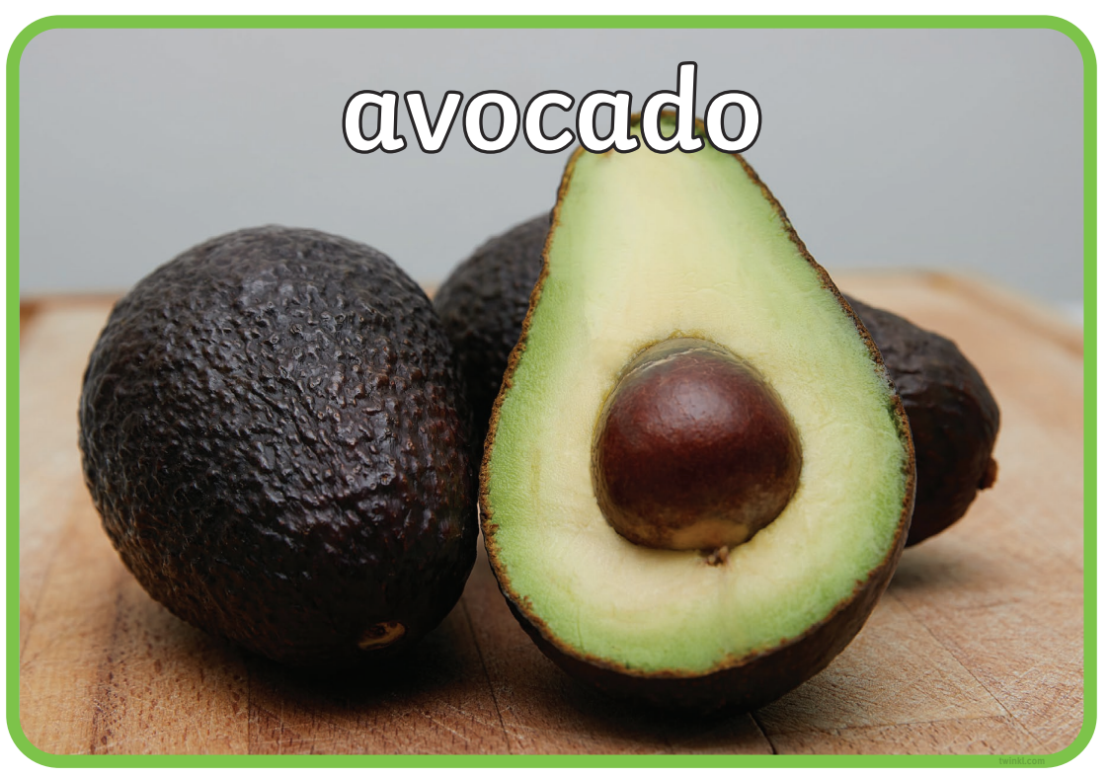 | 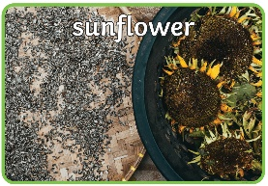 | 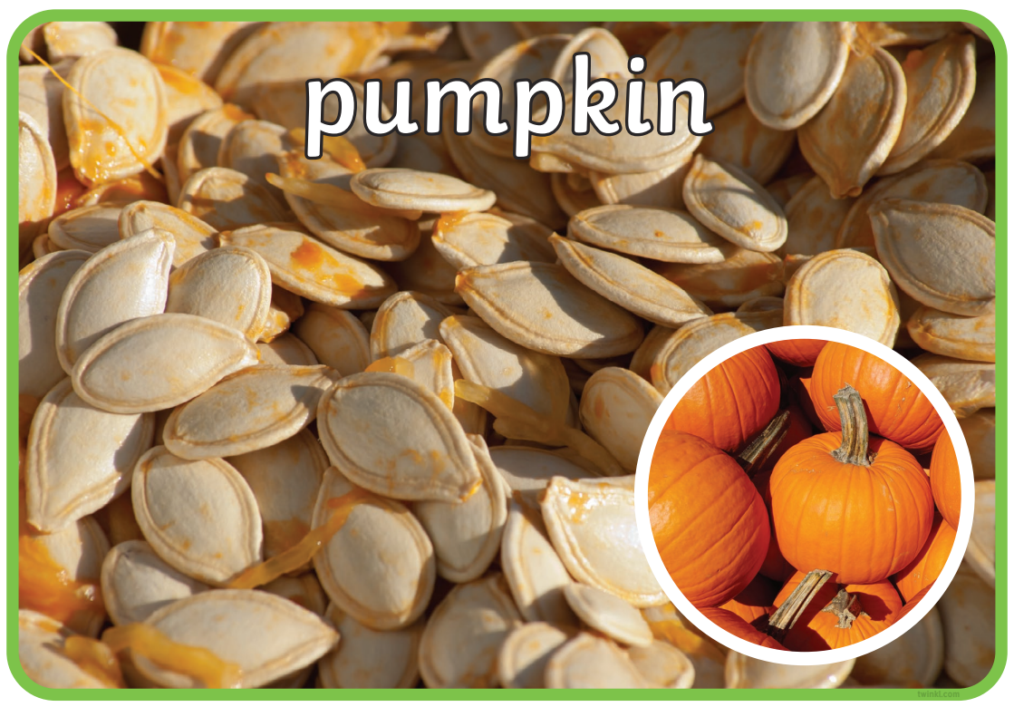
Plants that grow from bulbs
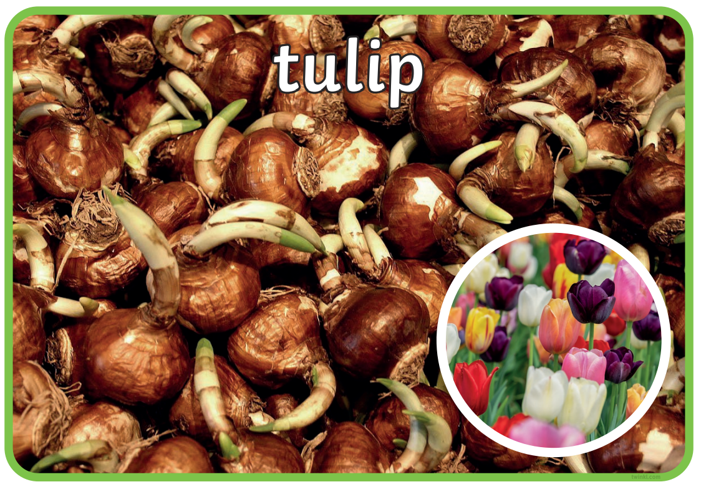 | 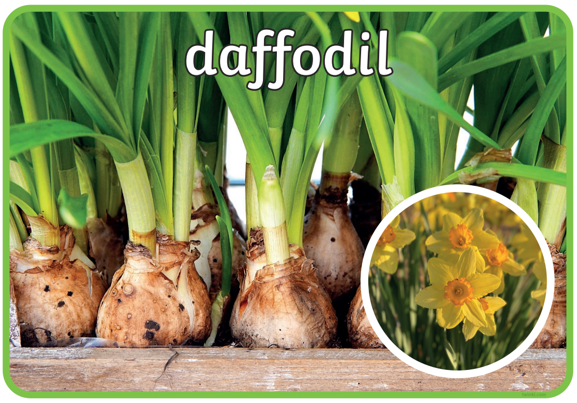 | 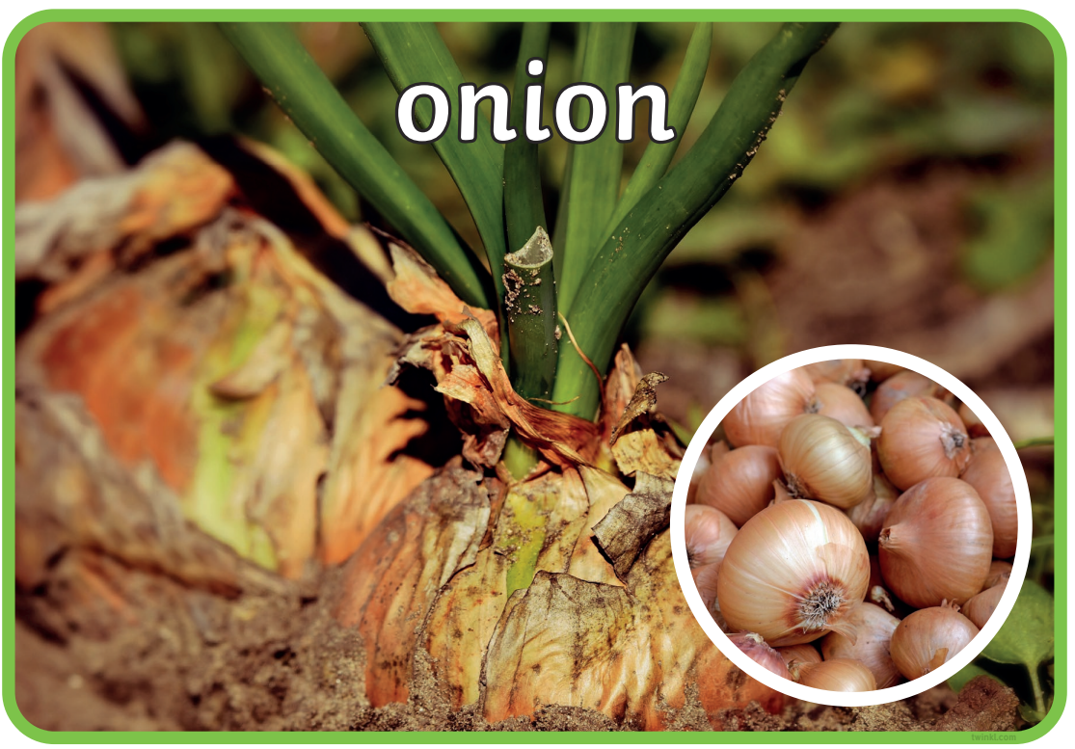 | 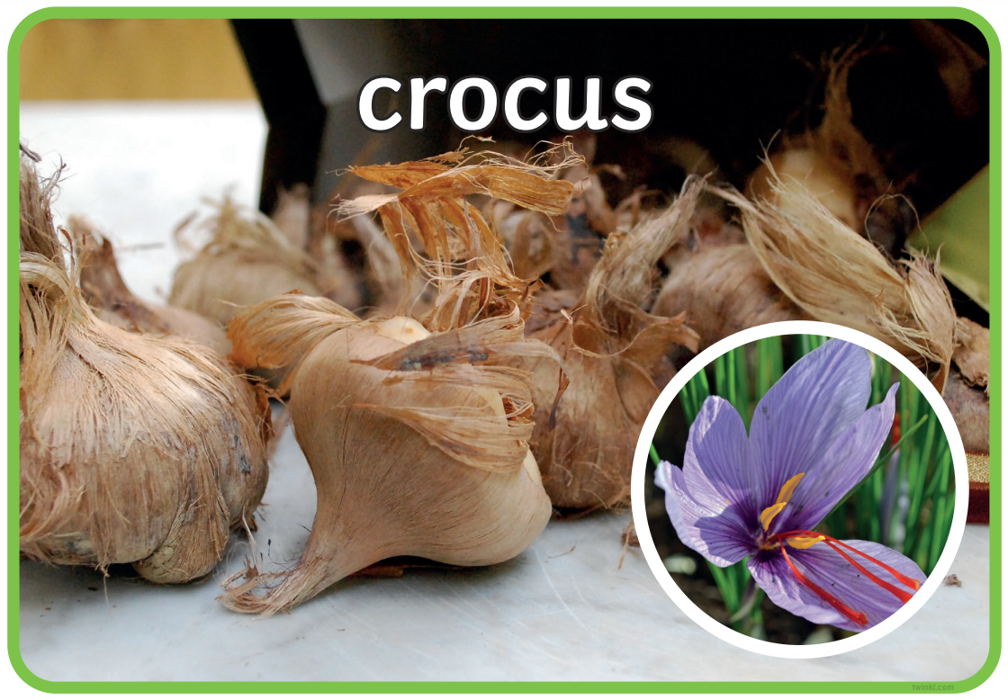
Key Facts
Seeds and bulbs contain food which gives plants the energy to start growing under the surface of the soil.
A shoot grows upwards from the seed or plant towards sunlight.
Plants take both nutrients and water from the soil through their roots.

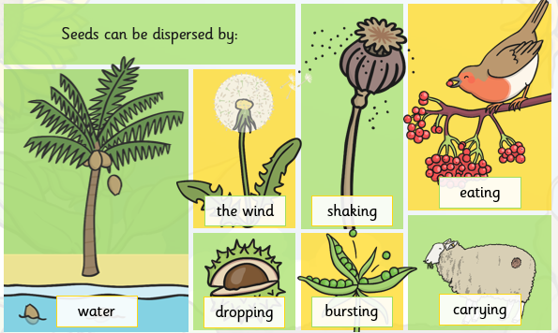
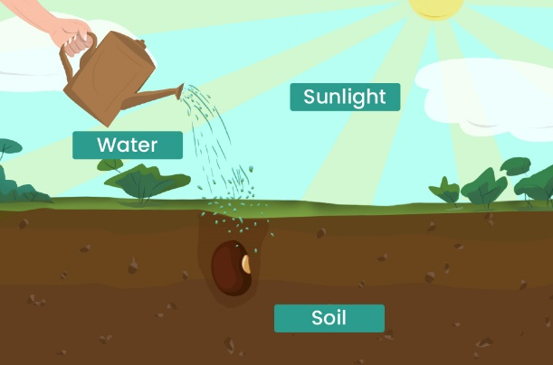
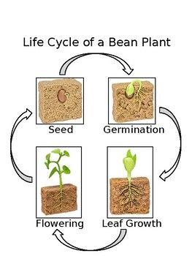

Key Vocabulary
Seed | A tiny plant in a protective case that grows into a new plant. | Sunlight | All plants need light from the sun to grow. Some need lots of sunlight and others only need a little sunlight.
Bulb | The underground bud of a plant that is in resting stage. | Water | All plants need water to grow.
Germination | When the seed begins to grow into a plant. | Temperature | Some plants like cooler temperatures and others like warmer temperatures.
Dispersal | How seeds move away from the parent plant. | Nutrition | How living things get the food they need to be healthy and strong.

