|  |
| --- |
| **Key Facts** |
| People in the Stone Age moved around with the seasons to stay safe and follow the animals they hunted. |
| Stonehenge is a prehistoric monument that took 1000 years to build. |
| Stone Age people hunted animals like mammoths and used their bones for tools like needles. |
| In the Bronze Age people lived in roundhouses. People would sleep in one and cook in another. |
| In the Iron Age rectangular houses on hills in farming communities became common. These are called hillforts. |
| Farming began from the late Stone Age and people had stopped moving around by the late Bronze Age. |

**Year 3 – Autumn 1 – Stone Age to Iron Age**

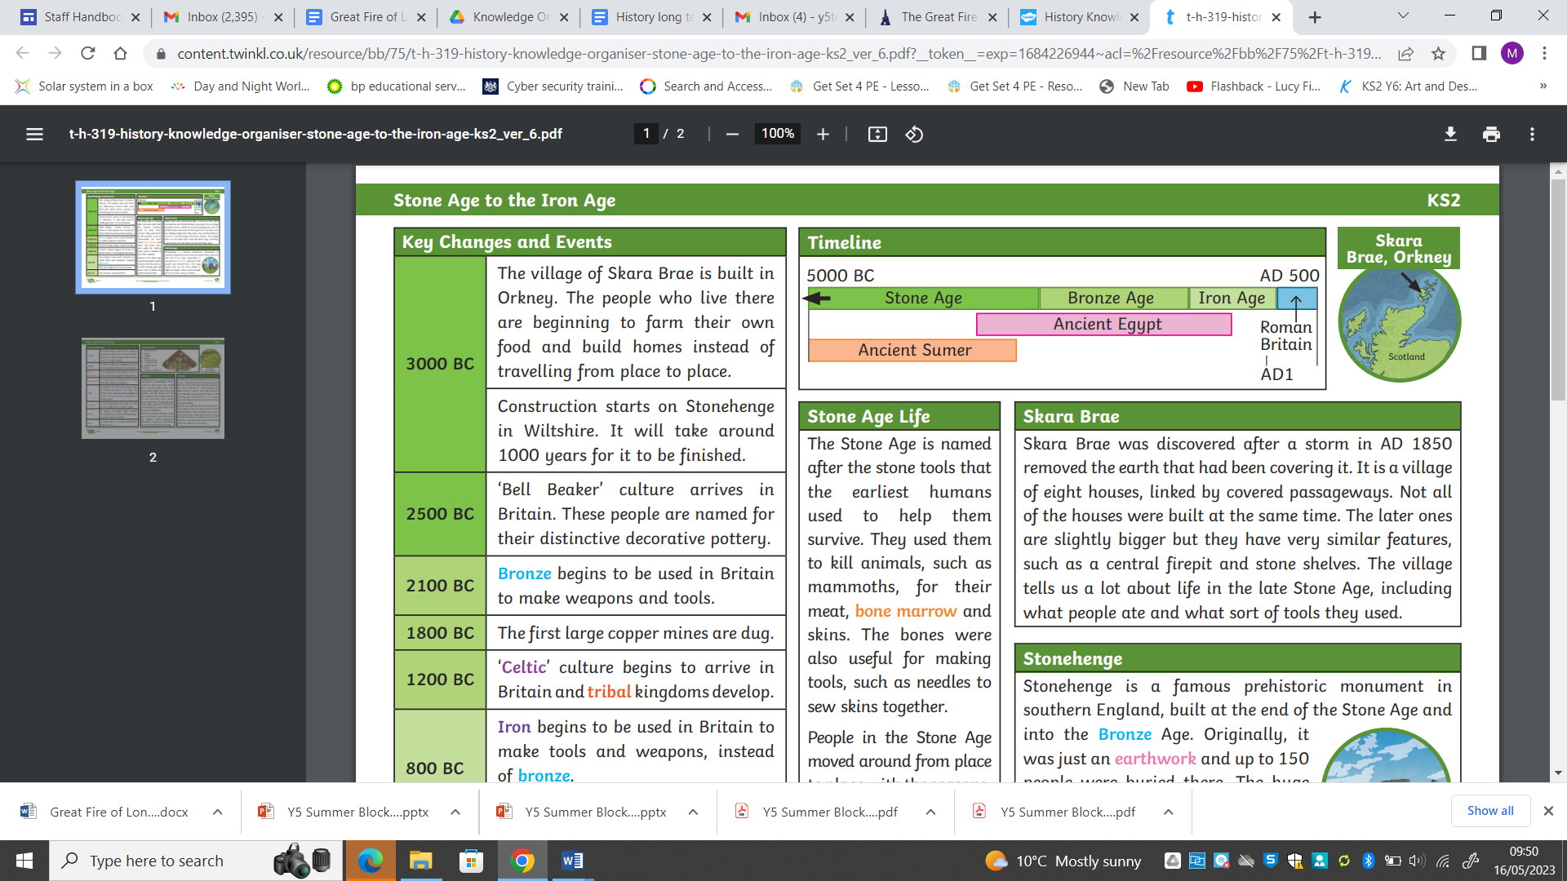

|  |  |  |  |  |  |  |
| --- | --- | --- | --- | --- | --- | --- |
| 3000BC | 2500BC | 2100BC | 1800BC | 1200BC | 800BC | AD43 |
| The village of Skara Brae is built in the Orkneys.  Stonehenge is begun and takes 1000 years to build. | ‘Bell Beaker’ culture arrives. It is named after the decorated pottery. | Bronze begins to be used to make weapons and tools. | The first large copper mines are dug. | ‘Celtic’ culture arrives in Britain and tribal kingdoms develop. | Iron is used to make tools and weapons. The first Hill forts are built. | The Romans invade Britain. |

|  |  |  |  |
| --- | --- | --- | --- |
| **Key Vocabulary** | | | |
| Bronze | A metal alloy made from copper and tin. It is harder and more long lasting than stone or copper. | Earthwork | A large bank or mound of soil that is made by humans. |
| Bone marrow | A substance inside bones which is high in fat and a good energy source. | Settlement | A place where people live. It can be one house or lots of houses together. |
| Iron | A metal that is stronger and harder than bronze. | Millennium | A thousand (1000) years |
| Tribe | A group of people often related by family, culture and language who have one leader. | Neolithic | Stone period 4300-2000BC when people began to farm crops and live in villages. The change was very slow. |
| Nomad | Member of a group who moves place to place and does not settle in place. | Agriculture | Growing and harvesting crops and rearing animals. It is another word for farming. |