Key Facts
Forces change the motion of something. They will make it start to move, speed up, slow down or stop.
Different surfaces create different amounts of friction.
Rough surfaces create lots of friction. Moving objects slow down quickly on rough surfaces.
Smooth surfaces don’t create much friction. Moving objects don’t slow down much on smooth surfaces.
Most forces need contact between objects but magnetic forces can act from a distance – it is a non-contact force.
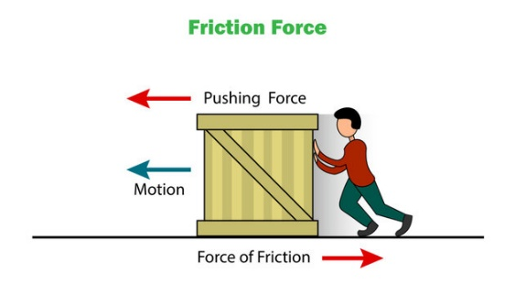
Year 3 – Summer 2 – Forces
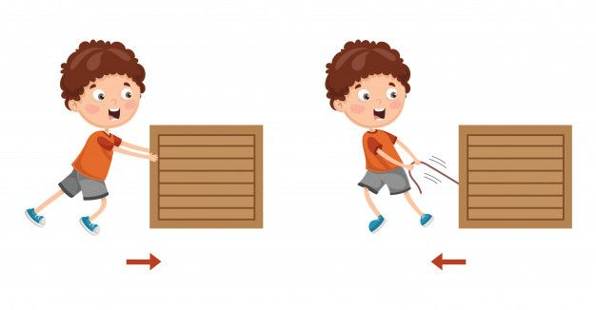

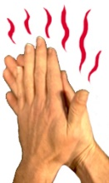
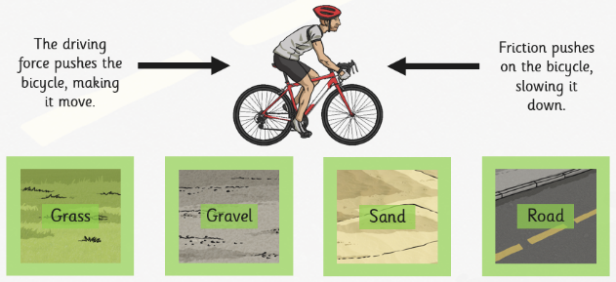

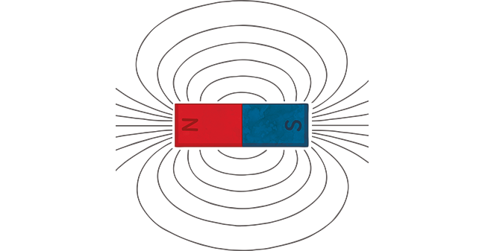
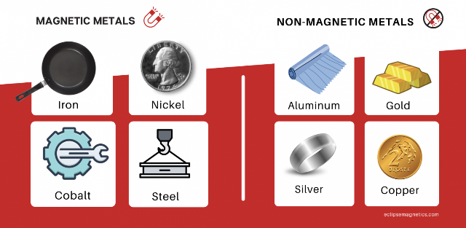
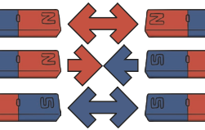
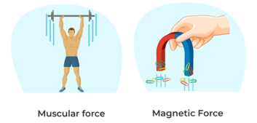

Key Vocabulary
Forces | These are different types of pushes and pulls. | Magnetic field | An area around a magnet where objects are attracted to the magnet.
Friction | A force between two surfaces that are sliding or trying to slide across each other. | Poles | The different sides of a magnet. There is a North pole and a South pole.
Surface | The top layer of something. | Repel | To force something away.
Magnet | A rock or a piece of metal that can pull certain types of metal towards itself. | Attract | To force something together.

