Key Facts
Light travels in a straight line. We can see objects when light reflects off them and hits our eyes.
Smooth surfaces reflect light better than rough surfaces.
Shadows are formed when opaque objects block light. Shadows are the shape of the object.
When the light source is directly above the object, the shadow will be underneath the object.
When the light source is to one side of the object, the shadow will appear on the opposite side and be longer.
Year 3 – Autumn 2 – Light
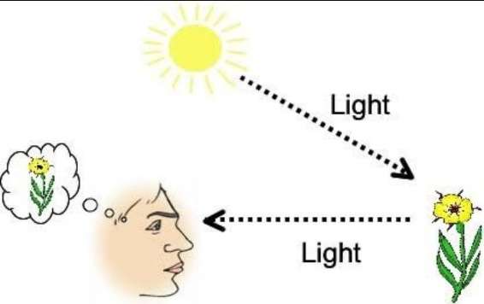
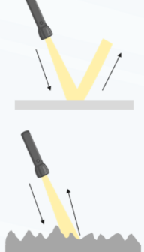

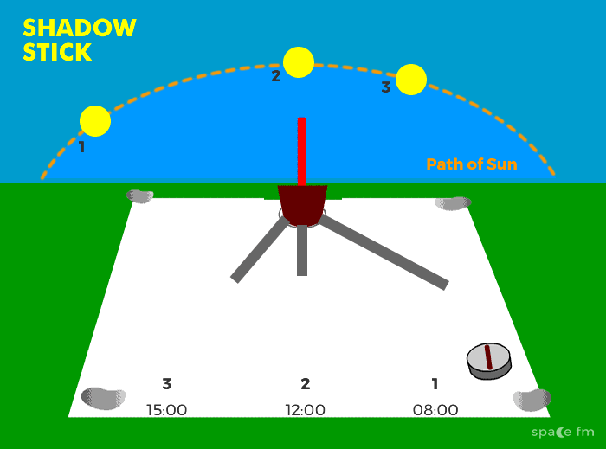
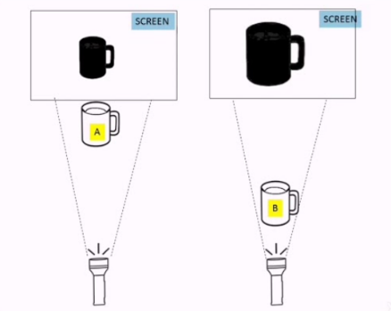
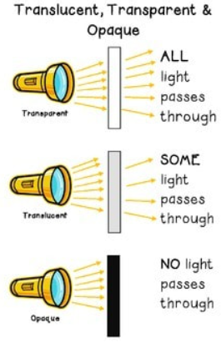
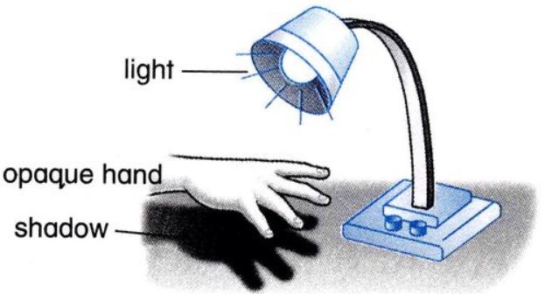

Key Vocabulary
Light | A form of energy that travels in waves from a source. | Translucent | Objects that let some light through. We can’t see through them properly.
Light source | An object that makes its own light. | Transparent | Objects that let light travel through them easily. We can see through them.
Dark | The absence of light. | Opaque | Objects that do not let light travel through them.
Ray | The path that light travels in. | Reflect | When light hits the surface of an object and bounces back into our eyes.
 |  | Shadow | A dark shape on a surface that is made when something is in between a light and the surface.

