Year 3 – Summer 1 – Plants
Key Facts
When the pollen joins with an ovule, a seed starts to form.
Plants need light, water and air to make their own food.
The green leaves use energy from the sun to turn water and carbon dioxide in the air into sugar and oxygen.
Seeds are structured differently to help with different ways of seed dispersal.
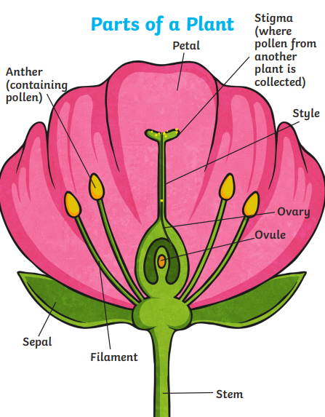
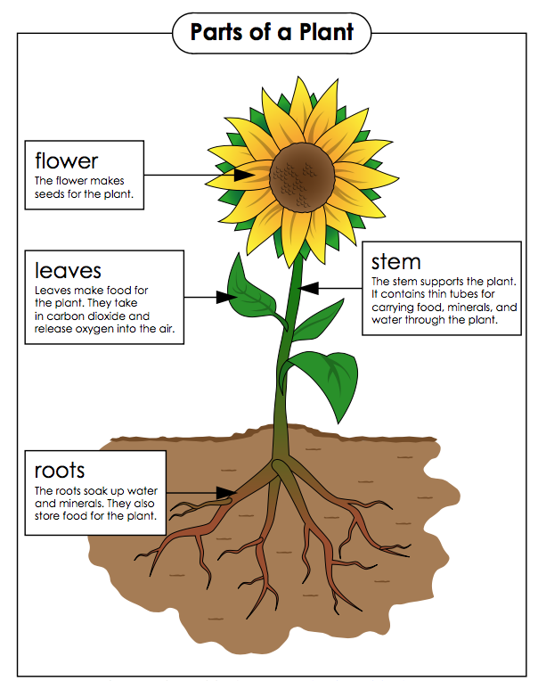

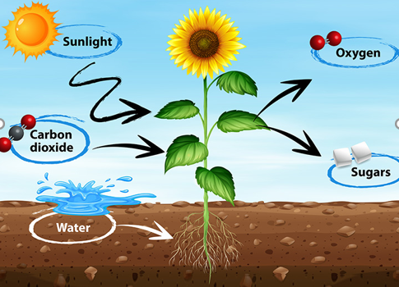
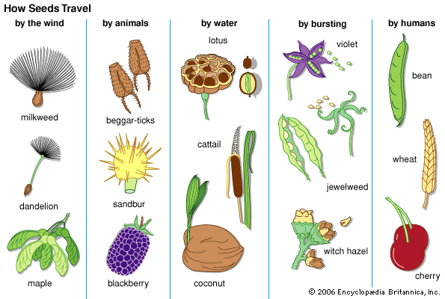

Key Vocabulary
Pollen | A fine powder that helps form a seed when joined to the ovule. | Stamen | The male parts of the flower. The stamen is made up of the anther and the filament.
Ovule | Contains an egg that helps form a seed when joined to the pollen. | Carpel | The female part of the flower. The carpel is made up of the stigma, style and ovary.
Reproduction | How a living thing creates offspring. | Sepal | Leaf like structures that protect the flower and petals before they open out.
Fertilisation | The joining of the pollen and the ovule. | Transportation | The movement of water and nutrition from the roots to different parts of the plant.
Pollination | The process of moving pollen from one plant to another. | Capillary action | The process in which water moves up something like a tube or a material with small holes in it.

