Key Facts
Soil is a mixture of minerals and organic material that covers much of the Earth’s surface.
Minerals are bits of rock and organic material is the remains of living things that have died.
Soil has small spaces that hold water and air.
Caves are formed when water permeates through the bedrock and erodes some of the rock away.
Over thousands of years these caves can become very large.
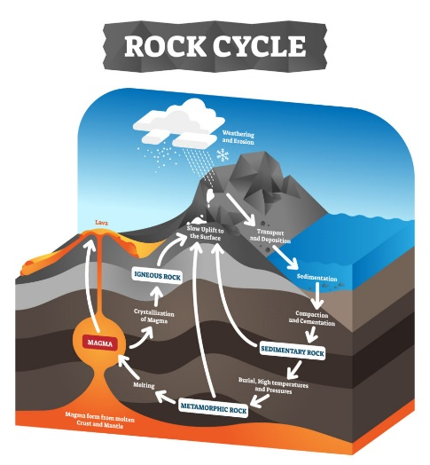
Year 3 – Spring 1 + 2 – Rocks
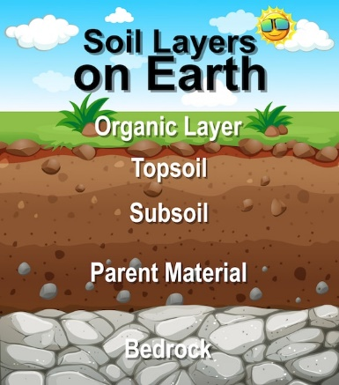

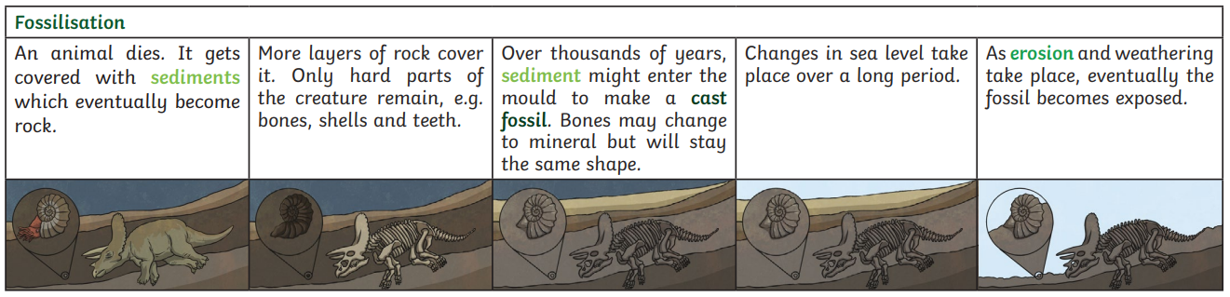
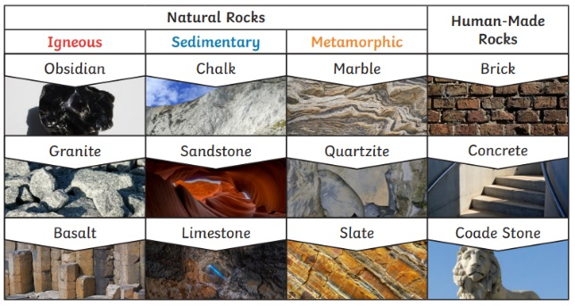

Key Vocabulary
Magma | Molten rock that remains underground. | Igneous rock | Rock that has been formed from magma/lava that has cooled.
Lava | Molten rock that comes out of the ground. | Sedimentary rock | Rock that has been formed from sediment.
Sediment | Solid material that is broken into smaller pieces. Sediment can include sand, mud, pebbles, minerals and plants. | Metamorphic rock | Rock that has changed structure due to pressure and heat.
Erosion | When water, wind, ice or rocks wear something away. | Permeable | Allows liquid to pass through it.
Deposit | When material is dropped and left somewhere else. | Impermeable | Does not allow liquid to pass through it.

