Key Facts
Incisors are the large flat teeth with straight edges that are at the front of the mouth for biting and cutting.
Canines are the sharp tearing teeth found at the side of the mouth behind the incisors.
Premolar are the teeth between the molars and the canines that are used for holding and crushing.
Molars are the large teeth at the back of the mouth with a broad surface for grinding.
The teeth of an animal are designed to eat different food depending on the diet of the animal.
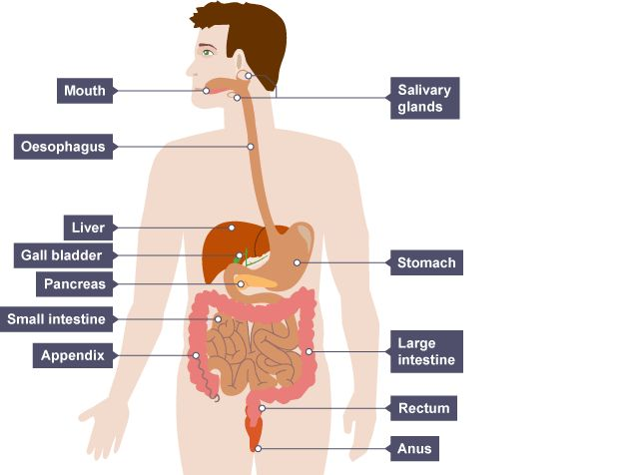
Year 4 – Summer 1 – Animals including Humans
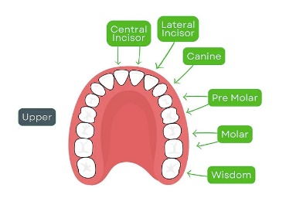

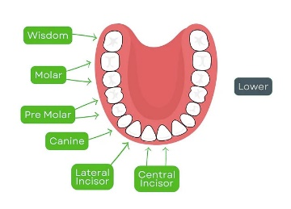

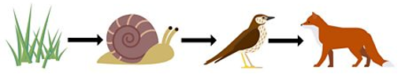
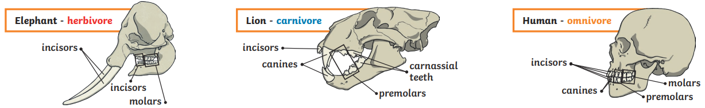

Key Vocabulary
Digestive System | The system for breaking down food. | Rectum | Faeces are stored in the rectum and leave the body via the anus.
Oesophagus | A tube that moves food from mouth to stomach. | Producer | A living thing that produces its own energy.
Stomach | An organ that breaks down food using acid and by churning food around. | Consumer | A living thing that eats animals and plants to produce energy.
Small intestine | An organ where nutrients from food are absorbed into the blood. | Prey | An animal that is hunted by other animals for food.
Large intestine | An organ where water from food is absorbed. | Predator | An animal that hunts other animals for food.

