|  |
| --- |
| **Key Facts** |
| It takes around **24 hours** for your dinner to wind its way through the **nine-metre-long digestive tract.** |
| There are an estimated 7.77 million species of animals on the planet. |
| You need to brush your teeth twice a day with a fluoride-based toothpaste. |
| The digestive system is made up of organs that break down food into protein, vitamins, minerals, carbohydrates, and fats, which the body needs for energy, growth, and repair. |
| Flamingos are naturally white but turn pink from eating pink shrimps! |
| Plants are the primary producers in the food chain. |
| Animals, including humans, need to get their nutrition from what they eat as they can’t make their own nutrients. |
| Some animals such as cows and sheep have more than one stomach. |

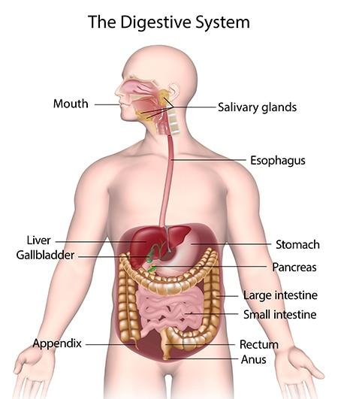**Year 4 – Spring 2 – Animals including Humans**

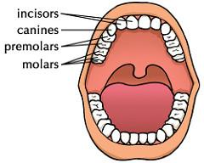

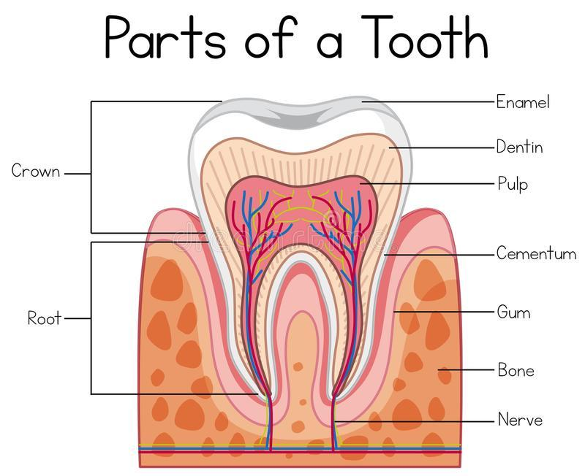

|  |  |  |  |
| --- | --- | --- | --- |
| **Key Vocabulary** | | | |
| **Canine** | The sharp, tearing teeth found at the side of the mouth behind the incisors. | **Oesophagus** | A tube- like structure that connects the mouth to the stomach. |
| **Incisor** | The large flat teeth with straight edges that are at the front of the mouth. | **Gall bladder** | An organ that secretes bile |
| **Molar** | The large teeth near the back of the mouth with a broad surface for grinding. | **Stomach** | After food has been chewed in the mouth it enters the stomach via the oesophagus. |
| **Premolar** | A tooth between the molars and the canines. | **Small Intestine** | A long and winding tube where most of digestion takes place. |
| **Digestive System** | The system for breaking down food. | **Large Intestine** | The final section of the digestive tract that runs from the small intestine to the anus. |
| **Pancreas** | A large gland that secretes digestive enzymes. | **Liver** | A large organ that helps with metabolism. |