|  |
| --- |
| **Key Facts** |
| There were 6 Tudor monarchs including Lady Jane Grey who ruled for 9 days. |
| Tudor fashion changed during the Tudor period to show England’s growing wealth. |
| England led explorations that discovered America during this period. |
| Henry VIII formed a new church, the Church of England, to make sure he got an heir to his throne. |
| The views of the monarchs led to religious changes that affected the people and caused many deaths. |
| Cardinal Wolsey, one of King Henry VIII’s advisors, until he was accused of treason, was born in Ipswich. |

**Year 4 – Autumn 1 – The Tudors**

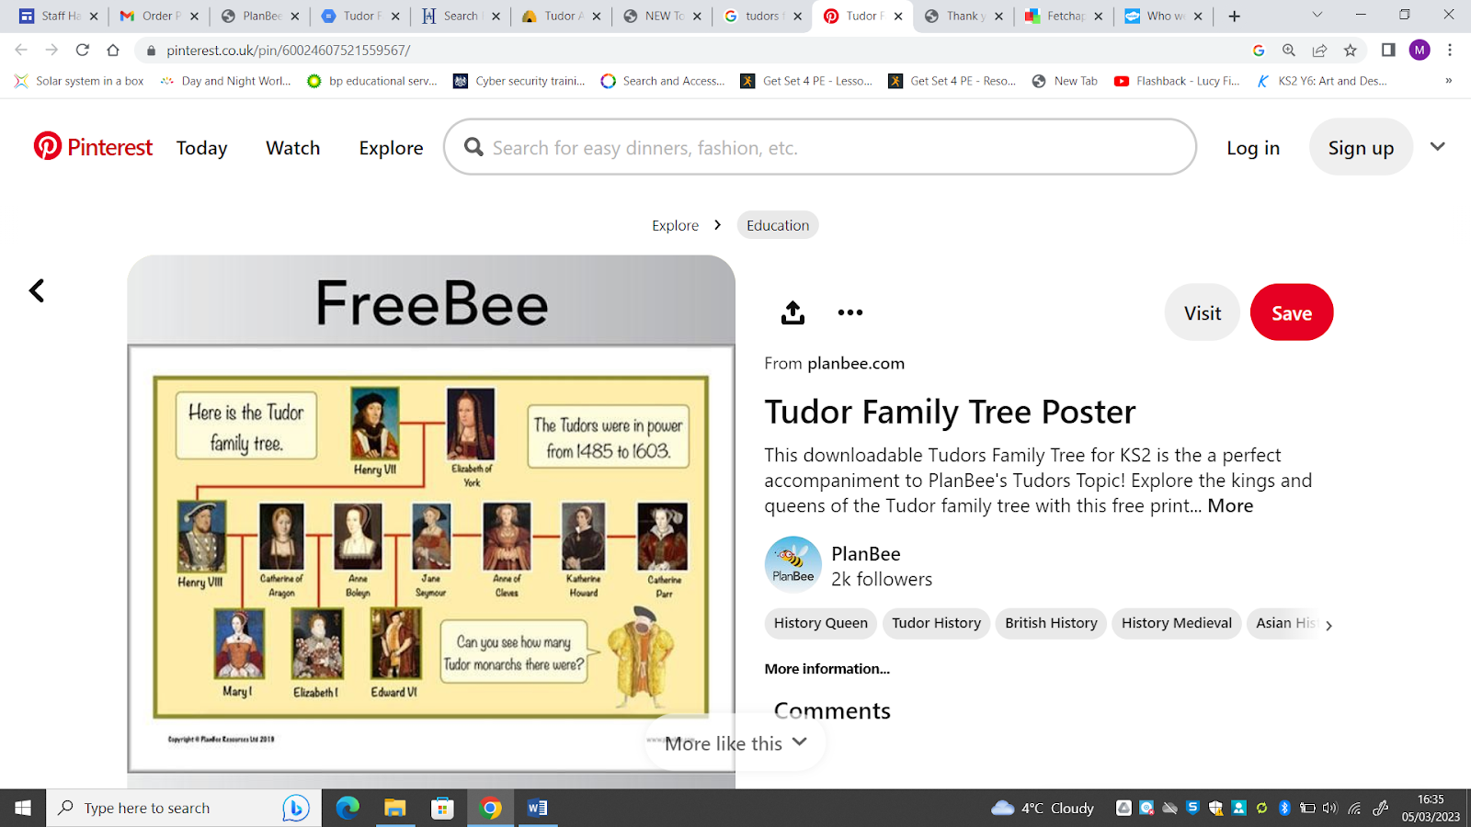

|  |  |  |  |
| --- | --- | --- | --- |
| **Key Vocabulary** | | | |
| Reign | The period of rule of a monarch (king/queen). | Monastery | A community of monks. |
| Heir | Person who becomes the monarch when the previous one dies. | The Reformation | Changes that took place in the 1500s when groups left the Catholic Church and became Protestant. |
| Protestant | Christian who belonged to one of the groups that left the Catholic Church. | The Church of England | Christian religion with the English monarch as its head. |
| Treason | Crime of trying to overthrow the monarch or helping their enemies. | Catholic | Christian Church with the Pope in Rome as its head. |
| Heresy | Belief that is not the same as that of the ruler. | Monarch | A king or queen who rules a country. |