Key Facts
Electrical energy can be turned into different types of energy such as light, heat, sound or movement.
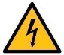
Electricity is dangerous so we need to careful using appliances.

Mains electricity is made by the burning of fossil fuels (coal, oil and gas), wind and solar (the sun).
Electricity can only flow when the circuit is complete and there is a battery.
Lightening and static electricity are natural forms of electricity.

Year 4 – Spring 2 – Electricity
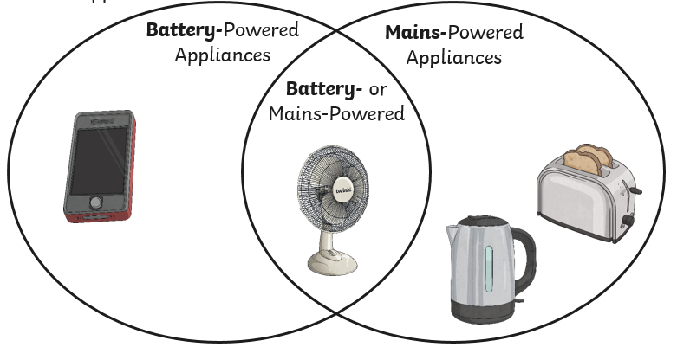

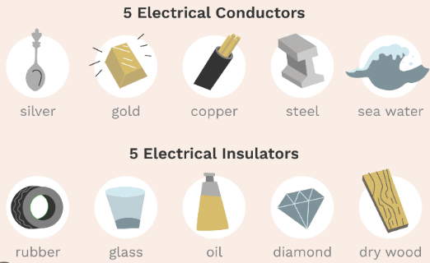
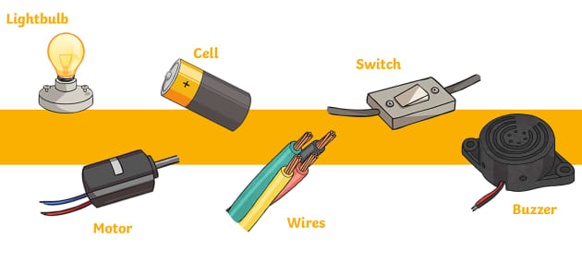
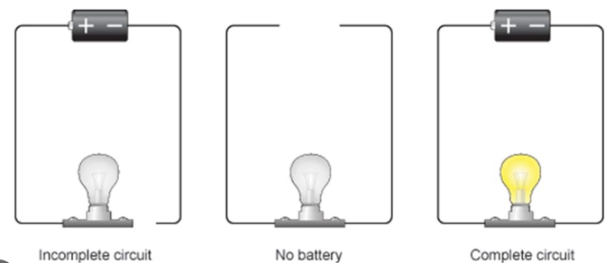

Key Vocabulary
Electricity | A form of energy that makes things work. | Circuit | The route that electricity flows around.
Appliances | A piece of equipment designed to perform a particular purpose. | Component | Part of the route that electricity flows around.
Mains | Electricity supplied to a building through wires. | Electrical conductor | A material that allows electricity to flow through it.
Battery | Electricity stored as a chemical. | Electrical insulator | A material that does not allow electricity to flow through it.

