Key Facts
A classification key is a way of grouping, identifying and naming living things.
Vertebrates can be sorted into 5 main groups: mammals, fish, birds, reptiles and amphibians.
There are many invertebrate groups and they include: snails and slugs, worms, spiders and insects.
Plants can be grouped into flowering and non-flowering.
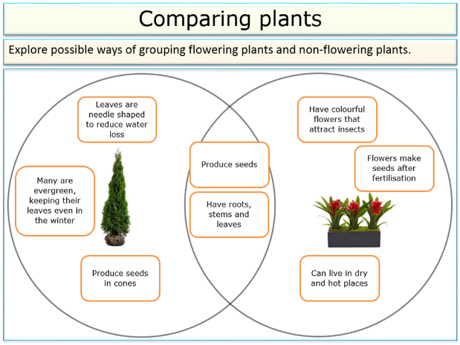
Year 4 – Summer 2 – Living Things & Their Habitats
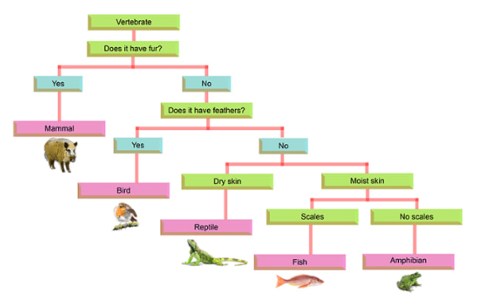

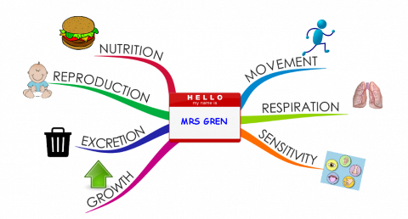
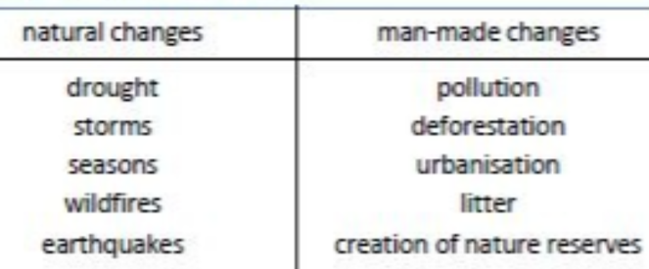

Key Vocabulary
Classify | Sort things into different groups. | Deforestation | The clearing and cutting down of forests.
Characteristics | Special qualities or appearances that make an individual or groups of things different to others. | Urbanisation | The increase of the number of people living in towns and cities.
Life processes | What living things need to do to stay alive and include movement, respiration, sensitivity, growth, reproduction, excretion and nutrition. | Endangered species | Any plant or animals that is in danger of disappearing forever.
Environment | The physical surroundings of Earth. | Extinct | The disappearance of a species from Earth.
Pollution | When the environment gets dirtied by waste, chemicals and other harmful substances. | Conservation | Protecting the environment and the wildlife that lives in it.

