Key Facts
Sound is a kind of energy, created by vibrations.
Sound can travel through solids, liquids and gases. Sound cannot travel through a vacuum.
Sound waves travel to the ear and make the ear drum vibrate.
Quiet sounds are created by smaller sound waves.
Loud sounds are created by larger sound waves.
Low pitch sounds are created by long sound waves.
High pitch sounds are created by short sound waves.
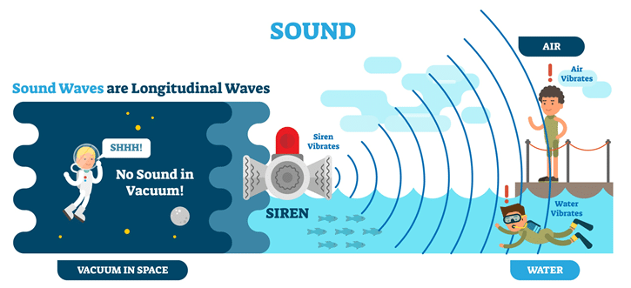
Year 4 – Spring 1 – Sound

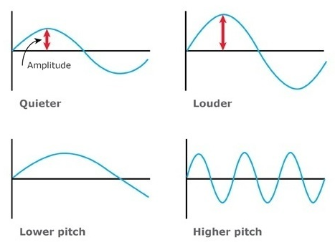
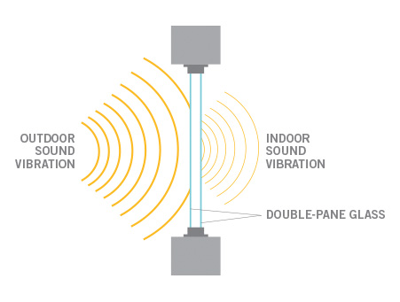
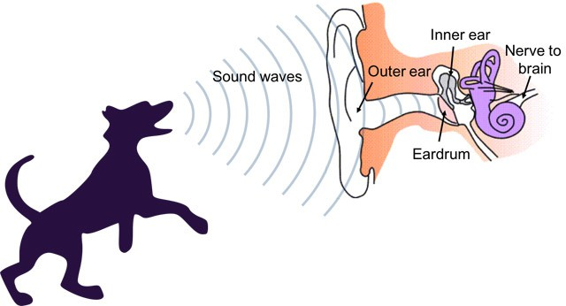

Key Vocabulary
Vibration | Very fast back-and-forth movements. | Volume | How loud or quiet sound is.
Sound source | The point where the sound starts. It can be natural or man-made. | Decibel | A unit for measuring how loud or quiet something is (dB).
Sound wave | The way sound travels from a source. | Pitch | How high or low the sound is.
Vacuum | A space with nothing in it, not even air. | Amplitude | The size of the vibration (sound wave). The larger the amplitude (vibration), the louder the sound.
Sound proofing | The process of reducing excess sound. | Frequency | The number of vibrations (sound waves) in a second. The higher the frequency (number of vibrations), the higher the pitch.

