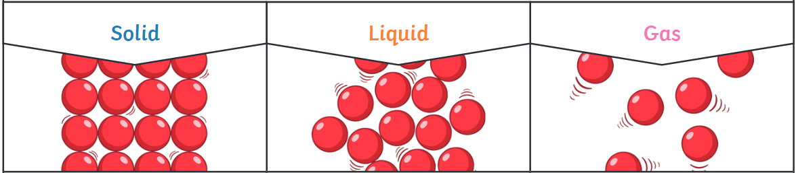
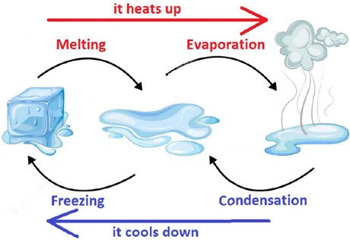
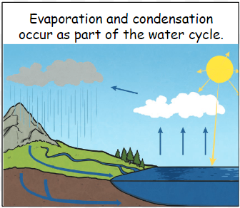
Year 4 – Autumn 1 - States of Matter

Key Facts
Solids | Solids are materials that keep their shape unless a force is applied to them. Particles in a solid are close together and can only vibrate.
Liquids | Liquids take the shape of their container. They can change shape but do not change the amount of space they take up. They can flow or be poured. Particles in a liquid are close together but can move around each other easily.
Gases | Gases can spread out to completely fill the container or room they are in. They do not have any fixed shape but they do have a mass. Particles in a gas are spread out and can move around very quickly in all directions.

Key Vocabulary
State of matter | Matter is anything that takes up space. The state of matter is the form it takes. | Condensation | The process when a gas turns into a liquid when it cools.
Particle | A miniscule piece of matter that we cannot see with our eyes. | Evaporation | The process when a liquid turns into a gas.
Melting | The process when a solid turns into a liquid when heat is applied. | Water vapour | This is water that takes the form of a gas.
Freezing | The process when a liquid turns into a solid when it cools. | Precipitation | Liquid or solid particles that fall from a cloud as rain, sleet, hail or snow.

