Year 5 – Summer 2 – Animals including Humans
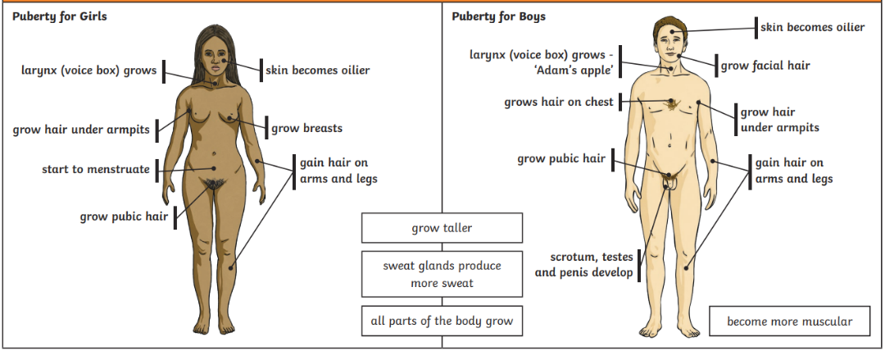
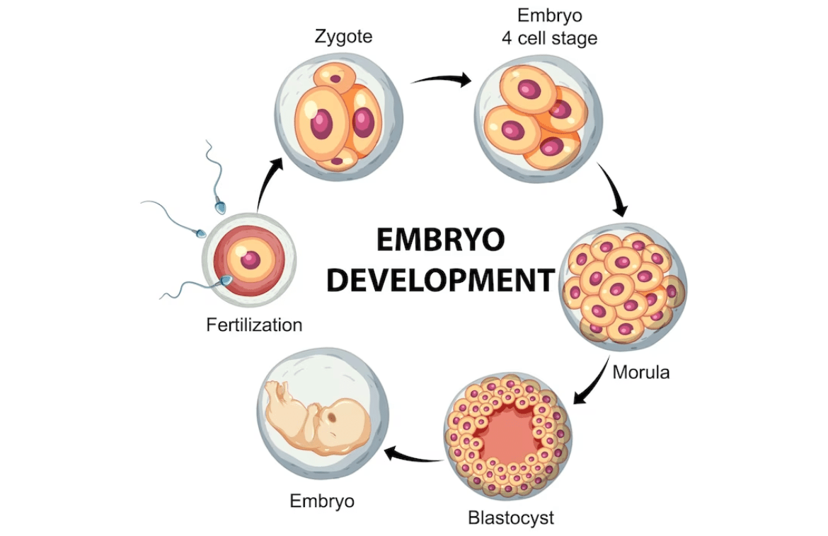

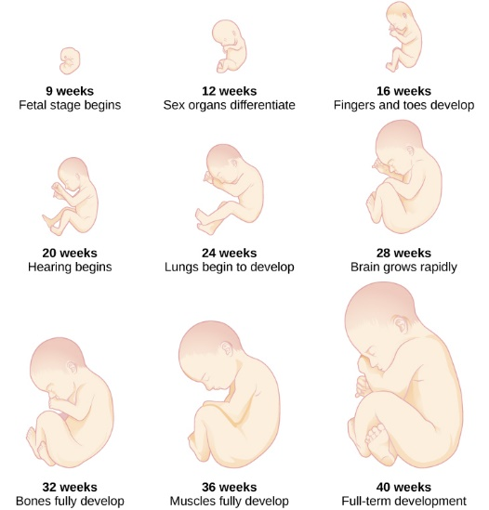

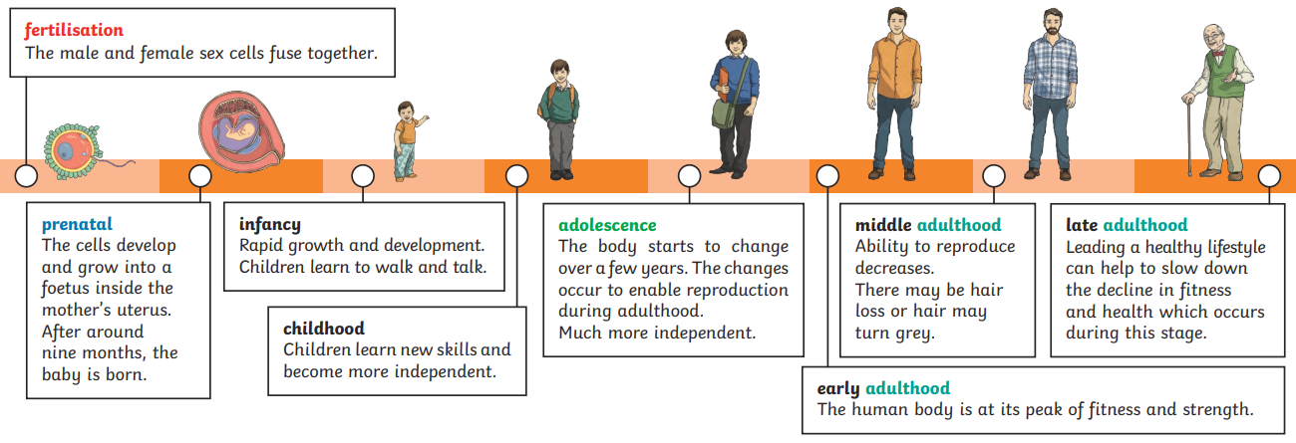

Key Vocabulary
Uterus | The organ of a woman were offspring are created. | Infancy | The stage of development between birth and childhood.
Prenatal | The stage of development from fertilisation to the time of birth. | Adolescence | The stage of development between childhood and adulthood.
Embryo | A fertilised cell that develops into a foetus. | Puberty | The changes to a child’s body to become an adult.
Foetus | An unborn offspring that develops from an embryo. | Menstruation | When a female body discharges the lining of the uterus.

